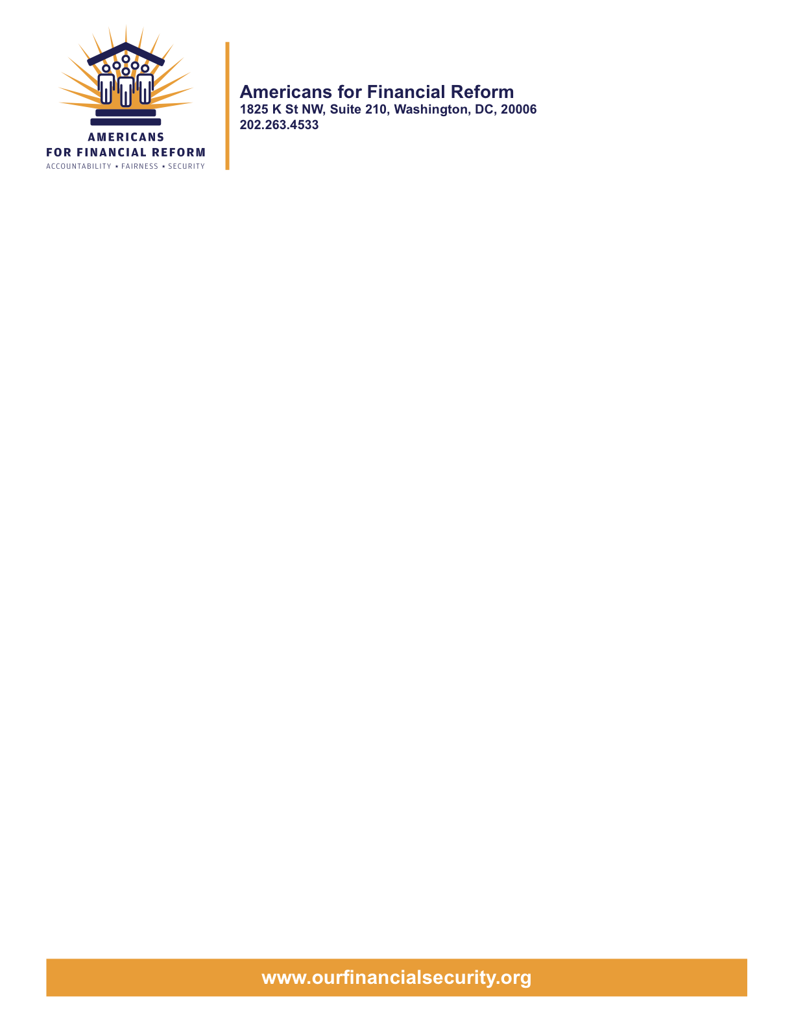

June 22, 2010

Senator Scott Brown
317 Russell Senate Office Building
Washington D.C. 20510

Senator Susan Collins
413 Dirksen Senate Office Building
Washington, DC 20510

Senator Chuck Grassley
135 Hart Senate Office Building
Washington, DC 20510

Senator Olympia Snowe
154 Russell Senate Office Building
Washington, DC 20510
To Senators Brown, Collins, Grassley, and Snowe:
The Americans for Financial Reform (AFR) coalition is grateful for your support for the landmark Wall Street reform legislation passed by the Senate last month. The coalition and you have a shared determination to move the nation beyond the bailout era. We also share the stated goal of enjoining recourse to taxpayers to finance the failure of financial institutions. We hope that we can come to agreement about how best to prevent taxpayer-financed bailouts in the future.
The legislation now before the conference committee is not a bailout bill. It is a plan for conducting funerals. As you know, a bailout involves using money to revive a failing business so that it can continue operations. By contrast, in this legislation, the FDIC is given the mandate to dismantle, shut down and liquidate failing firms. In no way does the bill’s Orderly Liquidation Fund (OLF) bailout and resuscitate failed firms. Instead, such a fund provides the FDIC with the necessary financial tools to dismantle and terminate firms; it is a funeral fund. Access to resources at the time of receivership is necessary so that the firm can be liquidated carefully, minimizing the systemic contagion effects that a sudden, disorderly halt to business would have.
In response to anti-bailout rhetoric, under the Senate version of bill, the taxpayers now front the funeral expenses. In contrast, under the House version, Wall Street does.
Under the Senate bill, the amount FDIC can borrow from the U.S. Treasury is capped by a “Maximum Obligation Limit” calculation. The taxpayers may be on the hook for up to five years or beyond. Given that one of the greatest objections to the Bush Bailout of 2008 was the burden on taxpayers, how did this happen?
In December the House financial reform bill passed with its $150 billion dissolution fund intact, and that fund has been included with the House’s Title II offer. The Systemic Dissolution Fund is created via assessments on systemically risky financial institutions with more the $50 billion in assets over the course of ten years. At the instant that the fund reaches $150 billion, assessments immediately stop. In the event that the SDF is required by the financial industry, like the OLF, it serves in no way to bailout and resuscitate failed firms.
Now that an upfront industry assessment has been removed from the original Senate bill, taxpayers are equally, if not more vulnerable than they were in 2008. In fact, and ironically, a financial reform bill without industry pre-funding is a taxpayer-financed solution: in the case of a financial crisis, if no industry assessments are available to the FDIC, the lone source of funeral financing is a line of credit from the Treasury. As we all know, the U.S. Treasury is funded by taxpayers, not by the financial industry. Real taxpayer protection is created by an industry-financed OLF or SDF; excluding this from the financial reform bill maintains the status quo, and sustains the possibility of future taxpayer-fronted solutions.
Furthermore, the removal of the industry-financed OLF fund from the Senate bill creates a PAYGO compliance issue. The Congressional Budget Office’s April 2010 score of the original Senate bill, which included the $50 billion OLF fund, was revenue positive, and yields a $21 billion surplus over ten years. The June 2010 CBO report on the Senate bill, in which the OLF Fund had been removed, is revenue negative, and creates a $19.7 deficit over ten years.
The House attempted to address PAYGO via two “pay-fors”—Provisions 5 (raising an estimated $12 billion over 10 years) and 6 (raising an estimated $8 billion over 10 years) in the Title III House offer. But the Senate conferees have rejected Provision 6 (making permanent the Transaction Account Guarantee program), so the bill as it now stands is in violation of PAYGO.
We would welcome the opportunity to discuss the foregoing issues with you at your convenience, issues which must necessarily be resolved if we are to enact financial reform legislation that indeed puts the taxpayer-funded solutions to bank failures behind us.
Sincerely,

Americans for Financial Reform

Following are the partners of Americans for Financial Reform.

All the organizations support the overall principles of AFR and are working for an accountable, fair and secure financial system. Not all of these organizations work on all of the issues covered by the coalition or have signed on to every statement.

National Organizations
- A New Way Forward
- AARP
- Accountable America
- Adler and Colvin
- AFL-CIO
- AFSCME
- Alliance For Justice
- American Family Voices
- American Income Life Insurance
- Americans for Democratic Action, Inc.
- Americans for Fairness in Lending
- American Sustainable Business Council
- Americans United for Change
- Business for Shared Prosperity
- Calvert Asset Management Company, Inc.
- Campaign for America’s Future
- Campaign Money
- Center for Digital Democracy
- Center for Economic and Policy Research
- Center for Economic Progress
- Center for Responsible Lending
- Center for Justice and Democracy
- Center of Concern
- Change to Win
- Clean Yield Asset Management
- Coastal Enterprises Inc.
- Color of Change
- Common Cause
- Communications Workers of America
- Community Development Transportation Lending Services
- Community Law Center
- Consumer Action
- Consumer Association Council
- Consumers for Auto Safety and Reliability
- Consumer Federation of America
- Consumer Watchdog
- Consumers Union
- Corporation for Enterprise Development
- CREDO
- CTW Investment Group
- Demos
- Economic Policy Institute
- Essential Action
- Green America
- Greenlining Institute
- Good Business International
- Help Is On the Way, Inc
- HNMA Funding
- Home Actions
- Housing Counseling Services
- Information Press
- Institute for Global Communications
- Institute for Policy Studies: Global Economy Project
- International Brotherhood of Teamsters
- Institute of Women’s Policy Research
- Keystone Research Center
- Krull & Company
- Laborers’ International Union of North America
- Lake Research Partners
- Lawyers’ Committee for Civil Rights Under Law
- Leadership Conference on Civil Rights
- MoveOn.org Political Action
- NAACP
- NASCAT
- National Association of Consumer Advocates
- National Association of Investment Professionals
- National Association of Neighborhoods
- National Coalition for Asian Pacific American Community Development
- National Community Reinvestment Coalition
- National Consumer Law Center (on behalf of its low-income clients)
- National Consumers League
- National Council of La Raza
- National Fair Housing Alliance
- National Federation of Community Development Credit Unions
- National Housing Institute
- National Housing Trust
- National Housing Trust Community Development Fund
- National NeighborWorks Association
- National Peoples Action
- National Council of Womens Organizations
- National Worksright Institute
- Next Step
- OMB Watch
- Opportunity Finance Network
- Partners for the Common Good
- National People’s Action (NPA)
- PICO
- Progress Now Action
- Progressive States Network
- Poverty and Race Research Action Council
- Public Citizen
- Responsible Endowments Coalition
- Sargent Shriver Center on Poverty Law
- Scam Victims United
- SEIU
- Sojourners
- State Voices
- Taxpayer’s for Common Sense
- The Association for Housing and Neighborhood Development
- The Carrots and Sticks Project
- The Fuel Savers Club
- The Seminal
- UNET
- Union Plus
- United for a Fair Economy
- U.S. PIRG
- Unitarian Universalist for a Just Economic Community
- United Food and Commercial Workers
- United States Student Association
- USAction
- Veris Wealth Partners
- Veterans Chanmber of Commerce
- We The People Now
- Western States Center
- Woodstock Institute
- Working America
- World Business Academy
- World Privacy Forum

State Organizations
- 207 CCAG
- 9 to 5, the National Association of Working Women (CO)
- AARP Rhode Island
- Alaska PIRG
- Arizona PIRG
- Arizona Advocacy Network
- Arizonans for Responsible Lending
- Arkansas Community Organizations
- Arkansas Public Policy Panel
- Association for Neighborhood and Housing Development (NY)
- Audubon Partnership for Economic Development LDC (New York, NY)
- Aurora NAACP
- BAC Funding Consortium Inc. (Miami, FL)
- Beech Capital Venture Corporation (Philadelphia, PA)
- Bell Policy Center (CO)
- California PIRG
- California Reinvestment Coalition
- Center for Media and Democracy
- Center for NYC Neighborhoods
- Century Housing Corporation (Culver City, CA)
- Changer(NY)
- Chautauqua Home Rehabilitation and Improvement Corporation (NY)
- Chicago Community Loan Fund (Chicago, IL)
- Chicago Community Ventures (Chicago, IL)
- Chicago Consumer Coalition
- Citizen Potawatomi CDC (Shawnee, OK)
- Club Change of Martin County (Florida)
- Coalition on Homeless Housing in Ohio
- Coffee Party of Pensacola, Florida
- Coffee Party of Union Square, New York City
- Colorado AFL-CIO
- Colorado Center on Law and Policy
- Colorado Immigrants Rights Coalition
- Colorado PIRG
- Colorado Spring NAACP
- Community Action of Nebraska
- Community Capital Development
- Community Capital Fund (Bridgeport, CT)
- Community Capital of Maryland (Baltimore, MD)
- Community Development Financial Institution of the Tohono O’odham Nation (Sells, AZ)
- Community Redevelopment Loan and Investment Fund, (Atlanta, GA)
- Community Reinvestment Association of North Carolina
- Community Resource Group (Fayetteville, AR)
- Connecticut Association for Human Services
- Connecticut Citizen Action Group
- Connecticut PIRG
- Consumer Assistance Council
- Cooper Square Committee (New York, NY)
- Cooperative Fund of New England (Wilmington, NC)
- Corporacion de Desarrollo Economico de Ceiba (Ceiba, PR)
- CWA 7777 (CO)
- Delta Foundation, Inc. (Greenville, MS)
- Economic Opportunity Fund (EOF) (Philadelphia, PA)
- Empire Justice Center (NY)
- Enterprises, Inc., Berea KY
- Fair Housing Contact Service OH
- Federation of Appalachian Housing Enterprises, Inc. (Berea, KY)
- Fitness and Praise Youth Development, Inc. (Baton Rouge, LA)
- Florida Consumer Action Network
- Florida PIRG
- Forward Community Investments (Madison, WI)
- Funding Partners for Housing Solutions (Ft. Collins, CO)
- Georgia PIRG
- Grow Iowa Foundation (Greenfield, IA)
- Homewise, Inc. (Santa Fe, NM)
- Humanitas Community Development Corporation
- Idaho Chapter, National Association of Social Workers
- Idaho Community Action Network
- Idaho Nevada CDFI (Pocatello, ID)
- Illinois PIRG
- Impact Capital (Seattle, WA)
- Indiana PIRG
- Indiana University PIRG
- Information Press (CA)
- Iowa PIRG
- Iowa Citizens for Community Improvement
- JobStart Chautauqua, Inc. (Mayville, NY)
- Keystone Research Center
- La Casa Federal Credit Union (Newark, NJ)
- Low Income Investment Fund (San Francisco, CA)
- Long Island Housing Services NY
- MaineStream Finance (Bangor, ME)
- Maryland PIRG
- Massachusetts Consumers’ Coalition
- Massachusetts Fair Housing Center
- MASSPIRG
- Michigan PIRG
- Midland Community Development Corporation (Midland, TX)
- Midwest Minnesota Community Development Corporation (Detroit Lakes, MN)
- Mile High Community Loan Fund (Denver, CO)
- Missouri PIRG
- Montana Community Development Corporation (Missoula, MT)
- Montana PIRG
- Mortgage Recovery Service Center of L.A.
- Neighborhood Economic Development Advocacy Project
- New Hampshire PIRG
- New Jersey Community Capital (Trenton, NJ)
- New Jersey Citizen Action
- New Jersey PIRG
- New Mexico PIRG
- New York PIRG
- New York City AIDS Housing Network
- Next Step (MN)
- NOAH Community Development Fund, Inc. (Boston, MA)
- Nonprofit Finance Fund (New York, NY)
- Nonprofits Assistance Fund (Minneapolis, MN)
- North Carolina Association of Community Development Corporations
- North Carolina PIRG
- Northern Community Investment Corporation (St. Johnsbury, VT)
- Northside Community Development Fund (Pittsburgh, PA)
- Ohio Capital Corporation for Housing (Columbus, OH)
- Ohio PIRG
- Oregon State PIRG
- Our Oregon
- PennPIRG
- Piedmont Housing Alliance (Charlottesville, VA)
- Rhode Island PIRG
- Rights for All People
- The Rocky Mountain Peace and Justice Center
- Rural Community Assistance Corporation (West Sacramento, CA)
- Rural Organizing Project OR
- San Francisco Metropolitan Transportation Authority
- Seattle Economic Development Fund dba Community Capital Development
- SEIU Local 105 (Colorado)
- SEIU Rhode Island
- Siouxland Economic Development Corporation (Sioux City, IA)
- Southern Bancorp (Arkadelphia, AR)
- TexPIRG
- The Association for Housing and Neighborhood Development
- The Fair Housing Council of Central New York
- The Help Network
- The Loan Fund (Albuquerque, NM)
- Third Reconstruction Institute (NC)
- V-Family, Inc.
- Vermont PIRG
- Village Capital Corporation (Cleveland, OH)
- Virginia Citizens Consumer Council
- Virginia Poverty Law Center
- War on Poverty – Florida
- Washington Community Action Network
- WashPIRG
- Westchester Residential Oppurtunities Inc. NY
- Wigamig Owners Loan Fund, Inc. (Lac du Flambeau, WI)
- WISPIRG

Businesses

- Blu
- Bowden-Gill Environmental
- Community MedPAC
- Diversified Env. Planning
- Hayden & Craig, PLLC\
- The Holographic Repatterning Institute at Austin
- Mid City Animal Hospital (Phoenix, AZ)
- UNET

