

May 4, 2010

Dear Senator:

Consumers Union Urges Senators to Support Key Amendments
to Strengthen Financial Reform Legislation and to Oppose Amendments that Would Weaken the Bill

As the Senate debates S. 3217, the Restoring America’s Financial Stability Act of 2010, Consumers Union ®, the nonprofit of Consumer Reports®, urges you to support amendments to protect consumers from unsafe financial products and to strengthen rules to stop banks from getting so big that they could threaten the financial system. We urge you to oppose any amendments that would weaken the bill.

Please support the following amendments:

- Put Consumer Protection in a Separate, Independent Agency: Consumers Union supports an amendment to be proposed by Senator Jack Reed to strengthen the legislation’s proposed financial watchdog by making it a fully independent, stand-alone agency. Currently, the bill’s Consumer Financial Protection Bureau (CFPB) would be housed within the Federal Reserve Board. Although it has several important features to ensure its independence, the rules it develops could be vetoed by a two-thirds vote of a panel made up mostly of other federal banking regulators if the panel decides the protections pose a risk to the stability of the financial system. Consumers Union also supports an amendment by Senator Reed to eliminate the veto power of other banking regulators over new consumer protections.

- Stop “Too Big to Fail” by Limiting the Size of Banks: The top six banks in the U.S. have assets equal to 60 percent of the Gross Domestic Product, up from just 17 percent in 1994. An amendment proposed by Senators Sherrod Brown and Ted Kaufman would limit the size of insured banks so they cannot become “too big to fail.” It would prohibit any bank from holding more than 10 percent of deposits of insured depository institutions and impose other size limits on big banks.

- Let States Protect Consumers from Unfair Interest Rates: S. 3217 allows states to enforce federal and state consumer protection laws and enact even stronger safeguards. But the legislation does not override a 1978 U.S. Supreme Court decision, Marquette National Bank of Minneapolis v. First of Omaha Service Corp., which allows an out-of-state bank to ignore interest rate limits imposed by a consumer’s home state. Consumers Union supports Amendment 3746 offered by Senator Sheldon Whitehouse that would restore the ability of states to set and enforce stronger limits on interest rates no matter where the bank is based.

We ask you to oppose a number of amendments that would weaken the reform bill, including:

- No Loopholes for Auto Dealers or Payday Lenders: Opponents of strong financial reform are expected to offer amendments to limit the authority of the proposed CFPB so that it can’t protect consumers from certain types of lenders. Consumers Union is urging Senators to oppose loophole amendments, including one that would exempt loans made or arranged by car dealers. Car dealer auto loan overcharges cost Americans an estimated $20 billion annually. Likewise, Consumers Union opposes an expected amendment to exempt payday lenders from the CFPB. Payday loans carry an annual interest rate of 391 percent and are so difficult to pay off that many borrowers end up paying more in interest than they originally borrowed.

- Don’t Undermine the New Financial Watchdog’s Authority: Some reform opponents are expected to offer amendments that would make it easier for existing banking regulators to veto new protections developed by the Consumer Financial Protection Bureau. For example, amendments might lower the standard for when banking regulators could second guess the CFPB (currently the bill only allows the panel of banking regulators to block a proposed rule if it threatens the stability of the financial system) or lower the threshold for a veto (currently the bill requires a two-thirds vote to veto new protections).

- Don’t Block States from Protecting Consumers: Amendments are expected to weaken the provisions in S. 3217 that allow states to enforce state and federal consumer laws and enact stronger protections for consumers that apply to national banks. Consumers Union opposes all amendments that would prevent state Attorneys General from enforcing the law or that would undermine state consumer safeguards.

Active ongoing oversight of the financial marketplace is essential to ensuring that consumers will not be ripped off and that big financial firms will not continue to engage in risky schemes that can undermine our economy. We look forward to continuing to work with you as S. 3217 proceeds to final passage.

Sincerely,
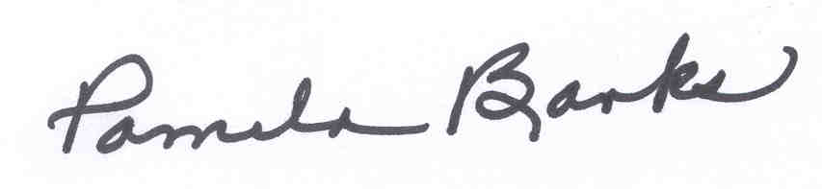

Pamela Banks
Senior Policy Counsel

