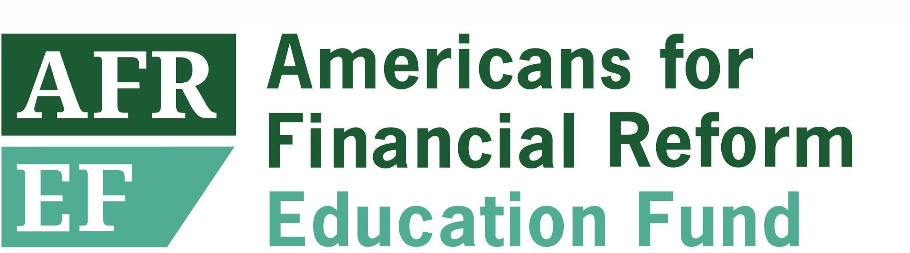

Managing Director of Policy
Washington, DC

Americans for Financial Reform (AFR) has been called “the leading voice for Wall Street accountability” in Washington. Help us continue and grow this important work.

Our organization played a leading role in winning passage of the Dodd Frank Financial Reform bill and the creation of the Consumer Financial Protection Bureau, and we are continuing the fight to eliminate inequity and systemic racism in the financial system in service of a just and sustainable economy. Americans for Financial Reform Education Fund (AFREF)’s staff effectively advances the agenda of a coalition of more than 200 consumer, civil rights, labor, community-based, and other organizations, along with academics and other experts, working together to advance this fundamentally important part of the economic and racial justice agenda. We focus on priorities ranging from stopping private equity abuses to curbing junk fees in consumer finance to promoting public options in banking and integrating climate risk into financial regulation.

AFREF invites nominations and applications for a Managing Director of Policy. As a key member of the senior leadership team and reporting to the Executive Director, the Managing Director will increase our impact and capacity to drive change. She/he/they will partner with AFREF’s leadership and staff to strengthen our policy analysis and advocacy, build connections between different threads of our work, and will bring an inclusive management style that supports staff members to achieve their highest potential and is grounded in principles of equity and inclusion.

KEY RESPONSIBILTIES

Leadership and Management
- Working with the Executive Director and members of the senior leadership team to set organizational goals and strategy and to guide and implement work to build a generative and collaborative organization; contributing to organizational planning and fundraising
- Leading a team of AFREF policy staff; managing the work of the team to help identify priorities and accomplish goals, and increase coordination of work streams within the team.
- Providing mentorship and support to policy staff that helps build and sustain a strong culture of inclusion, growth, and performance.
- Working with the Executive Director, senior leadership team, and policy staff and campaigns, research and policy teams to develop and implement specific strategies to advance our policy agenda.
- Strengthening communication collaboration and coordination between the policy team and other AFREF teams
- Contributing as a member of the senior leadership team to planning and to fundraising for the organization as a whole.
Policy Effectiveness and Impact
- Collaborating with and supporting members of the policy team to produce high quality work including regulatory comments, bill analyses, reports, and memos.
- Providing strategic guidance and support to policy team members in their development and implementation of plans to advance policy goals
- Collaborating with members of the policy team, and across the organization, to identify, develop and articulate connecting themes in AFREF’s work to build a shared strategic vision.

External Engagement
- Representing the organization and presenting on our policy agenda in meetings with policy makers, at public events, and with the media in an effective manner that advances AFREF goals
- Building and maintaining relationships with policy experts and leaders at partner organizations and academic and research institutions.
- Building and maintaining relationships with policy staff and principals at financial regulatory agencies and on Capitol Hill.

Ideal candidates will have:
- A serious commitment to economic and racial justice.
- 15+ years of relevant experience, including five years of leadership and management experience in a mission-driven, fast-paced, high-performance environment.
- Deep knowledge of at least some areas of AFREF’s policy work, and a demonstrated ability and willingness to learn in additional areas.
- Experience with and enthusiasm for mentorship and staff development; demonstrated commitment to equity and ability to put it into practice in management, and to responsive, accountable leadership and proactively managing others to take ownership, initiative, and action.
- Excellent strategic judgement about policy advocacy
- Exceptional writing and editing skills, including for both general and technical audiences.
- Excellent public speaking skills, and experience dealing with the media.
- Knowledge of the federal legislative and regulatory processes, experience on the Hill or at a Federal Regulatory Agency an asset.
- Excellent time management skills and the ability to handle multiple projects at once, and to adapt to a swiftly changing environment.
- A record of creative big picture thinking and the ability to make connections between ideas and people.
- A law degree or an advanced degree in economics or a related field is an asset but not required.

Compensation:
Annual salary range for this position: $135,000-155,000 commensurate with experience. Generous benefits, including medical, dental, vision, and 401K.

Location:
AFREF’s offices are located in downtown Washington DC. The Managing Director of Policy position is open for full-time remote work for candidates depending on location, with hybrid in-office/remote work arrangements available for those residing in the DMV area.

How to apply:
Please submit your application to our candidate portal linked here, including a resume, letter of interest, and two writing samples (ideally, related to AFR’s mission or to the job responsibilities outlined above).

AFR Education Fund is committed to a workplace that reflects diversity defined broadly, and where the talent, skills and uniqueness of each staff member are respected. We value a diverse workforce and are committed to a policy of equity for all employees and for all applicants. We strongly encourage People of Color; LGBTQIA+ people; women; people with disabilities; and veterans to apply.

Meet some but not all our qualifications? Don’t let that deter you from applying. If you believe that you could excel in our organization and believe in our mission, we hope you apply. We are dedicated to considering a broad array of candidates, including those with diverse workplace experiences and backgrounds. Please use your cover letter to tell us about your interest in our work and what you would bring to the role.

