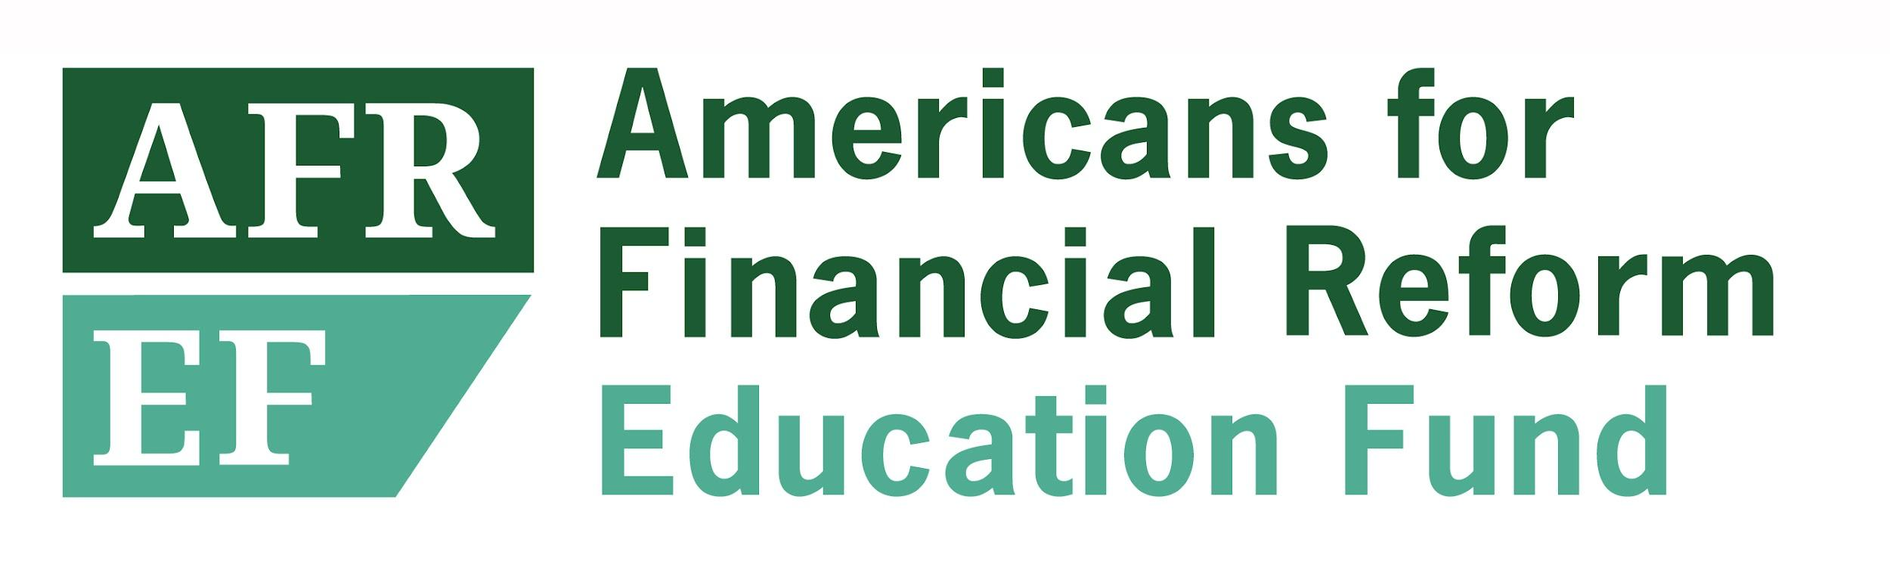

**Staff Writer**

Join our work to hold Wall Street accountable and make finance work for us, not against us. Americans for Financial Reform Education Fund (AFREF) is seeking a Staff Writer who can help us tell the story of how and why transforming the financial system is key to advancing racial and economic justice.

AFREF played a leading role in securing passage of the Dodd Frank Financial Reform law and the creation of the Consumer Financial Protection Bureau. We have been winning consequential policy change ever since and we are driving the fight for broader transformations of the financial system to build a more just economy and society. AFREF’s growing staff works in collaboration with a coalition of more than 200 consumer, civil rights, labor, community-based, and other organizations, along with academics and policy experts.

The **Staff Writer** will draw on the work of AFREF staff and partners to create materials including reports, fact sheets, memos, blog posts, op eds, and more to explain our policy analysis and our work to a variety of audiences including coalition partners, the general public, funders, and policymakers; and to help grassroots and advocacy organizations identify and take advantage of opportunities to advance their goals. The Staff Writer will also contribute to editing work by AFR policy and research staff. AFREF produces a significant volume of policy material frequently written for specialized expert readers; the Staff Writer will help make the issues at stake more accessible for a wider audience and place them in a broader context.

**Job responsibilities include:**

* Writing reports, fact sheets, memos, blog posts, op eds, presentations, etc.
* Editing reports and policy materials created by other AFREF staff to increase clarity, impact, and consistency.
* Explaining financial policy issues to non-experts and making connections between financial policy and broader economic, racial, and social justice goals.
* Learning about AFREF’s many areas of work in order to write effectively about them and understand the connections between issues.
* Collaborating with AFR teams including policy, communications, development, research and campaigns, as well as with partner organizations.

**Ideal candidates will have:**

* A strong commitment to racial and economic justice
* Excellent writing skills, including the ability to: write vividly and effectively for a broad range of audiences and in a variety of formats; organize complex material; articulate strategy and vision; and translate technical arguments so that their impact and import are clear to a general audience.
* Excellent editing skills and the ability to help others create polished final products.
* Knowledge of some areas of financial policy and excitement about learning new subject areas and issues.
* Strong strategic judgement.
* Both the ability to work independently and comfort cooperating with colleagues and coalition members
* At least five years of related experience

**Compensation:**

Annual salary range: $65,000 to $80,000 commensurate with experience. Generous benefits including medical, dental, vision, and 401K.

**How to apply:**

Please submit a letter of interest, resume and two writing samples via our [candidate portal linked here](https://apply.workable.com/americans-for-financial-reform-education-fund-afref-1/j/6D3E3AD482/).

*AFREF is committed to a workplace that reflects the diversity of America, defined broadly, and where the talent, skills, and uniqueness of each staff member are respected. We are committed to a policy of equity for all employees and to equal opportunity for all applicants for employment without regard to race, color, religion, national origin, sex, age, marital status, sexual orientation, gender identity/expression, family responsibilities, and disability.*