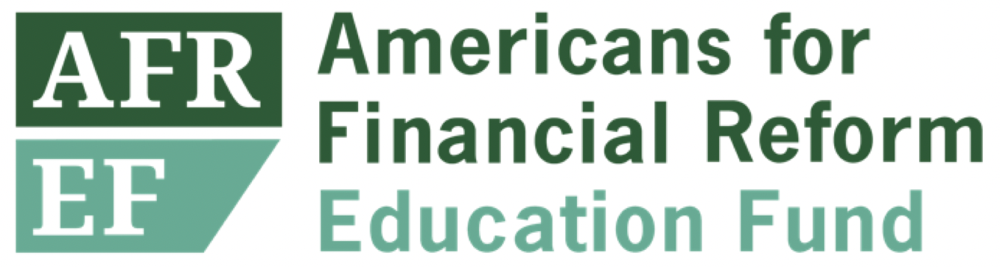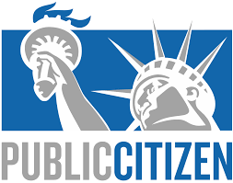

April 28, 2022

**Results of a nationwide survey: Retail investors’ support for the SEC mandating climate-related financial disclosures from public companies**

A nationwide survey of retail investors was conducted between March 18 and 29, 2022, by [Embold Research](https://emboldresearch.com) on behalf of Americans for Financial Reform Education Fund and Public Citizen. Broadly, these survey results show that investors care about climate-related risks and opportunities of public companies, support the SEC requiring climate-related disclosures with third-party audit, and would factor the information disclosed into their investment practices.

**Support for SEC Climate Disclosures**

***Seventy percent (70%) of investors surveyed support the SEC requiring all public corporations to disclose standardized information about their financial risks due to climate change, including risks due to new regulations, competing technologies, and consumer demand changes.[1]***

To make smart, sustainable investment decisions, investors and the public want—and need—more standardized information about companies’ growing climate financial risk,

their contribution to climate change, and their plans for remaining solvent in a low-carbon economy. According to the survey results,

* only 36% of investors trust voluntary disclosures of climate change risks;
* 58% of investors would trust disclosures made to the SEC; and
* 71% of investors would trust these disclosures if submitted to the SEC and if validated by a third-party auditor.[2]

**Factoring Climate Information Into Investment Decisions**

**Sixty-three percent** of investors would factor in information about a corporation's financial risks related to climate change if that information was audited and disclosed to the SEC.[3]

**Fifty-eight percent** of investors say they would be likely to factor in information about an investment’s financial risks and opportunities related to climate change if that information was standardized, free, and easy to find.[4]

* Demographic Breakdown: A majority of investors in nearly all cohorts would be likely to factor in this information. Notable cohorts more likely to factor in this information were Black or African American investors (73%) and young investors with the longest investment horizons (18-34 years of age, 69%).

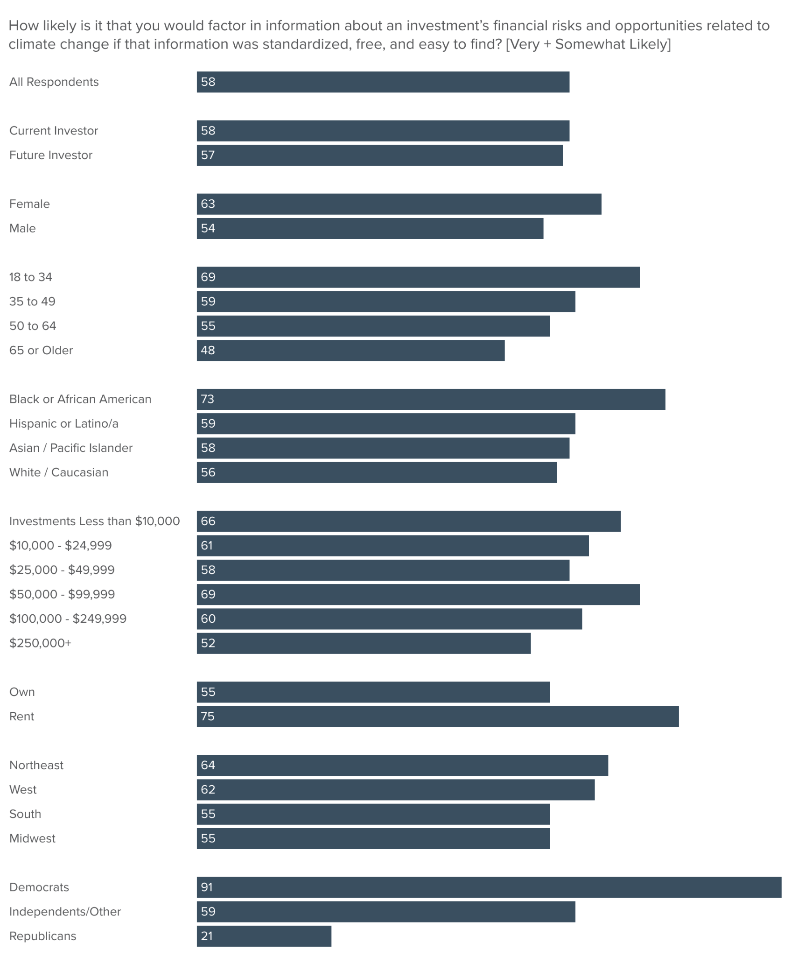

Despite the technical complexity and novelty of these issues, **63% of investors would factor in** **at least one**[5] of the following climate change related factors into their investment decisions if that information was standardized, free, and easy to find:

* corporations’ records on environmental justice, Indigenous rights, and impacts on communities (48% of investors)
* corporation’s’ climate commitments, strategies, and progress (46%)
* corporations’ risk management plans around climate change (44%)
* greenhouse gas emissions produced by a corporation’s products and supply chain (42%)[6]
* greenhouse gas emissions produced by a corporation’s day-to-day operations (41%)[7]
* greenhouse gas emissions produced by activities funded by banks’ and financial institutions’ investments and loans (37%)[8]
* a corporation’s use of carbon offsets (35%).

**Detailed Investor Preferences on Climate and Disclosure**

* Transition Plans: 78% of investors believe that if a company has committed to net-zero emissions targets, then their climate action plan’s annual metrics and progress should be freely available to the public and investors.
* Climate Risk Scenario Analysis: 66% of investors think it is valuable for investors if companies and banks publish analysis on the short and long-term risks their company has under different levels of climate warming.
* Environmental, Social, and Governance (ESG) Factors: 64% of investors would prefer to invest in companies that disclose their ESG criteria and practices.
* Adjusting to Climate Change: More than half of respondents (57%) want companies they invest in to adjust their businesses to climate change because it’s necessary for their financial performance.[9]
* Climate Strategy: 65% of investors believe it is important for corporations, banks, and other financial institutions to disclose information to investors about their climate change risks and strategy.[10]

**Financial Impacts of Climate Change Related Risks**

Sixty-eight percent of investors believe at least one of the following climate change related factors[11] could have a significant effect on the financial performance and/or stock price of a company:

* regulations on greenhouse gas pollution (45% of investors)
* consumer demand for more environmentally friendly products and business practices (45%)
* climate change and extreme weather events (42%)
* investor demand for action on climate change (35%)

**Conclusion**

This survey conveys that retail investors want standardized, free, and easy to find information on climate-related financial risks, they prefer information that is filed with the SEC and subject to third-party audit, and they would factor this information into their investment decision making.

Americans for Financial Reform Education Fund and Public Citizen support the [SEC’s recent proposed rule](https://www.sec.gov/rules/proposed/2022/33-11042.pdf) on this topic because the current practice of relying on companies’ voluntary climate disclosures is inconsistent, inefficient, and costly. Investors spend significant time and money, including through shareholder initiatives, on attempts to fill information gaps and verify the information they can currently access. It is the SEC’s duty to make sure this information is freely available to all investors and the public, not just large financial institutions with vast resources. A mandatory disclosure regime is important for promoting investor protection, fair and efficient capital markets, and capital formation.

Citation for Survey Results

Americans for Financial Reform Education Fund and Public Citizen. *Results of a nationwide survey: Retail investors’ support for the SEC mandating climate-related financial disclosures from public companies*. Embold Research. Published April 2022: [https://ourfinancialsecurity.org/final-report_climate-disclosure-survey-results_afr-pc 2/](https://ourfinancialsecurity.org/final-report_climate-disclosure-survey-results_afr-pc%202/)

Appendix

**Survey Methodology**

These results are from a nationwide survey run by [Embold Research](https://emboldresearch.com/) - a nonpartisan unit of Change Research, on behalf of Americans for Financial Reform Education Fund and Public Citizen. 2,621 surveys were completed by current (n=2532, 97%) and future investors (n=89, 3%), between March 18 and March 29, 2022.

“Current investors” were those who listed having one or more of the following investments: Retirement account, such as a pension, 401k, 403b, 457b, or Individual Retirement Account (IRA), Stocks, Bonds, Government Certificates of Deposit (CDs), Mutual funds, Exchange traded funds or index funds.[12] “Future investors” were those who indicated that they plan to begin investing independently (excluding real estate or cryptocurrency) or through an employer sponsored retirement plan within the next five years.[13] Given the small sample size of future investors, excluding future investors does not change any of the above statistics by more than 1 percentage point.

The survey was fielded online using Change/Embold Research’s proprietary Dynamic Online Sampling Engine, augmented by e-mailed surveys to pre-identified investors. Pre-screener responses were weighted to accurately depict the country’s regional, age, gender, vote, education and income distributions, resulting in a representative sample of the nation’s current and future investors. The modeled margin of error: +/- 3.04%

**Key Survey Demographics**

The survey was fielded among a representative sample of Americans, 57% of whom have at least one form of investment, the most common type being retirement accounts (49%), followed by stocks (31%), then mutual funds (18%). Only respondents who self-reported being investors (excluding those only invested in cryptocurrencies or other digital assets), or intend to invest in the next five years, were asked to complete the entire survey, which forms the basis of the above statistics on climate disclosure.

Current investors were asked about the size of their portfolio[14]:

* 18% are small-scale investors with combined assets less than $10,000
* 27% of respondents have investments ranging between $10,000 and $100,000
* 15% have assets ranging between $100,000 and $250,000
* 23% have portfolios exceeding $250,000
* 5% didn’t know
* 11% preferred not to say

**Questions from Survey (in order of appearance within the above results)**

1. The Securities and Exchange Commission (SEC) could require that all public corporations disclose standardized information about their financial risks due to climate change, including risks due to new regulations, competing technologies, and consumer demand changes.

Do you support or oppose the SEC requiring corporations to disclose this information to investors?

* Strongly support
* Somewhat support
* Somewhat oppose
* Strongly oppose

1. Generally speaking, how much do you trust information that corporations, banks and other financial institutions *voluntarily* disclose about their climate change risks, impacts and strategy?

* Strongly trust
* Somewhat trust
* Somewhat distrust
* Strongly distrust

1. How much would you trust the information corporations, banks, and other financial institutions disclose about climate change risks if they were required to report this information to the Securities and Exchange Commission (SEC)?

* Strongly trust
* Somewhat trust
* Somewhat distrust
* Strongly distrust

1. How much would you trust corporations’ climate change risk information if their disclosure to the SEC was also validated by a third-party auditor?

* Strongly trust
* Somewhat trust
* Somewhat distrust
* Strongly distrust

1. How likely is it that you would factor in information about a corporation’s financial risks related to climate change if that information was audited and disclosed to the SEC?

* Very likely
* Somewhat likely
* Somewhat unlikely
* Very unlikely

1. How likely is it that you would factor in information about an investment’s financial risks and opportunities related to climate change *if* that information was standardized, free, and easy to find?

* Very likely
* Somewhat likely
* Somewhat unlikely
* Very unlikely

1. Which types of corporate information would you factor into your investment decisions if the information was standardized, free, and easy to find? Select all that apply. [RANDOMIZED]

* Greenhouse gas emissions produced by a corporation’s day-to-day operations
* Greenhouse gas emissions produced by a corporation’s products and supply chain
* Greenhouse gas emissions produced by activities funded by banks’ and financial institutions’ investments and loans
* Risk management plans around climate change
* Climate commitments, strategies, and progress
* A corporation’s use of carbon offsets
* Record on environmental justice, Indigenous rights, and impacts on communities
* None of the above

1. Do you agree or disagree with each of the following statements? [Strongly agree | Somewhat agree | Somewhat disagree | Strongly disagree] [RANDOMIZED]

* I want companies I invest in to adjust their business to climate change because it’s necessary for their financial performance.
* I would prefer to invest in companies that disclose their environmental, social and governance (ESG) criteria and practices.
* I think it is valuable for investors if companies and banks publish analysis on the short and long-term financial risks their company has under different levels of climate warming.
* If a company has committed to net-zero emissions targets, then their climate action plan’s annual metrics and progress should be freely available to the public and investors.
* I would prefer to invest in companies that transparently report more standardized information.

1. How important do you think it is for corporations, banks, and other financial institutions to disclose information to investors about their climate change risks and strategy?

* Very important
* Somewhat important
* Not very important
* Not at all important

1. Which of the following do you believe could have a significant effect on the financial performance and/or stock price of a company? Select all that apply. [RANDOMIZED]

* Climate change and extreme weather events
* Regulations on greenhouse gas pollution
* Investor demand for action on climate change
* Consumer demand for more environmentally friendly products and business practices
* Global political instability and conflict
* Pandemics
* Labor and workforce issues
* Technology breakthroughs
* Commitment to diversity, equity, and inclusion
* None of the above

1. Which of the following types of investments do you currently have? Select all that apply.

* Retirement account, such as a pension, 401k, 403b, 457b, or Individual Retirement Account (IRA)
* Stocks
* Bonds
* Government Certificates of Deposit (CDs)
* Mutual funds
* Exchange traded funds or index funds
* Cryptocurrencies or other digital assets
* None of the above

1. Do you plan to begin investing independently (excluding real estate or cryptocurrency) or through an employer sponsored retirement plan:

* Within the next year
* In 1-2 years
* In 3-5 years
* More than 5 years [TERMINATE]
* Never [TERMINATE]
* Don’t know [TERMINATE]

1. Approximately how much money do you currently have invested across all of your investments, excluding real estate and residences?

* Less than $10,000
* $10,000 - $24,999
* $25,000 - $49,999
* $50,000 - $99,999
* $100,000 - $249,999
* $250,000+
* I don’t know

1. *See Appendix: Question 1*
2. *See Appendix: Questions 2-4*
3. *See Appendix: Question 5*
4. *See Appendix: Question 6*
5. *See Appendix: Question 7*
6. “Greenhouse gas emissions produced by a corporation’s products and supply chain” is a subset of Scope 3 emissions. We used this language rather than “Scope 3 emissions” for easier comprehension for a general audience.
7. “Greenhouse gas emissions produced by a corporation’s day-to-day operations” is a subset of Scope 1 and 2 emissions, and was used instead of “Scope 1 and 2 emissions” in this survey for easier comprehension for a general audience.
8. “Greenhouse gas emissions produced by activities funded by banks’ and financial institutions’ investments and loans” was used in place of the term “financed emissions” for easier comprehension for a general audience.
9. *See Appendix: Question 8*
10. *See Appendix: Question 9*
11. *See Appendix: Question 1*0
12. See Appendix: Question 11
13. See Appendix: Question 12
14. See Appendix: Question 13