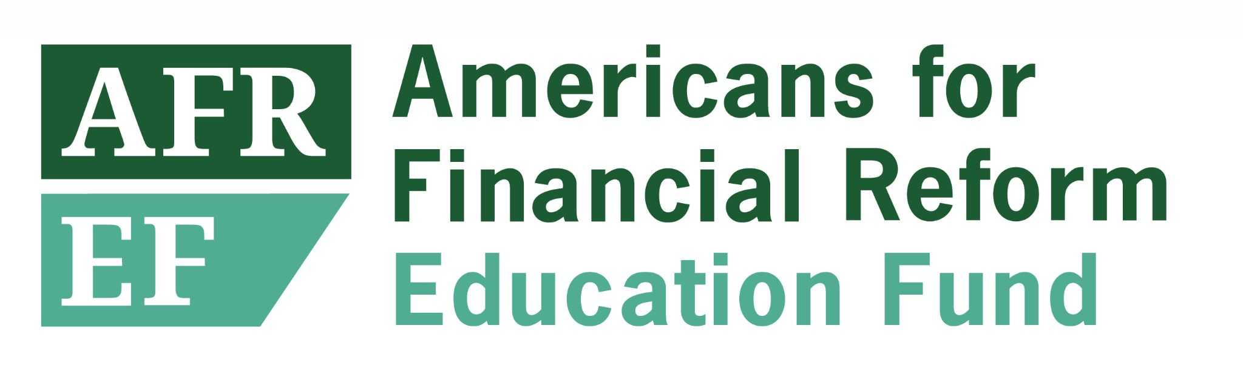
July 1, 2021

Dr. Michelle Asha Cooper
Acting Assistant Secretary for Postsecondary Education
and Deputy Assistant Secretary for Higher Education Programs
United States Department of Education
400 Maryland Avenue, SW
Room 2C179
Washington, DC 20202

Re: Negotiated Rulemaking for Higher Education 2021-22
Docket ID: ED-2021-OPE-0077

Dear Dr. Cooper,

Americans for Financial Reform Education Fund submits these comments in response to the Department of Education’s notice of intention to establish negotiated rulemaking committees to prepare proposed regulations for programs authorized under Title IV of the Higher Education Act of 1965, as amended (HEA). We thank you for the opportunity to provide input. We hope that you will consider the following priorities while examining topics for rulemaking.

- The Negotiated Rulemaking Process Must Work in Conjunction with Administrative Student Debt Cancellation.

We appreciate the steps the Department of Education (“Department”) has taken thus far to discharge debts where borrowers are entitled to discharge under the law. Total and permanent disability discharges, and borrower defense for some Corinthian and ITT students, are good and necessary first steps. But the Department has the ability to do much more to remake the federal student loan servicing system for the better, and to bring relief to millions in ways that will both close the racial wealth gap and turbo-charge our economic recovery: by administratively cancelling federal student loan debt.

Any Department of Education negotiated rulemaking should work together with — and not as a replacement for —broad-based administrative debt cancellation. The Department has a once in a generation opportunity with the federal student loan collection machine turned off to address problems that have been plaguing us for decades. There are over 4.4 million borrowers who’ve been in repayment for more than twenty years. In the 25 years that Income-Driven Repayment Plans have existed, only 32 borrowers had their loans cancelled. And in their most recent Supervisory Highlights, the CFPB found that servicers were providing inaccurate information to FFEL borrowers that prevented them from accessing the Public Service Loan Forgiveness (PSLF) program. These shocking numbers are indicative of the failures of the current system, and they must be addressed.

The most direct way to make progress & bring immediate relief to millions left out of the K-shaped recovery, where the gains have largely gone to the wealthy, is to clear out federal student loan debt through broad-based cancellation. A recent Roosevelt Institute paper pointed out that when you look carefully at what federal student debt cancellation does--when you look at assets and race, include wealthy people without debt in the denominator, and exclude private student loans--it is clear student debt cancellation will benefit those in the lower ends of the asset brackets dramatically more than people on the upper end of the wealth spectrum. We urge the Department to consider the wide-reaching benefits that cancellation would bring.

- The Disparate Impact of Student Debt on Black and Brown Borrowers Must be at the Forefront of Policy Making

Centuries of systemic discrimination have created the toxic combination of the racial wealth gap and the gender wage gap. Black and Brown borrowers, especially women, often find that they must go further in their education to gain access to higher wages and opportunities to build wealth. For many, this means taking on more debt - more than 70% of Black students go into debt to pay for their higher education, compared to 56% of white students. And Black students on average borrow more than $5,000 more than their white counterparts. Yet because of the persistent racial wealth gap, white high school dropouts still have a higher median net worth than Black and Hispanic college graduates.

Failure to address the harms caused by the systemic racism that has been entrenched in our nation’s political economy for centuries allows it to continue. Broad-based debt cancellation will significantly help to narrow the racial wealth gap, but for the borrowers of color who will continue to hold student loans, the Department must ensure an affordable pathway out of debt through a robust income-driven repayment plan and functioning cancellation programs. The Department should always center the disparate impact of student borrowing on Black and Brown students and other students of color and consider the effects of any policy changes on these groups.

- Negotiators Must Reflect All Stakeholders, Especially those Most Impacted by Student Loans

It is important that the Department have an inclusive negotiated rulemaking table. The Trump administration doubled the for-profit representation around the table. The Department should reverse this change, and also ensure that policy is set not just by technical experts, but with the input of those with the real lived experience of what it is like to live with student debt, including as we recover from the pandemic. Many recent graduates are facing ongoing challenges at finding employment in their fields and are at risk of suffering permanent “scarring” effects to their earnings, simply due to the bad luck of graduating during a pandemic. To better incorporate these perspectives, the Department should double the student and borrower negotiator representation, and specifically include a borrower as a negotiator.

It is also essential that the Department create space at the table for ample representation of a wide range of borrower experiences, including different schools, degrees, and racial and economic backgrounds. The Department must include representatives of all types of impacted student loan borrowers in its rulemaking negotiations. It is especially important that the Department make seats for disability advocates, who have for too long been excluded from the conversation, particularly on any negotiating committee discussing the disability discharge regulations.

- Negotiated Rulemaking Must Include Options for Defaulted Borrowers

Finally, the Department must include improving options and providing relief for defaulted borrowers in its negotiated rulemaking topics. These are the borrowers most likely to still be struggling with the effects of the pandemic -- facing eviction, and at risk of garnishments and offsets. Under the Higher Education Act, the Department has the power to terminate debt collection practices that harm borrowers, expand pathways back into repayment, and can also provide options that will help these borrowers, such as income-driven repayment.

There are multiple problems in the current student-lending system, from the broken PSLF program, to issues with closed schools, borrower defense, and false certification discharges. We applaud the Department for beginning a rulemaking process to tackle some of them. We urge the Department to prioritize the issues discussed above in its upcoming negotiated rulemaking, and to take the opportunity to advocate for the well-being of all borrowers by centering the needs of those who have been historically marginalized and excluded.

We thank you for your consideration of these comments. If you have any questions please contact Emily Hirtle, Policy Associate, Americans for Financial Reform Education Fund, at emily@ourfinancialsecurity.org.

Sincerely,
Americans for Financial Reform Education Fund

Naomi Zewde and Derrick Hamilton. “What Cancelling Student Debt Would Do for the Racial Wealth Gap.” NY Times. Feb 1, 2021. https://www.nytimes.com/2021/02/01/opinion/student-debt-cancellation-biden.html
“Education Department Responses to Data Request by Senator Warren,” April 2, 2021.” https://www.warren.senate.gov/imo/media/doc/Education%20Department%20Response%20to%20Sen%20Warren%20-%204-8-21.pdf
“Education Department's Decades-Old Debt Trap: How the Mismanagement of Income-Driven Repayment Locked Millions in Debt.”National Consumer Law Center and Student Borrower Protection Center. March 2021. https://protectborrowers.org/wp-content/uploads/2021/03/IDR-Brief-NCLC-SBPC.pdf
“Supervisory Highlights, Issue 24, Summer 2021.” Consumer Financial Protection Bureau. June 2021. https://files.consumerfinance.gov/f/documents/cfpb_supervisory-highlights_issue-24_2021-06.pdf#page=35
Charlie Eaton, Adam Goldstein, Laura Hamilton, and Frederick Wherry. “Student Debt Cancellation IS Progressive: Correcting Empirical and Conceptual Errors.” Roosevelt Institute. June 8, 2021. https://rooseveltinstitute.org/publications/student-debt-cancellation-is-progressive/
Kriston McIntosh, Emily Moss, Ryan Nunn, and Jay Shambaugh. “Examining the Black-white wealth gap.” Brookings. Feb 27, 2020. https://www.brookings.edu/blog/up-front/2020/02/27/examining-the-black-white-wealth-gap/
Robin Bleiweis. “Quick Facts About the Gender Wage Gap.” Center for American Progress. March 24, 2020. https://www.americanprogress.org/issues/women/reports/2020/03/24/482141/quick-facts-gender-wage-gap/
“Fast Facts: Women & Student Debt.” American Association of University Women. https://www.aauw.org/resources/article/fast-facts-student-debt/
Michael A. Fletcher. “White high school dropouts are wealthier than black and Hispanic college graduates. Can a new policy tool fix that?.” Washington Post. March 10, 2015. https://www.washingtonpost.com/news/wonk/wp/2015/03/10/white-high-school-dropouts-are-wealthier-than-black-and-hispanic-college-graduates-can-a-new-policy-tool-fix-that/

