Overdraft is essentially an automated loan program. Just like people stuck in a payday cycle, the bulk of overdraft fee income comes from repeat borrowers who incur multiple overdrafts. In fact, overdraft fees are the second-largest source of revenue for Wells Fargo’s consumer deposits group and cost American’s over $16 Billion a year across institutions.

Overdraft fees are disproportionately paid by a relatively small portion of account holders:

- CFPB found that nearly three-fourths of overdraft and NSF fees are paid by only 8% of account holders, who incur 10 or more fees per year.¹
- According to the Center for Responsible Lending, nearly 2 million Americans pay 20 or more overdraft fees annually, translating to $700 or more. ¹
- Internal Wells Fargo documents, made public as a result of a 2012 lawsuit, recognized that just four percent of Well Fargo customers receiving overdraft fees supplied a whopping 40 percent of its total overdraft revenue.²

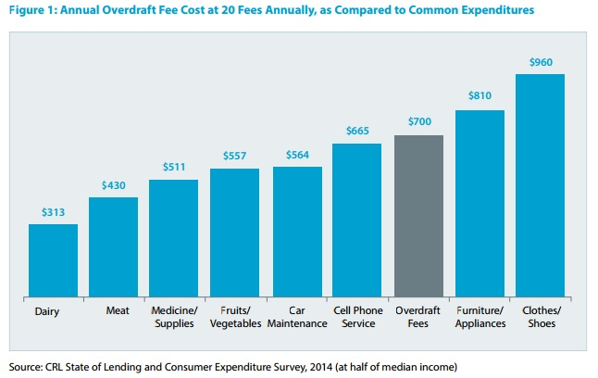
One overdraft fee can create a cascade of consequences:

- Nearly 2 million Americans pay $700 or more in overdraft fees annually. For a low income family, loosing these funds may put other needed expenses out of reach. ¹
- Costly overdraft fee practices push some families out of the banking system altogether. FDIC data indicate that approximately 778,800 households and over 1 million adults who once had bank accounts are currently unbanked (primarily due to high or unpredictable fees). ¹

Banks make millions from high cost overdraft loans: that’s one real reason they don’t offer lower cost short term loans.
- The typical overdraft fee is $34, yet a CFPB study found that the majority of overdrafts occur on transactions of $24 or less. Treated as the loan that it is, that $24 from the bank has a whopping 17,000% annual percentage rate (APR).³
- (removed for space saving purposes only). Predatory practices like check re-ordering, which Wells Fargo has long defended, are specifically designed to increase customer overdrafts, and thereby increase the fees extracted from their customers for the service of providing a short term loan.²
- Debit card purchases are the most common trigger of overdraft fees. ATM withdrawals can also trigger overdraft fees. Both of these transactions could easily be declined for no fee with the customer lacks sufficient funds. Some banks choose not to charge overdraft fees on one or the other; Bank of America and Citi do not charge them on debit card purchases; Citi and Chase do not charge them on ATM withdrawals. Wells Fargo charges them on both.

¹ Center for Responsible Lending, Broken Banking “How Overdraft Fees Harm Consumers and Discourage Responsible Bank Products (May 2016),
http://www.responsiblelending.org/sites/default/files/nodes/files/research-publication/crl_broken_banking_may2016.pdf
² Gutierrez v. Wells Fargo Bank, N.A., 730 F.Supp.2d 1080 (9th Cir. 2012)
³ CNN: Money: ATM Overdraft Fees Top $6 billion at the Big 3 Banks, (January 2016),
http://money.cnn.com/2016/01/14/investing/atm-overdraft-fees/

