J O H N R O B E R T S I M P SO N
S ON OF MR . A ND MRS . D A N I E L T . SI MP S ON

R E QUE S T T HE H ONO UR O F Y O UR P R E SE NCE A T T HE I R M A R R I A GE



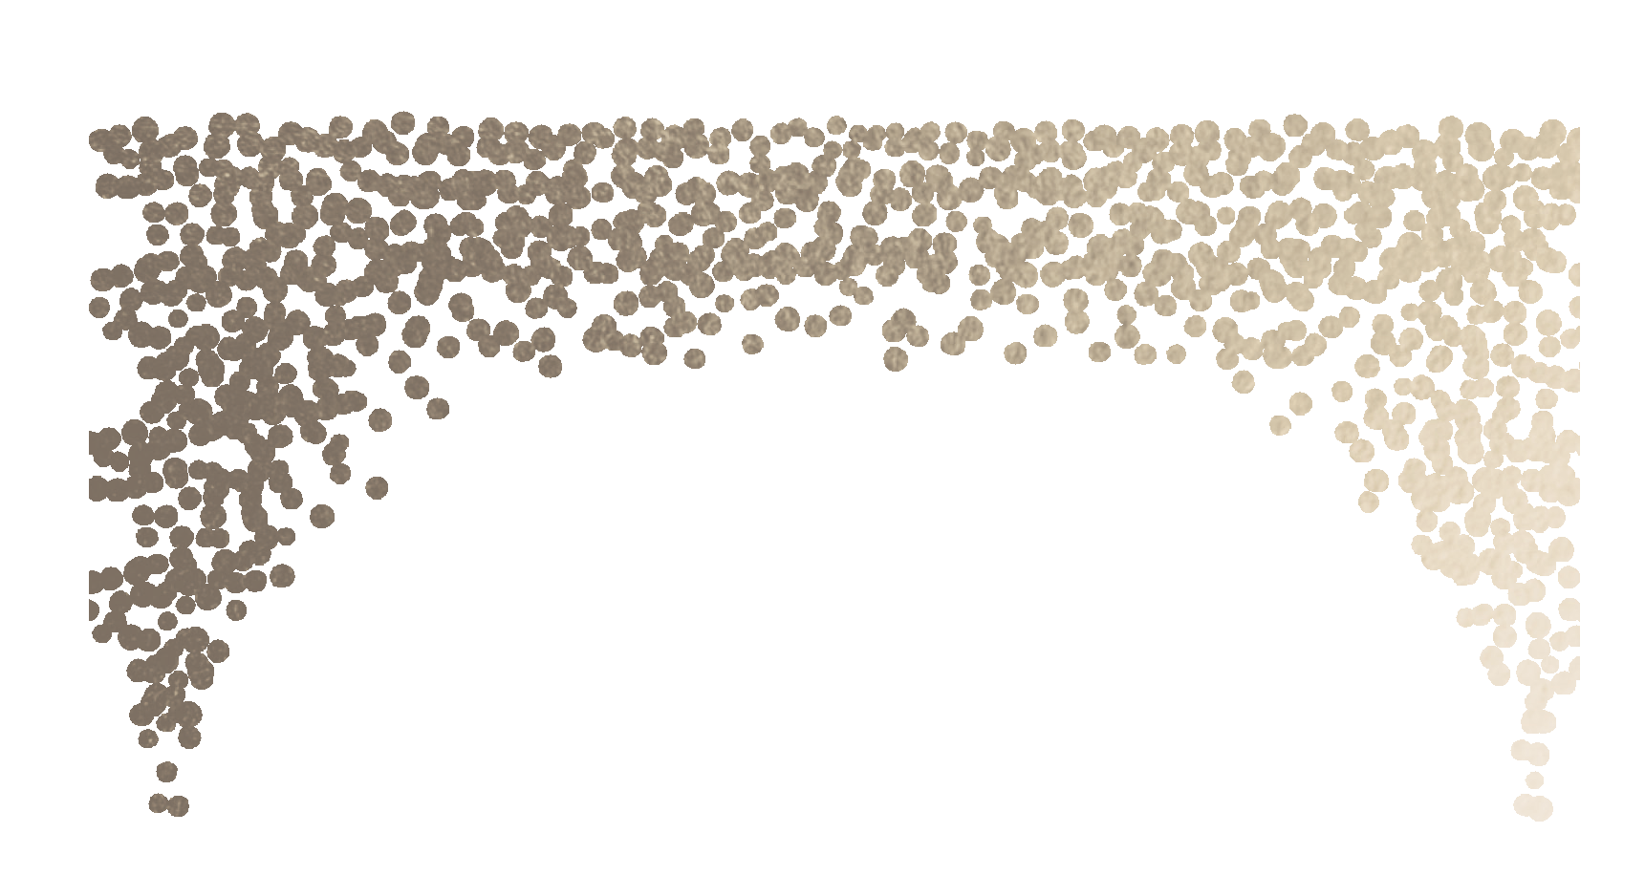





S A T U R DA Y

T OGE T HE R W I T H T HE IR F A MI L I E S

E R IN M A R IE K IL RO Y
D A UGH T E R OF MR . W I L L I A M K I L R O Y A ND T HE L A T E MRS . C A R O L K I L R O Y

and
T WO T HO US A N D F OU R T E E N
A T T W O O ‘ CL OCK I N T HE A F T E R NOON

St. Peter's on Capitol Hill

3 1 2 2 ND S T R E E T S O U T HE A S T W A SHI NG T ON , D C 2 000 3
4 O C T OB E R

