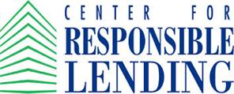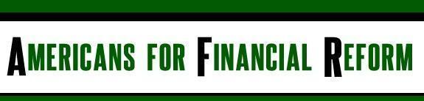

October 23, 2014

Dear Senator,

The undersigned organizations write to urge you to oppose H.R. 3211, the “Mortgage Choice Act of 2014”—as included in the package of measures contained in H.R. 5461—or any Senate companion bill. H.R. 3211’s provisions would undermine the new mortgage rules, making mortgages more expensive and reducing the protections put in place earlier this year to protect consumers against the very types of loans that sparked the economic crisis.

Certain provisions in the bill would both increase fees for homebuyers and provide additional legal protections for lenders who make riskier loans. The passage of this bill would result in a losing proposition for consumers seeking to purchase a home or refinance their current mortgage.

Under H.R. 3211, affiliated title insurance companies would receive an exemption from the rules that place a cap on fees that can be charged on Qualified Mortgages. Mortgages made under the new rules are safer and more affordable for borrowers.

The title insurance market is a broken market. Studies have shown that 70% of the premiums are for commissions to brokers; only between 5% and 11% are paid out in claims. By way of comparison, health insurance companies pay 80% of the premiums in claims. For auto insurance companies, the loss ratios are typically between 50% and 60%.

The inflated prices unnecessarily harm consumers, who, according to a GAO study, “have little or no influence over the price of title insurance but have little choice but to purchase it.” One newer company charges 30% less for title insurance suggesting a fair and open market would benefit consumers with more reasonable pricing. Their experience, however, is telling. Consumers have had a difficult time obtaining this kind of competitive pricing because the market is dominated by business-to-business referral relationships that leave consumers in the dark about their full range of options. Two recent actions by the Consumer Financial Protection Bureau also illustrate some of the problems in the market. In October 2013, the CFPB filed a federal lawsuit against a business for illegally paying kickbacks for mortgage settlement referrals. Subsequently, in September 2014, the Bureau signed a consent order imposing a $200,000 civil penalty against a title insurance agency for illegal quid pro quo referral agreements.

The current rules will not solve all the problems in the title insurance market, but they put in place some basic consumer protections to guard against unfettered and unjustifiable rate increases.

The housing market across the country is beginning to recover, even if unevenly. Undermining basic consumer safeguards by allowing for an unnecessary spike in fees will deter borrowers and slow the recovery.

Sincerely,

Action for the Common Good
AFL-CIO
Alliance for a Just Society
Americans for Financial Reform
Center for Economic Justice
Center for Popular Democracy
Center for Responsible Lending
Connecticut Fair Housing Center
Consumer Action
Consumer Federation of America
Consumers Union
Empire Justice Center
Home Defenders League
The Leadership Conference on Civil and Human Rights
NAACP
National Association of Consumer Advocates
National Consumer Law Center (on behalf of its low income clients)
National Council of La Raza
National Fair Housing Alliance
New Economic Project
New Jersey Citizen Action
Public Citizen
Woodstock Institute

