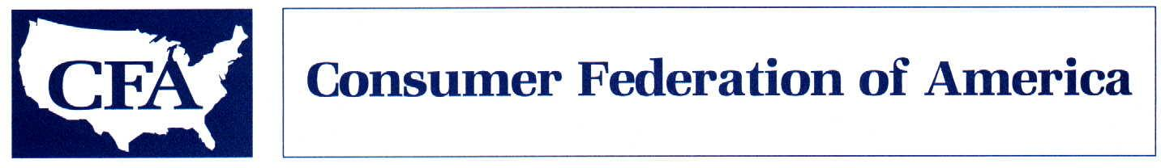

May 3, 2013

The Honorable Jeb Hensarling The Honorable Maxine Waters
Chairman Ranking Member
Financial Services Committee Financial Services Committee
U.S. House of Representatives U.S. House of Representatives
Washington, D.C. 20515 Washington, D.C. 20515

Dear Chairman Hensarling, Ranking Member Waters and Members of the Committee:
We understand that the Committee is scheduled to hold a mark-up next week of a series of bills that would roll back reforms adopted as part of the 2010 Wall Street reform bill to rein in risky and abusive practices in the over-the-counter derivatives markets. I am writing on behalf of the Consumer Federation of America (CFA) to ask you to oppose the following bills, each of which would erode needed market protections and put the safety and stability of our financial system at risk.
Oppose H.R. 1256, the Swaps Jurisdiction Certainty Act. Without a strong policy on cross-border application of U.S. derivatives rules, efforts to increase transparency, reduce risks, and restore integrity to the swaps market will be for naught. This legislation undermines efforts to achieve such a policy by requiring the SEC and CFTC to jointly issue rules in this area. Based on recent experience, that would likely delay implementation for several years, all the while leaving U.S. businesses and taxpayers exposed to unacceptable risks. But the inevitable delay it would cause is not the only problem. The bill creates a presumption that overseas transactions in G20 member states would be governed by home country regulations, allowing exemptions only where CFTC and SEC agree that those regulations are not “broadly equivalent” to U.S. regulations. A standard based on broad equivalence provides no objective means to hold regulators accountable for the decisions they make and all but guarantees that we will delegate regulatory authority to countries that lack crucial components of a strong regulatory regime. Global institutions would be able to channel transactions through these less regulated jurisdictions in order to evade appropriate regulation.
Oppose H.R. 677, the Inter-affiliate Swap Clarification Act. This legislation would recklessly expand a broad exemption for inter-affiliate transactions from clearing and margin requirements already adopted by the CFTC. Using a very loose definition of “affiliate” and exempting transactions between such affiliates from all but reporting requirements, it would remove meaningful regulatory oversight from a huge swath of market activity without any evidence that such a regulatory roll-back is either needed or justified.
Oppose H.R. 992, the Swaps Regulatory Improvement Act. Recognizing the risks to taxpayers posed by derivatives dealing in federally insured financial institutions, the Wall Street reform bill effectively required such institutions to conduct their derivatives transactions in separately capitalized businesses not guaranteed by the bank. This legislation would reverse that progress by significantly expanding the range of swaps dealing activities that could be conducted within the insured institution, forcing federal taxpayers to once again subsidize the cost of derivatives dealing by banks and exposing them to renewed risks.
Oppose H.R. 634, the Business Risk Mitigation and Price Stabilization Act. Under this legislation, any swap that qualifies for the commercial end user exemption from clearing would be exempt from capital and margin requirements. The CFTC and SEC would lose their statutory authority to require end user margin at the non-banks they regulate. Regulators have already proposed to exempt the vast majority of end user swaps from margin requirements. With no evidence that regulators are using their authority inappropriately, this legislation would eliminate their ability to refine their regulatory approach if subsequent events demonstrate that it is exposing the system to excessive risk.
Oppose H.R. 1341, the Financial Competitive Act. Before the financial crisis, concerns about global competitiveness were routinely used to defeat regulatory proposals designed to increase the safety and soundness of the financial system. This legislation represents a return to that misguided thinking, requiring a one-sided study of the “competitiveness” impact of the derivatives credit valuation capital adjustment and ignoring the potential benefits to the public of better capitalized derivatives. If Congress wishes to require a study of this issue, it should ensure that any such study is appropriately balanced and includes, among other things, a thorough evaluation of the role that under-capitalized derivatives played as a cause of the 2008 financial crisis.
Oppose H.R. 1062, the SEC Regulatory Accountability Act. Courts already set a very high bar when assessing the adequacy of economic analysis by federal agencies. This has already slowed the SEC’s progress in implementing the congressional mandates, such as those in the Wall Street reform legislation and the JOBS Act. This legislation would impose extensive new cost-benefit analysis requirements on the SEC under vague standards that would leave it open to legal challenge without any evidence that the more bureaucratic approach required by this legislation would result in better regulations. If Congress wants to improve the quality of economic analysis at the agency, it should provide additional funding for this purpose, not impose costly new requirements that serve only to further slow the regulatory process.
* * *
Before the crisis, many policymakers complacently assumed that derivatives acted exclusively to reduce risk in the financial system. The crisis should have taught us that, in an inadequately regulated market, derivatives can have precisely the opposite effect – spreading risk into every corner of the global economy and creating a hidden web of counterparty exposures with the potential to set in motion a series of cascading failures by major financial institutions. Each of these bills contributes in its own way to a return to the reckless disregard of systemic threats that just a few short years ago brought the global economy to the brink of collapse. We urge you to defend the safety, integrity, and transparency of our financial markets by opposing these ill-conceived bills.
Respectfully submitted,
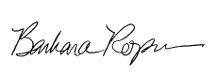
Barbara Roper
Director of Investor Protection

