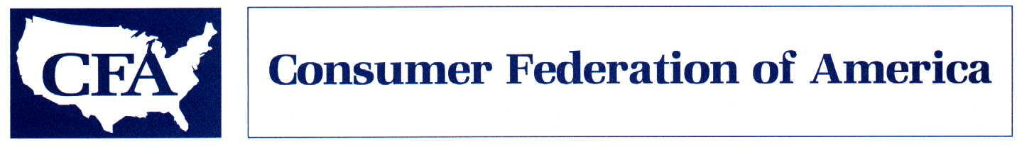

November 3, 2009

Don’t Be Fooled: Revised Adler SOX 404 Amendment
Is Bad for Investors and Bad for the Economy

Dear House Financial Services Committee Member:

We understand that Congressman Adler plans to offer a revised amendment to weaken protections against accounting fraud at smaller public companies during today’s continued mark-up of the Investor Protection Act. This amendment is reportedly being portrayed as a less extreme, more investor-friendly version of his original amendment. Nothing could be further from the truth.

- Where his original amendment required the Securities and Exchange Commission to weaken Sarbanes-Oxley Act protections against accounting fraud, the new amendment would eliminate those protections entirely at the roughly half of all public companies with market capitalizations of less than $75 million.

- And it doesn’t stop there. It sets up another round of attacks on the standards with yet another wasteful and unnecessary study.

Don’t be fooled. The revised Adler amendment is bad for investors and bad for the economy. We urge you to vote no.

1) Weakening fraud protections does not promote job growth.

The supporters of the proposed amendments argue that reducing regulatory costs will promote job growth. This thinking – that we need to reduce regulatory “burdens” in order to promote economic growth – is precisely the sort of thinking that landed us in the current economic crisis. It is misguided at best, cynical at worst, and has not place in the current regulatory reform debate.

In fact, experience has shown that companies that aren’t sustainable don’t provide sustainable job growth. That was the lesson of the tech stock bubble, which wiped out trillions in market value and more than a million jobs when the bubble burst. A few years later, roughly half the tech companies that had gone public during the boom were gone. By encouraging companies to go public that cannot meet the basic requirements for raising money from the public, the Adler amendment invites a repeat of that experience.
2) Costs of compliance have been greatly exaggerated.

In advocating for his amendment, Congressman Adler has cited SOX 404 compliance costs of “as much as $900 million.” This is simply not supported by the admittedly limited cost information that is available for companies with market caps under $75 million. The Securities and Exchange Committee study released in September found median costs of a 404b audit of $157,000 for these companies. A 2008 study by the Lord & Benoit consulting firm looked at actual SOX 404a and b compliance costs at 29 small companies and found average costs of just $78,474. Further, it found that these costs averaged just 0.3 percent of market cap and 0.8 percent of revenues. While neither study is based on a representative sample, both are more credible than the highly inflated cost figure cited by Congressman Adler.

3) SOX has not caused companies to flee U.S. markets.

Congressman Adler has repeatedly blamed SOX 404 for sending listings overseas. In fact, however, a look at the IPO statistics he cites tells a very different story. The declining U.S. share of the world IPO market, which began in the mid-1990s, is the inevitable result of the growing size and sophistication of overseas markets and has nothing to do with SOX. On the contrary, the number of companies listing here, which had plummeted following the bursting of the tech stock bubble, enjoyed a resurgence after passage of the Sarbanes-Oxley Act, a resurgence that lasted until the latest financial crisis once again devastated the market. Even then, the U.S. topped the world list in 2008 of IPO capital raised. One reason our exchanges continue to do well: the market rewards companies that demonstrate they can comply with our tougher regulatory requirements with lower capital costs and higher valuations. Weakening our investor protections makes us less competitive, not more.

4) The amendment would harm the very companies it purports to help.

Extensive research has shown that small companies have weaker controls over financial reporting, poorer quality financial reporting, and a higher incidence of both accounting fraud and errors. Far from benefitting small companies, the Adler amendment would allow them to avoid taking steps that would ultimately prove beneficial to both them and their investors, by reducing the incidence of fraud and costly restatements. The fraud risk at small companies is of particular concern, since fraud, when it does occur at small companies, almost always includes the involvement of the CEO or CFO. That makes an independent assessment of fraud controls at these companies more important, not less.

* * *

If the current financial crisis hasn’t taught us that us that weakening regulation weakens the economy, it is hard to imagine what it would take to pound that lesson home. The revised Adler amendment represents more of the same anti-regulatory policy that landed us in our current mess. It is bad for investors and bad for the economy. We urge you to vote no.

Respectfully submitted,
Barbara Roper, Director of Investor Protection

