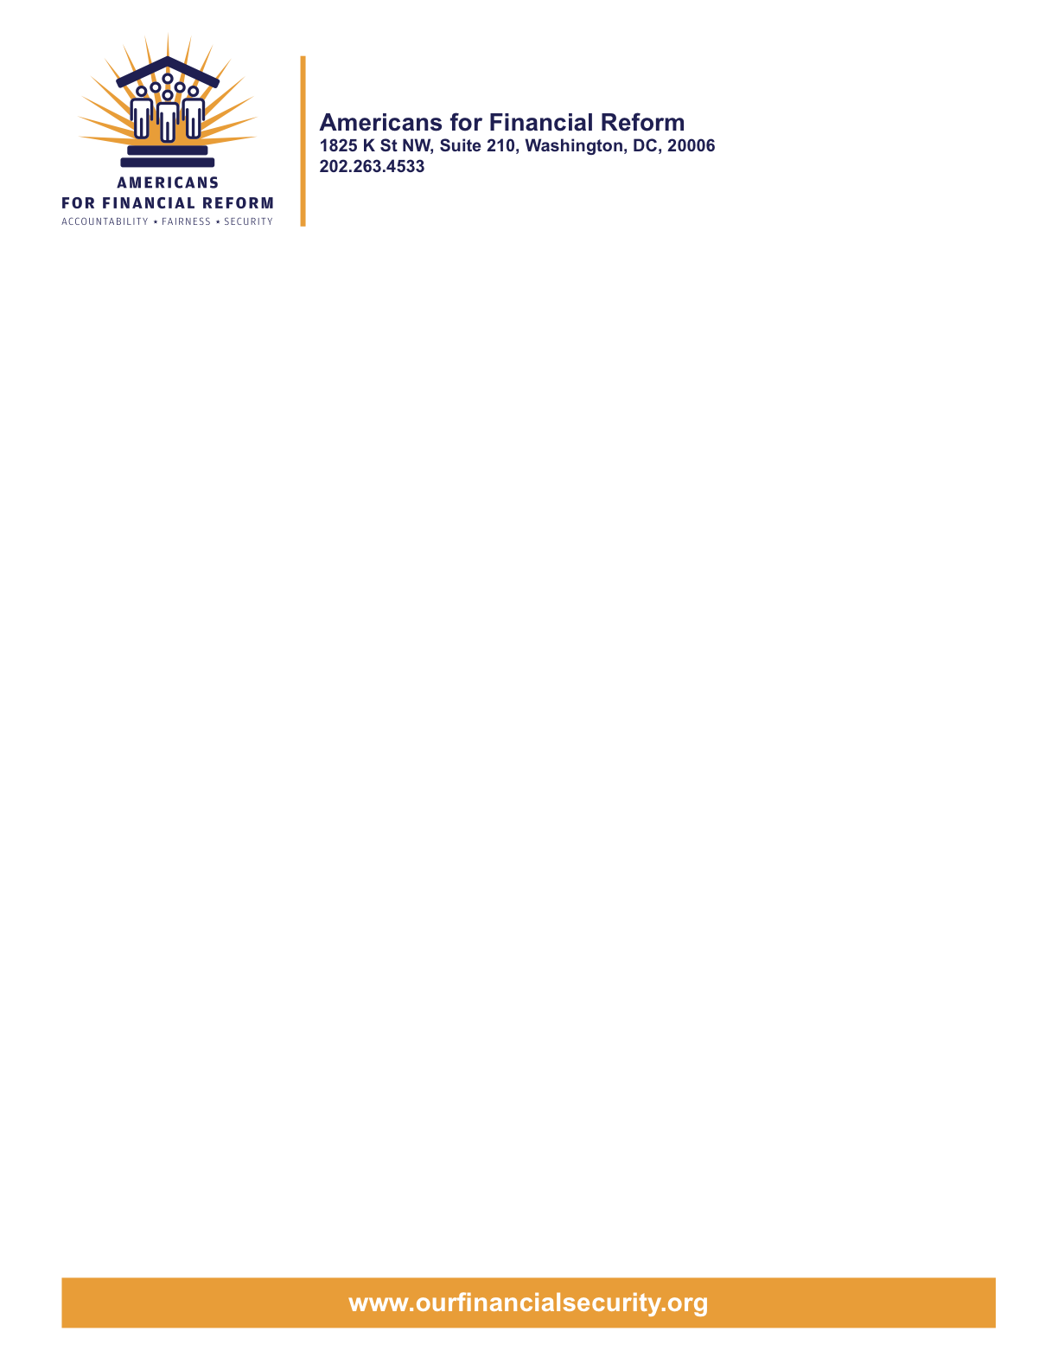

May 13, 2010

Senator
United States Senate
Washington, DC 20510

Re: Reject the Vitter Loophole for Bailed-Out Shadow Banks (S.A. 4003)

Dear Senator,

The 250 consumer, employee, investor, community, small business and civil rights groups who are members of Americans for Financial Reform (AFR) urge you to reject Senator Vitter’s dangerous proposed shadow bank loophole, S.A. 4003. It is an attempt to prevent the oversight of non-bank financial companies that could pose a threat to our economy, including key bailed-out “shadow banks”. Shadow banks – unregulated entities often attached to non-financial companies – received hundreds of billions of dollars in bailouts and were recently the subject of a two-day Financial Crisis Inquiry Commission hearing. A vote for this amendment risks American jobs and keeps us stuck in the bailout era.

Bailed-Out Shadow Banks: Not “Predominate” but “Substantial” and Highly Systemic:
Senator Vitter’s amendment would create a loophole big enough for the bailed-out shadow bank GE Capital, the financial arm of General Electric. While financial services are not the “predominant” business line of the multi-billion dollar corporation, GE Capital is a “substantial” player in the financial market: it was the single largest issuer of commercial paper in the United States before the crisis, with $620 billion in assets at the end of 2007. GE Capital received more than $50 billion in bailouts, and was the second-largest beneficiary of the FDIC debt guarantee program even though it held only a relatively small amount of deposits. By focusing on the way the company is organized and not the magnitude of the threat to our economy, the Vitter loophole’s 85/15 threshold would let financial giants evade even basic oversight.

The danger of creating an explicit loophole is not just which bailed-out shadow banks it would affect today, but what risks it could create going forward. Under the Vitter loophole, AIG could buy a company earning 15% of its total revenues and escape oversight from the new Systemic Risk Council. The American people lost 8 million jobs and $17 trillion in savings because of regulatory gaps like this one.

Fears of the Fed (which was not interested in regulating supbrime mortgages for 14 years though it had the authority) overreaching to regulate light bulbs and car parts are overblown:

- True Manufacturers Should Not Fear Fed Oversight: Under the current bill, only the rare manufacturers that are attached to massive, systemically risky financial giants competing with the likes of Goldman Sachs in the capital markets would be even eligible for Fed oversight. Even then, two-thirds of the nation's banking regulators must vote to exercise jurisdiction and any arbitrary or capricious decision would be voidable.

- Firewalls to Shield the Parent Company from Regulatory Action: In that rare situation where the company’s affiliated financial activities do make it a potential threat to our economy, both the House and Senate bills direct the Fed to create “intermediate financial holding companies” to firewall the financial entity from the parent company—allowing regulators to create safeguards for the high-risk financial player without interfering with the company’s main line(s) of business.

The Vitter loophole for bailed-out shadow banks is an unnecessary and dangerous amendment that would keep American jobs and Main Street businesses vulnerable to another Wall Street-led financial meltdown. If you have any questions, please contact Heather McGhee, Washington Office Director of Demos, at hmcghee@demos.org or (202) 559-1543.
Sincerely,

American for Financial Reform

Following are the partners of Americans for Financial Reform.

All the organizations support the overall principles of AFR and are working for an accountable, fair and secure financial system. Not all of these organizations work on all of the issues covered by the coalition or have signed on to every statement.

National Organizations
- A New Way Forward
- AARP
- Accountable America
- Adler and Colvin
- AFL-CIO
- AFSCME
- Alliance For Justice
- American Family Voices
- American Income Life Insurance
- Americans for Democratic Action, Inc.
- Americans for Fairness in Lending
- American Sustainable Business Council
- Americans United for Change
- Business for Shared Prosperity
- Calvert Asset Management Company, Inc.
- Campaign for America’s Future
- Campaign Money
- Center for Digital Democracy
- Center for Economic and Policy Research
- Center for Economic Progress
- Center for Responsible Lending
- Center for Justice and Democracy
- Center of Concern
- Change to Win
- Clean Yield Asset Management
- Coastal Enterprises Inc.
- Color of Change
- Common Cause
- Communications Workers of America
- Community Development Transportation Lending Services
- Community Law Center
- Consumer Action
- Consumer Association Council
- Consumers for Auto Safety and Reliability
- Consumer Federation of America
- Consumer Watchdog
- Consumers Union
- Corporation for Enterprise Development
- CREDO
- CTW Investment Group
- Demos
- Economic Policy Institute
- Essential Action
- Green America
- Greenlining Institute
- Good Business International
- Help Is On the Way, Inc
- HNMA Funding
- Home Actions
- Housing Counseling Services
- Information Press
- Institute for Global Communications
- Institute for Policy Studies: Global Economy Project
- International Brotherhood of Teamsters
- Institute of Women’s Policy Research
- Keystone Research Center
- Krull & Company
- Laborers’ International Union of North America
- Lake Research Partners
- Lawyers’ Committee for Civil Rights Under Law
- Leadership Conference on Civil Rights
- MoveOn.org Political Action
- NAACP
- NASCAT
- National Association of Consumer Advocates
- National Association of Investment Professionals
- National Association of Neighborhoods
- National Coalition for Asian Pacific American Community Development
- National Community Reinvestment Coalition
- National Consumer Law Center (on behalf of its low-income clients)
- National Consumers League
- National Council of La Raza
- National Fair Housing Alliance
- National Federation of Community Development Credit Unions
- National Housing Institute
- National Housing Trust
- National Housing Trust Community Development Fund
- National NeighborWorks Association
- National Peoples Action
- National Council of Womens Organizations
- National Worksright Institute
- Next Step
- OMB Watch
- Opportunity Finance Network
- Partners for the Common Good
- National People’s Action (NPA)
- PICO
- Progress Now Action
- Progressive States Network
- Poverty and Race Research Action Council
- Public Citizen
- Responsible Endowments Coalition
- Sargent Shriver Center on Poverty Law
- Scam Victims United
- SEIU
- Sojourners
- State Voices
- Taxpayer’s for Common Sense
- The Association for Housing and Neighborhood Development
- The Carrots and Sticks Project
- The Fuel Savers Club
- The Seminal
- UNET
- Union Plus
- United for a Fair Economy
- U.S. PIRG
- Unitarian Universalist for a Just Economic Community
- United Food and Commercial Workers
- United States Student Association
- USAction
- Veris Wealth Partners
- Veterans Chanmber of Commerce
- We The People Now
- Western States Center
- Woodstock Institute
- Working America
- World Business Academy
- World Privacy Forum

State Organizations
- 207 CCAG
- 9 to 5, the National Association of Working Women (CO)
- AARP Rhode Island
- Alaska PIRG
- Arizona PIRG
- Arizona Advocacy Network
- Arizonans for Responsible Lending
- Arkansas Community Organizations
- Arkansas Public Policy Panel
- Association for Neighborhood and Housing Development (NY)
- Audubon Partnership for Economic Development LDC (New York, NY)
- Aurora NAACP
- BAC Funding Consortium Inc. (Miami, FL)
- Beech Capital Venture Corporation (Philadelphia, PA)
- Bell Policy Center (CO)
- California PIRG
- California Reinvestment Coalition
- Center for Media and Democracy
- Center for NYC Neighborhoods
- Century Housing Corporation (Culver City, CA)
- Changer(NY)
- Chautauqua Home Rehabilitation and Improvement Corporation (NY)
- Chicago Community Loan Fund (Chicago, IL)
- Chicago Community Ventures (Chicago, IL)
- Chicago Consumer Coalition
- Citizen Potawatomi CDC (Shawnee, OK)
- Club Change of Martin County (Florida)
- Coalition on Homeless Housing in Ohio
- Coffee Party of Pensacola, Florida
- Coffee Party of Union Square, New York City
- Colorado AFL-CIO
- Colorado Center on Law and Policy
- Colorado Immigrants Rights Coalition
- Colorado PIRG
- Colorado Spring NAACP
- Community Action of Nebraska
- Community Capital Development
- Community Capital Fund (Bridgeport, CT)
- Community Capital of Maryland (Baltimore, MD)
- Community Development Financial Institution of the Tohono O’odham Nation (Sells, AZ)
- Community Redevelopment Loan and Investment Fund, (Atlanta, GA)
- Community Reinvestment Association of North Carolina
- Community Resource Group (Fayetteville, AR)
- Connecticut Association for Human Services
- Connecticut Citizen Action Group
- Connecticut PIRG
- Consumer Assistance Council
- Cooper Square Committee (New York, NY)
- Cooperative Fund of New England (Wilmington, NC)
- Corporacion de Desarrollo Economico de Ceiba (Ceiba, PR)
- CWA 7777 (CO)
- Delta Foundation, Inc. (Greenville, MS)
- Economic Opportunity Fund (EOF) (Philadelphia, PA)
- Empire Justice Center (NY)
- Enterprises, Inc., Berea KY
- Fair Housing Contact Service OH
- Federation of Appalachian Housing Enterprises, Inc. (Berea, KY)
- Fitness and Praise Youth Development, Inc. (Baton Rouge, LA)
- Florida Consumer Action Network
- Florida PIRG
- Forward Community Investments (Madison, WI)
- Funding Partners for Housing Solutions (Ft. Collins, CO)
- Georgia PIRG
- Grow Iowa Foundation (Greenfield, IA)
- Homewise, Inc. (Santa Fe, NM)
- Humanitas Community Development Corporation
- Idaho Chapter, National Association of Social Workers
- Idaho Community Action Network
- Idaho Nevada CDFI (Pocatello, ID)
- Illinois PIRG
- Impact Capital (Seattle, WA)
- Indiana PIRG
- Indiana University PIRG
- Information Press (CA)
- Iowa PIRG
- Iowa Citizens for Community Improvement
- JobStart Chautauqua, Inc. (Mayville, NY)
- Keystone Research Center
- La Casa Federal Credit Union (Newark, NJ)
- Low Income Investment Fund (San Francisco, CA)
- Long Island Housing Services NY
- MaineStream Finance (Bangor, ME)
- Maryland PIRG
- Massachusetts Consumers’ Coalition
- Massachusetts Fair Housing Center
- MASSPIRG
- Michigan PIRG
- Midland Community Development Corporation (Midland, TX)
- Midwest Minnesota Community Development Corporation (Detroit Lakes, MN)
- Mile High Community Loan Fund (Denver, CO)
- Missouri PIRG
- Montana Community Development Corporation (Missoula, MT)
- Montana PIRG
- Mortgage Recovery Service Center of L.A.
- Neighborhood Economic Development Advocacy Project
- New Hampshire PIRG
- New Jersey Community Capital (Trenton, NJ)
- New Jersey Citizen Action
- New Jersey PIRG
- New Mexico PIRG
- New York PIRG
- New York City AIDS Housing Network
- Next Step (MN)
- NOAH Community Development Fund, Inc. (Boston, MA)
- Nonprofit Finance Fund (New York, NY)
- Nonprofits Assistance Fund (Minneapolis, MN)
- North Carolina Association of Community Development Corporations
- North Carolina PIRG
- Northern Community Investment Corporation (St. Johnsbury, VT)
- Northside Community Development Fund (Pittsburgh, PA)
- Ohio Capital Corporation for Housing (Columbus, OH)
- Ohio PIRG
- Oregon State PIRG
- Our Oregon
- PennPIRG
- Piedmont Housing Alliance (Charlottesville, VA)
- Rhode Island PIRG
- Rights for All People
- The Rocky Mountain Peace and Justice Center
- Rural Community Assistance Corporation (West Sacramento, CA)
- Rural Organizing Project OR
- San Francisco Metropolitan Transportation Authority
- Seattle Economic Development Fund dba Community Capital Development
- SEIU Local 105 (Colorado)
- SEIU Rhode Island
- Siouxland Economic Development Corporation (Sioux City, IA)
- Southern Bancorp (Arkadelphia, AR)
- TexPIRG
- The Association for Housing and Neighborhood Development
- The Fair Housing Council of Central New York
- The Help Network
- The Loan Fund (Albuquerque, NM)
- Third Reconstruction Institute (NC)
- V-Family, Inc.
- Vermont PIRG
- Village Capital Corporation (Cleveland, OH)
- Virginia Citizens Consumer Council
- Virginia Poverty Law Center
- War on Poverty – Florida
- Washington Community Action Network
- WashPIRG
- Westchester Residential Oppurtunities Inc. NY
- Wigamig Owners Loan Fund, Inc. (Lac du Flambeau, WI)
- WISPIRG

Businesses

- Blu
- Bowden-Gill Environmental
- Community MedPAC
- Diversified Env. Planning
- Hayden & Craig, PLLC\
- The Holographic Repatterning Institute at Austin
- Mid City Animal Hospital (Phoenix, AZ)
- UNET

Similarly, the commercial firm GMAC received $12.5 billion in TARP funds, even though GMAC’s parent company General Motors revenues were not “predominately” from financial services.
See Sec. 113. Manufacturers’ internal financing operations are exempted in Sec. 167(b)(2).

