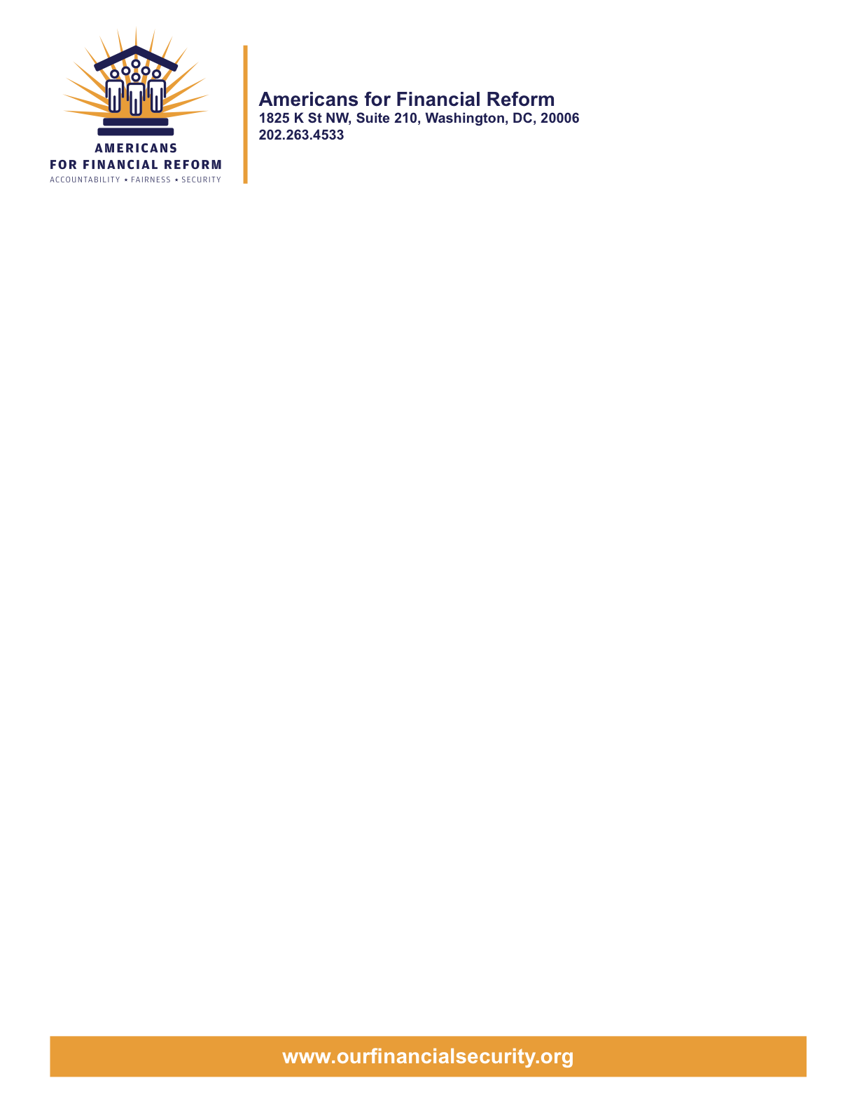

United States Senate
Washington, DC 20510
May 14, 2010

Re: Dorgan Amendment #4008 to Restoring Financial Stability Act of 2010 to Regulate Credit Default Swaps

Dear Senator:

The over 250 consumer, employee, investor, community and civil rights groups who are members of Americans for Financial Reform (AFR) write to express strong support for Amendment No. 4008 to S. 3217 offered by Senator Dorgan. The amendment will mandate that all credit default swaps must clear through, and trade on, an exchange without exception. This amendment will also end the destructive practice of betting against the survival of a company or government entity survival through “naked” shorting of credit default, thereby filling an important gap in an otherwise strong package of derivatives reform proposals.

America has experienced the worst economic recession since the Great Depression due in large part to the proliferation of unregulated and opaque over-the-counter (OTC) derivatives which Warren Buffet famously called “weapons of financial mass destruction.” During the crisis in 2008, speculators made dramatic short bets against companies’ survival by entering “naked” positions in credit default swaps. These abusive trading practices (which harm entities credit at the worst possible time) continue to be employed today, as speculators gang up to bet on the demise of Greece – a sovereign nation.

With Senate Bill 3217, the Senate is now taking the necessary steps to mandate that clear-able OTC derivatives must clear through a central counterparty and that trade-able OTC derivatives must be moved onto an exchange for trading. We strongly support your efforts as the most important thing America can do to prevent the next financial meltdown and stop damaging trading practices. We also strongly support the adoption of Amendment 4008 offered by Senator Dorgan to end abusive, destabilizing practices related to credit default swaps.

Please contact Lisa Lindsley, Director, Capital Strategies, AFSCME, for more information: 202.429.1275 or llindsley@afscme.org.

Sincerely,
Americans for Financial Reform
Following are the partners of Americans for Financial Reform.

All the organizations support the overall principles of AFR and are working for an accountable, fair and secure financial system. Not all of these organizations work on all of the issues covered by the coalition or have signed on to every statement.

National Organizations

- A New Way Forward
- AARP
- Accountable America
- ACORN
- Adler and Colvin
- AFL-CIO
- AFSCME
- Alliance For Justice
- American Family Voices
- American Income Life Insurance
- Americans for Democratic Action, Inc.
- Americans for Fairness in Lending
- American Sustainable Business Council
- Americans United for Change
- Business for Shared Prosperity
- Calvert Asset Management Company, Inc.
- Campaign for America’s Future
- Campaign Money
- Center for Digital Democracy
- Center for Economic and Policy Research
- Center for Economic Progress
- Center for Responsible Lending
- Center for Justice and Democracy
- Center of Concern
- Change to Win
- Clean Yield Asset Management
- Coastal Enterprises Inc.
- Color of Change
- Common Cause
- Communications Workers of America
- Community Development Transportation Lending Services
- Community Law Center
- Consumer Action
- Consumer Association Council
- Consumers for Auto Safety and Reliability
- Consumer Federation of America
- Consumer Watchdog
- Consumers Union
- Corporation for Enterprise Development
- CREDO
- CTW Investment Group
- Demos
- Economic Policy Institute
- Essential Action
- Green America
- Greenlining Institute
- Good Business International
- Help Is On the Way, Inc
- HNMA Funding
- Home Actions
- Housing Counseling Services
- Information Press
- Institute for Global Communications
- Institute for Policy Studies: Global Economy Project
- International Brotherhood of Teamsters
- Institute of Women’s Policy Research
- Keystone Research Center
- Krull & Company
- Laborers’ International Union of North America
- Lake Research Partners
- Lawyers’ Committee for Civil Rights Under Law
- Leadership Conference on Civil Rights
- MoveOn.org Political Action
- NAACP
- NASCAT
- National Association of Consumer Advocates
- National Association of Investment Professionals
- National Association of Neighborhoods
- National Coalition for Asian Pacific American Community Development
- National Community Reinvestment Coalition
- National Consumer Law Center (on behalf of its low-income clients)
- National Consumers League
- National Council of La Raza
- National Fair Housing Alliance
- National Federation of Community Development Credit Unions
- National Housing Institute
- National Housing Trust
- National Housing Trust Community Development Fund
- National NeighborWorks Association
- National Peoples Action
- National Council of Womens Organizations
- National Worksright Institute
- Next Step
- OMB Watch
- Opportunity Finance Network
- Partners for the Common Good
- National People’s Action (NPA)
- PICO
- Progress Now Action
- Progressive States Network
- Poverty and Race Research Action Council
- Public Citizen
- Responsible Endowments Coalition
- Sargent Shriver Center on Poverty Law
- Scam Victims United
- SEIU
- State Voices
- Taxpayer’s for Common Sense
- The Association for Housing and Neighborhood Development
- The Carrots and Sticks Project
- The Fuel Savers Club
- The Seminal
- UNET
- Union Plus
- United for a Fair Economy
- U.S. PIRG
- Unitarian Universalist for a Just Economic Community
- United Food and Commercial Workers
- United States Student Association
- USAction
- Veris Wealth Partners
- Veterans Chamber of Commerce
- We The People Now
- Western States Center
- Woodstock Institute
- Working America
- World Business Academy
- World Privacy Forum

State Organizations

- 207 CCAG
- 9 to 5, the National Association of Working Women (CO)
- AARP Rhode Island
- Alaska PIRG
- Arizona PIRG
- Arizona Advocacy Network
- Arizonans for Responsible Lending
- Arkansas Community Organizations
- Arkansas Public Policy Panel
- Association for Neighborhood and Housing Development (NY)
- Audubon Partnership for Economic Development LDC (New York, NY)
- Aurora NAACP
- BAC Funding Consortium Inc. (Miami, FL)
- Beech Capital Venture Corporation (Philadelphia, PA)
- Bell Policy Center (CO)
- California PIRG
- California Reinvestment Coalition
- Center for Media and Democracy
- Center for NYC Neighborhoods
- Century Housing Corporation (Culver City, CA)
- Changer(NY)
- Chautauqua Home Rehabilitation and Improvement Corporation (NY)
- Chicago Community Loan Fund (Chicago, IL)
- Chicago Community Ventures (Chicago, IL)
- Chicago Consumer Coalition
- Citizen Potawatomi CDC (Shawnee, OK)
- Coalition on Homeless Housing in Ohio
- Colorado AFL-CIO
- Colorado Center on Law and Policy
- Colorado Immigrants Rights Coalition
- Colorado PIRG
- Colorado Spring NAACP
- Colorado Center on Law and Policy
- Community Action of Nebraska
- Community Capital Development
- Community Capital Fund (Bridgeport, CT)
- Community Capital of Maryland (Baltimore, MD)
- Community Development Financial Institution of the Tohono O’odham Nation (Sells, AZ)
- Community Redevelopment Loan and Investment Fund, (Atlanta, GA)
- Community Reinvestment Association of North Carolina
- Community Resource Group (Fayetteville, AR)
- Connecticut Association for Human Services
- Connecticut Citizen Action Group
- Connecticut PIRG
- Consumer Assistance Council
- Cooper Square Committee (New York, NY)
- Cooperative Fund of New England (Wilmington, NC)
- Corporacion de Desarrollo Economico de Ceiba (Ceiba, PR)
- CWA 7777 (CO)
- Delta Foundation, Inc. (Greenville, MS)
- Economic Opportunity Fund (EOF) (Philadelphia, PA)
- Empire Justice Center (NY)
- Enterprises, Inc., Berea KY
- Fair Housing Contact Service OH
- Federation of Appalachian Housing Enterprises, Inc. (Berea, KY)
- Fitness and Praise Youth Development, Inc. (Baton Rouge, LA)
- Florida Consumer Action Network
- Florida PIRG
- Forward Community Investments (Madison, WI)
- Funding Partners for Housing Solutions (Ft. Collins, CO)
- Georgia PIRG
- Grow Iowa Foundation (Greenfield, IA)
- Homewise, Inc. (Santa Fe, NM)
- Humanitas Community Development Corporation
- Idaho Chapter, National Association of Social Workers
- Idaho Community Action Network
- Idaho Nevada CDFI (Pocatello, ID)
- Illinois PIRG
- Impact Capital (Seattle, WA)
- Indiana PIRG
- Indiana University PIRG
- Information Press (CA)
- Iowa PIRG
- Iowa Citizens for Community Improvement
- JobStart Chautauqua, Inc. (Mayville, NY)
- Keystone Research Center
- La Casa Federal Credit Union (Newark, NJ)
- Low Income Investment Fund (San Francisco, CA)
- Long Island Housing Services NY
- MaineStream Finance (Bangor, ME)
- Maryland PIRG
- Massachusetts Consumers’ Coalition
- Massachusetts Fair Housing Center
- MASSPIRG
- Michigan PIRG
- Midland Community Development Corporation (Midland, TX)
- Midwest Minnesota Community Development Corporation (Detroit Lakes, MN)
- Mile High Community Loan Fund (Denver, CO)
- Missouri PIRG
- Montana Community Development Corporation (Missoula, MT)
- Montana PIRG
- Mortgage Recovery Service Center of L.A.
- Neighborhood Economic Development Advocacy Project
- New Hampshire PIRG
- New Jersey Community Capital (Trenton, NJ)
- New Jersey Citizen Action
- New Jersey PIRG
- New Mexico PIRG
- New York PIRG
- New York City AIDS Housing Network
- Next Step (MN)
- NOAH Community Development Fund, Inc. (Boston, MA)
- Nonprofit Finance Fund (New York, NY)
- Nonprofits Assistance Fund (Minneapolis, MN)
- North Carolina Association of Community Development Corporations
- North Carolina PIRG
- Northern Community Investment Corporation (St. Johnsbury, VT)
- Northside Community Development Fund (Pittsburgh, PA)
- Ohio Capital Corporation for Housing (Columbus, OH)
- Ohio PIRG
- Oregon State PIRG
- Our Oregon
- PennPIRG
- Piedmont Housing Alliance (Charlottesville, VA)
- Rhode Island PIRG
- Rights for All People
- The Rocky Mountain Peace and Justice Center
- Rural Community Assistance Corporation (West Sacramento, CA)
- Rural Organizing Project OR
- San Francisco Metropolitan Transportation Authority
- Seattle Economic Development Fund dba Community Capital Development
- SEIU Local 105 (Colorado)
- SEIU Rhode Island
- Siouxland Economic Development Corporation (Sioux City, IA)
- Southern Bancorp (Arkadelphia, AR)
- TexPIRG
- The Association for Housing and Neighborhood Development
- The Fair Housing Council of Central New York
- The Help Network
- The Loan Fund (Albuquerque, NM)
- Third Reconstruction Institute (NC)
- V-Family, Inc.
- Vermont PIRG
- Village Capital Corporation (Cleveland, OH)
- Virginia Citizens Consumer Council
- Virginia Poverty Law Center
- War on Poverty – Florida
- Washington Community Action Network
- WashPIRG
- Westchester Residential Oppurtunities Inc. NY
- Wigamig Owners Loan Fund, Inc. (Lac du Flambeau, WI)
- WISPIRG

Businesses

- Blu
- Bowden-Gill Environmental
- Diversified Env. Planning
- Hayden & Craig, PLLC\
- The Holographic Repatterning Institute at Austin
- Mid City Animal Hospital (Phoenix, AZ)
- UNET

