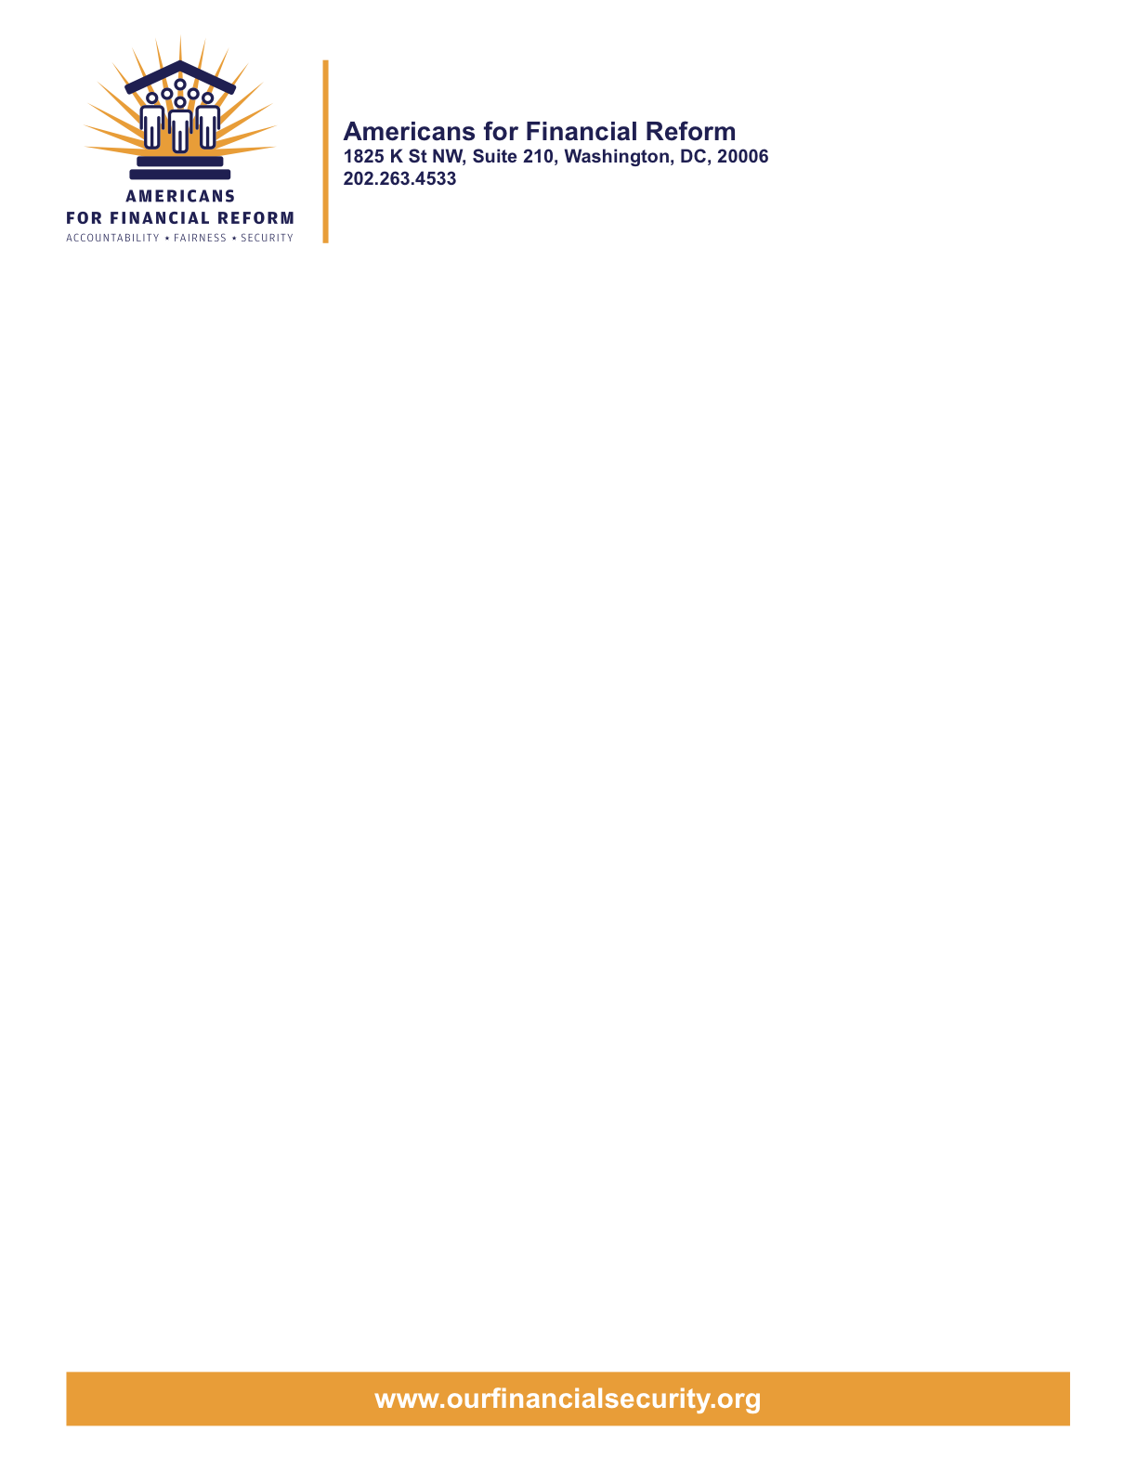

May 4, 2010
Hon. Al Franken
320 Hart Senate Office Building
Washington, DC 20510

Re: Support the Franken Amendment to Eliminate the Conflict of Interest in Credit Rating Assignments

Dear Senator Franken:
We are writing on behalf of the undersigned organizations to express our strong support for your amendment to strengthen the credit rating agency reform provisions of S. 3217. Your amendment would address a crucial weakness of the existing credit rating business model: the built-in conflict of interest between the rating agencies and the issuers who select and pay them.
Why did the ratings agencies gloss over the huge risks of mortgage-backed bonds and collateralized debt obligations? Because that was the way to attract business from the securities issuers who paid them, picked them, and, in many cases, had their help figuring out how to achieve the desired rating. The first imperative of reform is to bring the incentives of the ratings agencies into line with their mission.
Your amendment would accomplish this by authorizing the Securities and Exchange Commission to create a Credit Rating Assignment Board to take charge of the process of assigning bond offerings to ratings agencies. Rating agency performance could then be periodically compared on the basis of simple, transparent criteria, such as the number of times that investment-grade bonds defaulted or lost significant value. The most accurate ratings agencies could be rewarded with additional assignments. Those with the poorest records could, in extreme cases, be suspended or removed from the pool.
The mission that these companies so badly betrayed is a vital one. Even if regulators take steps to reduce investor reliance on ratings, as both the House and Senate reform measures urge, ratings agencies are needed to help investors accurately price risk and to allow issuers of bonds to compete for credit.
Your amendment fills an important gap in the Senate bill’s otherwise strong set of provisions to improve regulatory oversight of credit rating agencies. We are pleased to offer it our strong support.
Sincerely,

American for Financial Reform

Following are the partners of Americans for Financial Reform.

All the organizations support the overall principles of AFR and are working for an accountable, fair and secure financial system. Not all of these organizations work on all of the issues covered by the coalition or have signed on to every statement.

National Organizations
- A New Way Forward
- AARP
- Accountable America
- ACORN
- Adler and Colvin
- AFL-CIO
- AFSCME
- Alliance For Justice
- American Family Voices
- American Income Life Insurance
- Americans for Democratic Action, Inc.
- Americans for Fairness in Lending
- American Sustainable Business Coucil
- Americans United for Change
- Business for Shared Prosperity
- Calvert Asset Management Company, Inc.
- Campaign for America’s Future
- Campaign Money
- Center for Digital Democracy
- Center for Economic and Policy Research
- Center for Economic Progress
- Center for Responsible Lending
- Center for Justice and Democracy
- Center of Concern
- Change to Win
- Clean Yield Asset Management
- Coastal Enterprises Inc.
- Color of Change
- Common Cause
- Communications Workers of America
- Community Development Transportation Lending Services
- Community Law Center
- Consumer Action
- Consumer Association Council
- Consumers for Auto Safety and Reliability
- Consumer Federation of America
- Consumer Watchdog
- Consumers Union
- Corporation for Enterprise Development
- CREDO
- CTW Investment Group
- Demos
- Economic Policy Institute
- Essential Action
- Green America
- Greenlining Institute
- Good Business International
- Help Is On the Way, Inc
- HNMA Funding
- Home Actions
- Housing Counseling Services
- Information Press
- Institute for Global Communications
- Institute for Policy Studies: Global Economy Project
- International Brotherhood of Teamsters
- Institute of Women’s Policy Research
- Keystone Research Center
- Krull & Company
- Laborers’ International Union of North America
- Lake Research Partners
- Lawyers’ Committee for Civil Rights Under Law
- Leadership Conference on Civil Rights
- MoveOn.org Political Action
- NAACP
- NASCAT
- National Association of Consumer Advocates
- National Association of Investment Professionals
- National Association of Neighborhoods
- National Coalition for Asian Pacific American Community Development
- National Community Reinvestment Coalition
- National Consumer Law Center (on behalf of its low-income clients)
- National Consumers League
- National Council of La Raza
- National Fair Housing Alliance
- National Federation of Community Development Credit Unions
- National Housing Institute
- National Housing Trust
- National Housing Trust Community Development Fund
- National NeighborWorks Association
- National Peoples Action
- National Council of Womens Organizations
- National Worksright Institute
- Next Step
- OMB Watch
- Opportunity Finance Network
- Partners for the Common Good
- National People’s Action (NPA)
- PICO
- Progress Now Action
- Progressive States Network
- Poverty and Race Research Action Council
- Public Citizen
- Responsible Endowments Coalition
- Sargent Shriver Center on Poverty Law
- Scam Victims United
- SEIU
- State Voices
- Taxpayer’s for Common Sense
- The Association for Housing and Neighborhood Development
- The Carrots and Sticks Project
- The Fuel Savers Club
- The Seminal
- UNET
- Union Plus
- United for a Fair Economy
- U.S. PIRG
- Unitarian Universalist for a Just Economic Community
- United Food and Commercial Workers
- United States Student Association
- USAction
- Veris Wealth Partners
- Veterans Chanmber of Commerce
- We The People Now
- Western States Center
- Woodstock Institute
- Working America
- World Business Academy
- World Privacy Forum

State Organizations
- 207 CCAG
- 9 to 5, the National Association of Working Women (CO)
- AARP Rhode Island
- Alaska PIRG
- Arizona PIRG
- Arizona Advocacy Network
- Arizonans for Responsible Lending
- Arkansas Community Organizations
- Arkansas Public Policy Panel
- Association for Neighborhood and Housing Development (NY)
- Audubon Partnership for Economic Development LDC (New York, NY)
- Aurora NAACP
- BAC Funding Consortium Inc. (Miami, FL)
- Beech Capital Venture Corporation (Philadelphia, PA)
- Bell Policy Center (CO)
- California PIRG
- California Reinvestment Coalition
- Center for Media and Democracy
- Center for NYC Neighborhoods
- Century Housing Corporation (Culver City, CA)
- Changer(NY)
- Chautauqua Home Rehabilitation and Improvement Corporation (NY)
- Chicago Community Loan Fund (Chicago, IL)
- Chicago Community Ventures (Chicago, IL)
- Chicago Consumer Coalition
- Citizen Potawatomi CDC (Shawnee, OK)
- Coalition on Homeless Housing in Ohio
- Colorado AFL-CIO
- Colorado Center on Law and Policy
- Colorado Immigrants Rights Coalition
- Colorado PIRG
- Colorado Spring NAACP
- Colorado Center on Law and Policy
- Community Action of Nebraska
- Community Capital Development
- Community Capital Fund (Bridgeport, CT)
- Community Capital of Maryland (Baltimore, MD)
- Community Development Financial Institution of the Tohono O’odham Nation (Sells, AZ)
- Community Redevelopment Loan and Investment Fund, (Atlanta, GA)
- Community Reinvestment Association of North Carolina
- Community Resource Group (Fayetteville, AR)
- Connecticut Association for Human Services
- Connecticut Citizen Action Group
- Connecticut PIRG
- Consumer Assistance Council
- Cooper Square Committee (New York, NY)
- Cooperative Fund of New England (Wilmington, NC)
- Corporacion de Desarrollo Economico de Ceiba (Ceiba, PR)
- CWA 7777 (CO)
- Delta Foundation, Inc. (Greenville, MS)
- Economic Opportunity Fund (EOF) (Philadelphia, PA)
- Empire Justice Center (NY)
- Enterprises, Inc., Berea KY
- Fair Housing Contact Service OH
- Federation of Appalachian Housing Enterprises, Inc. (Berea, KY)
- Fitness and Praise Youth Development, Inc. (Baton Rouge, LA)
- Florida Consumer Action Network
- Florida PIRG
- Forward Community Investments (Madison, WI)
- Funding Partners for Housing Solutions (Ft. Collins, CO)
- Georgia PIRG
- Grow Iowa Foundation (Greenfield, IA)
- Homewise, Inc. (Santa Fe, NM)
- Humanitas Community Development Corporation
- Idaho Chapter, National Association of Social Workers
- Idaho Community Action Network
- Idaho Nevada CDFI (Pocatello, ID)
- Illinois PIRG
- Impact Capital (Seattle, WA)
- Indiana PIRG
- Indiana University PIRG
- Information Press (CA)
- Iowa PIRG
- Iowa Citizens for Community Improvement
- JobStart Chautauqua, Inc. (Mayville, NY)
- Keystone Research Center
- La Casa Federal Credit Union (Newark, NJ)
- Low Income Investment Fund (San Francisco, CA)
- Long Island Housing Services NY
- MaineStream Finance (Bangor, ME)
- Maryland PIRG
- Massachusetts Consumers’ Coalition
- Massachusetts Fair Housing Center
- MASSPIRG
- Michigan PIRG
- Midland Community Development Corporation (Midland, TX)
- Midwest Minnesota Community Development Corporation (Detroit Lakes, MN)
- Mile High Community Loan Fund (Denver, CO)
- Missouri PIRG
- Montana Community Development Corporation (Missoula, MT)
- Montana PIRG
- Mortgage Recovery Service Center of L.A.
- Neighborhood Economic Development Advocacy Project
- New Hampshire PIRG
- New Jersey Community Capital (Trenton, NJ)
- New Jersey Citizen Action
- New Jersey PIRG
- New Mexico PIRG
- New York PIRG
- New York City AIDS Housing Network
- Next Step (MN)
- NOAH Community Development Fund, Inc. (Boston, MA)
- Nonprofit Finance Fund (New York, NY)
- Nonprofits Assistance Fund (Minneapolis, MN)
- North Carolina Association of Community Development Corporations
- North Carolina PIRG
- Northern Community Investment Corporation (St. Johnsbury, VT)
- Northside Community Development Fund (Pittsburgh, PA)
- Ohio Capital Corporation for Housing (Columbus, OH)
- Ohio PIRG
- Oregon State PIRG
- Our Oregon
- PennPIRG
- Piedmont Housing Alliance (Charlottesville, VA)
- Rhode Island PIRG
- Rights for All People
- The Rocky Mountain Peace and Justice Center
- Rural Community Assistance Corporation (West Sacramento, CA)
- Rural Organizing Project OR
- San Francisco Metropolitan Transportation Authority
- Seattle Economic Development Fund dba Community Capital Development
- SEIU Local 105 (Colorado)
- SEIU Rhode Island
- Siouxland Economic Development Corporation (Sioux City, IA)
- Southern Bancorp (Arkadelphia, AR)
- TexPIRG
- The Association for Housing and Neighborhood Development
- The Fair Housing Council of Central New York
- The Help Network
- The Loan Fund (Albuquerque, NM)
- Third Reconstruction Institute (NC)
- V-Family, Inc.
- Vermont PIRG
- Village Capital Corporation (Cleveland, OH)
- Virginia Citizens Consumer Council
- Virginia Poverty Law Center
- War on Poverty – Florida
- Washington Community Action Network
- WashPIRG
- Westchester Residential Oppurtunities Inc. NY
- Wigamig Owners Loan Fund, Inc. (Lac du Flambeau, WI)
- WISPIRG

Businesses

- Blu
- Bowden-Gill Environmental
- Diversified Env. Planning
- Hayden & Craig, PLLC\
- The Holographic Repatterning Institute at Austin
- Mid City Animal Hospital (Phoenix, AZ)
- UNET

