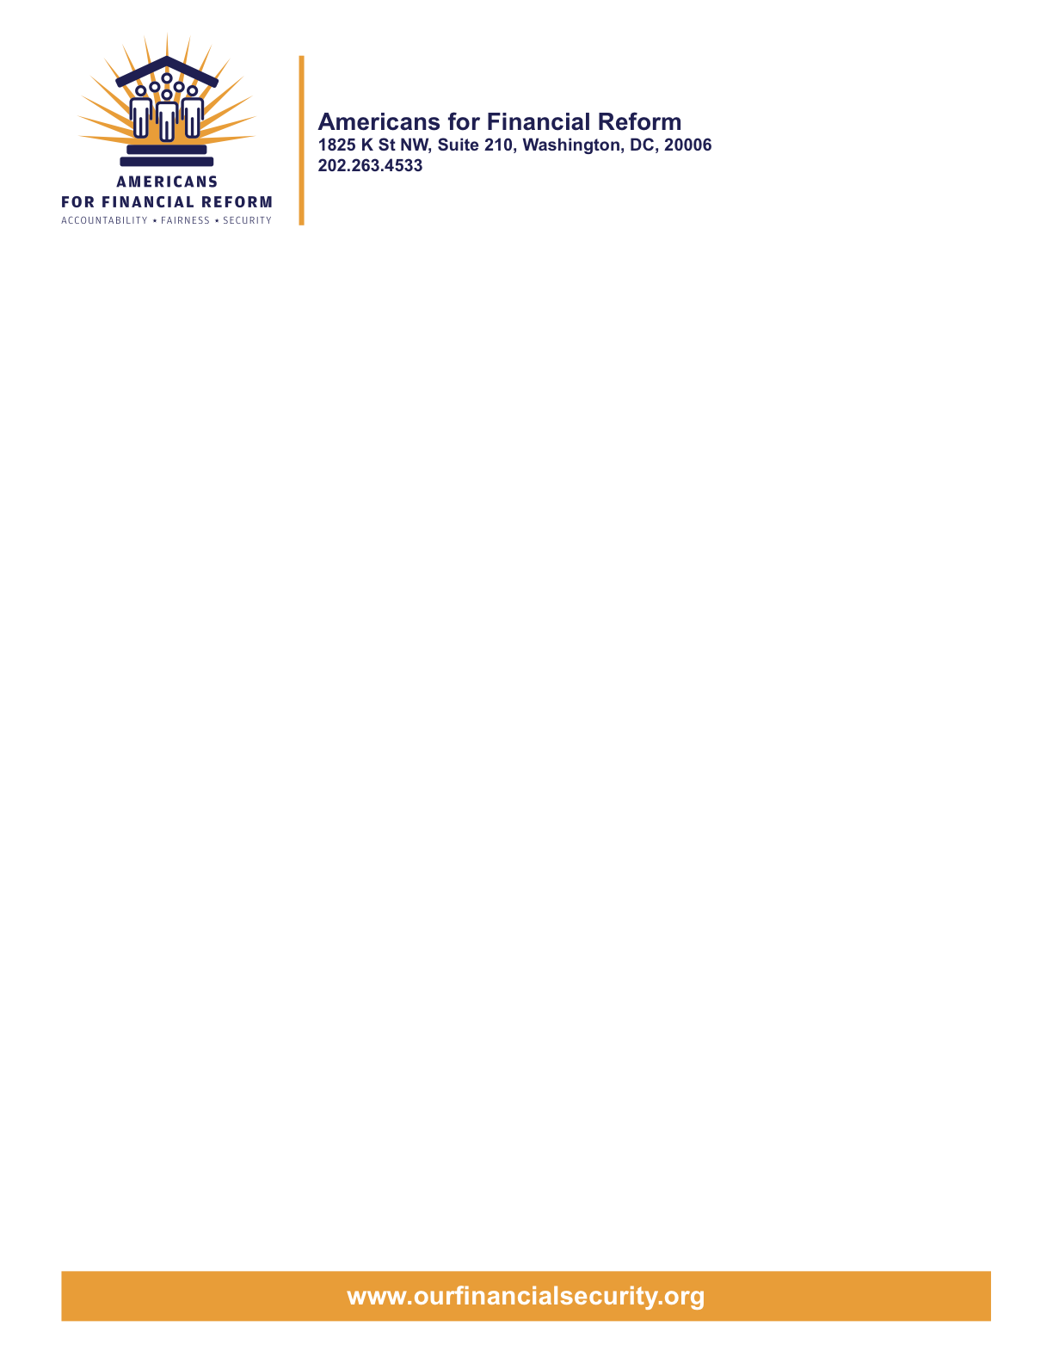

OPPOSE SNOWE-PRYOR #3883 REGULATORY “FLEXIBILITY” ACT
ADDS DELAYS AND RED TAPE, ENCOURAGES WASTEFUL LITIGATION
Senator May 19, 2010
United States Senate
Washington, DC 20510
Dear Senator:
We write on behalf of Americans for Financial Reform, an unprecedented coalition of over 250 national, state and local groups who have come together to reform the financial industry. Members of our coalition include consumer, civil rights, investor, retiree, community, labor, religious and business groups as well as Nobel Prize-winning economists. We support a strong Consumer Financial Protection Bureau (CFPB) and oppose weakening amendments to the Restoring American Financial Stability Act, S. 3217.
Snowe-Pryor Amendment #3883 is a misguided attempt to help small business. The amendment purports merely to require the agency to consider the impact of its rules on small businesses. But in fact it would needlessly delay CFPB rules by months and create gratuitous opportunities for industry to tie up the agency in court.
The ordinary rulemaking process provides ample opportunity for all stakeholders, including both small and large businesses, to make their views known to the agency and to hear the agency’s responses. It also permits affected parties to sue the agency to invalidate a rule if the agency gave inadequate notice or opportunity to comment, or if the agency acted arbitrarily or exceeded its authority in writing the rule. Businesses are adept at taking advantage of these opportunities, both individually and through trade associations, and need no more assistance in guarding their interests.
In fact, the delays created by Snowe-Pryor Amendment #3883 would hurt small business owners, who depend heavily on credit cards to finance their businesses and therefore would benefit from prompt, effective CFPB rules.
Snowe-Pryor Amendment #3883 would provide extra layers of bureaucracy, more red tape, and more litigation, harming small businesses and providing no benefit to the public. We urge you to oppose it.
For information, please contact David Arkush at (202) 454-5130 or darkush@citizen.org.

Sincerely,

Americans for Financial Reform

Following are the partners of Americans for Financial Reform.

All the organizations support the overall principles of AFR and are working for an accountable, fair and secure financial system. Not all of these organizations work on all of the issues covered by the coalition or have signed on to every statement.

National Organizations
- A New Way Forward
- AARP
- Accountable America
- ACORN
- Adler and Colvin
- AFL-CIO
- AFSCME
- Alliance For Justice
- American Family Voices
- American Income Life Insurance
- Americans for Democratic Action, Inc.
- Americans for Fairness in Lending
- American Sustainable Business Council
- Americans United for Change
- Business for Shared Prosperity
- Calvert Asset Management Company, Inc.
- Campaign for America’s Future
- Campaign Money
- Center for Digital Democracy
- Center for Economic and Policy Research
- Center for Economic Progress
- Center for Responsible Lending
- Center for Justice and Democracy
- Center of Concern
- Change to Win
- Clean Yield Asset Management
- Coastal Enterprises Inc.
- Color of Change
- Common Cause
- Communications Workers of America
- Community Development Transportation Lending Services
- Community Law Center
- Consumer Action
- Consumer Association Council
- Consumers for Auto Safety and Reliability
- Consumer Federation of America
- Consumer Watchdog
- Consumers Union
- Corporation for Enterprise Development
- CREDO
- CTW Investment Group
- Demos
- Economic Policy Institute
- Essential Action
- Green America
- Greenlining Institute
- Good Business International
- Help Is On the Way, Inc
- HNMA Funding
- Home Actions
- Housing Counseling Services
- Information Press
- Institute for Global Communications
- Institute for Policy Studies: Global Economy Project
- International Brotherhood of Teamsters
- Institute of Women’s Policy Research
- Keystone Research Center
- Krull & Company
- Laborers’ International Union of North America
- Lake Research Partners
- Lawyers’ Committee for Civil Rights Under Law
- Leadership Conference on Civil Rights
- MoveOn.org Political Action
- NAACP
- NASCAT
- National Association of Consumer Advocates
- National Association of Investment Professionals
- National Association of Neighborhoods
- National Coalition for Asian Pacific American Community Development
- National Community Reinvestment Coalition
- National Consumer Law Center (on behalf of its low-income clients)
- National Consumers League
- National Council of La Raza
- National Fair Housing Alliance
- National Federation of Community Development Credit Unions
- National Housing Institute
- National Housing Trust
- National Housing Trust Community Development Fund
- National NeighborWorks Association
- National Peoples Action
- National Council of Womens Organizations
- National Worksright Institute
- Next Step
- OMB Watch
- Opportunity Finance Network
- Partners for the Common Good
- National People’s Action (NPA)
- PICO
- Progress Now Action
- Progressive States Network
- Poverty and Race Research Action Council
- Public Citizen
- Responsible Endowments Coalition
- Sargent Shriver Center on Poverty Law
- Scam Victims United
- SEIU
- State Voices
- Taxpayer’s for Common Sense
- The Association for Housing and Neighborhood Development
- The Carrots and Sticks Project
- The Fuel Savers Club
- The Seminal
- UNET
- Union Plus
- United for a Fair Economy
- U.S. PIRG
- Unitarian Universalist for a Just Economic Community
- United Food and Commercial Workers
- United States Student Association
- USAction
- Veris Wealth Partners
- Veterans Chanmber of Commerce
- We The People Now
- Western States Center
- Woodstock Institute
- Working America
- World Business Academy
- World Privacy Forum

State Organizations
- 207 CCAG
- 9 to 5, the National Association of Working Women (CO)
- AARP Rhode Island
- Alaska PIRG
- Arizona PIRG
- Arizona Advocacy Network
- Arizonans for Responsible Lending
- Arkansas Community Organizations
- Arkansas Public Policy Panel
- Association for Neighborhood and Housing Development (NY)
- Audubon Partnership for Economic Development LDC (New York, NY)
- Aurora NAACP
- BAC Funding Consortium Inc. (Miami, FL)
- Beech Capital Venture Corporation (Philadelphia, PA)
- Bell Policy Center (CO)
- California PIRG
- California Reinvestment Coalition
- Center for Media and Democracy
- Center for NYC Neighborhoods
- Century Housing Corporation (Culver City, CA)
- Changer(NY)
- Chautauqua Home Rehabilitation and Improvement Corporation (NY)
- Chicago Community Loan Fund (Chicago, IL)
- Chicago Community Ventures (Chicago, IL)
- Chicago Consumer Coalition
- Citizen Potawatomi CDC (Shawnee, OK)
- Coalition on Homeless Housing in Ohio
- Colorado AFL-CIO
- Colorado Center on Law and Policy
- Colorado Immigrants Rights Coalition
- Colorado PIRG
- Colorado Spring NAACP
- Colorado Center on Law and Policy
- Community Action of Nebraska
- Community Capital Development
- Community Capital Fund (Bridgeport, CT)
- Community Capital of Maryland (Baltimore, MD)
- Community Development Financial Institution of the Tohono O’odham Nation (Sells, AZ)
- Community Redevelopment Loan and Investment Fund, (Atlanta, GA)
- Community Reinvestment Association of North Carolina
- Community Resource Group (Fayetteville, AR)
- Connecticut Association for Human Services
- Connecticut Citizen Action Group
- Connecticut PIRG
- Consumer Assistance Council
- Cooper Square Committee (New York, NY)
- Cooperative Fund of New England (Wilmington, NC)
- Corporacion de Desarrollo Economico de Ceiba (Ceiba, PR)
- CWA 7777 (CO)
- Delta Foundation, Inc. (Greenville, MS)
- Economic Opportunity Fund (EOF) (Philadelphia, PA)
- Empire Justice Center (NY)
- Enterprises, Inc., Berea KY
- Fair Housing Contact Service OH
- Federation of Appalachian Housing Enterprises, Inc. (Berea, KY)
- Fitness and Praise Youth Development, Inc. (Baton Rouge, LA)
- Florida Consumer Action Network
- Florida PIRG
- Forward Community Investments (Madison, WI)
- Funding Partners for Housing Solutions (Ft. Collins, CO)
- Georgia PIRG
- Grow Iowa Foundation (Greenfield, IA)
- Homewise, Inc. (Santa Fe, NM)
- Humanitas Community Development Corporation
- Idaho Chapter, National Association of Social Workers
- Idaho Community Action Network
- Idaho Nevada CDFI (Pocatello, ID)
- Illinois PIRG
- Impact Capital (Seattle, WA)
- Indiana PIRG
- Indiana University PIRG
- Information Press (CA)
- Iowa PIRG
- Iowa Citizens for Community Improvement
- JobStart Chautauqua, Inc. (Mayville, NY)
- Keystone Research Center
- La Casa Federal Credit Union (Newark, NJ)
- Low Income Investment Fund (San Francisco, CA)
- Long Island Housing Services NY
- MaineStream Finance (Bangor, ME)
- Maryland PIRG
- Massachusetts Consumers’ Coalition
- Massachusetts Fair Housing Center
- MASSPIRG
- Michigan PIRG
- Midland Community Development Corporation (Midland, TX)
- Midwest Minnesota Community Development Corporation (Detroit Lakes, MN)
- Mile High Community Loan Fund (Denver, CO)
- Missouri PIRG
- Montana Community Development Corporation (Missoula, MT)
- Montana PIRG
- Mortgage Recovery Service Center of L.A.
- Neighborhood Economic Development Advocacy Project
- New Hampshire PIRG
- New Jersey Community Capital (Trenton, NJ)
- New Jersey Citizen Action
- New Jersey PIRG
- New Mexico PIRG
- New York PIRG
- New York City AIDS Housing Network
- Next Step (MN)
- NOAH Community Development Fund, Inc. (Boston, MA)
- Nonprofit Finance Fund (New York, NY)
- Nonprofits Assistance Fund (Minneapolis, MN)
- North Carolina Association of Community Development Corporations
- North Carolina PIRG
- Northern Community Investment Corporation (St. Johnsbury, VT)
- Northside Community Development Fund (Pittsburgh, PA)
- Ohio Capital Corporation for Housing (Columbus, OH)
- Ohio PIRG
- Oregon State PIRG
- Our Oregon
- PennPIRG
- Piedmont Housing Alliance (Charlottesville, VA)
- Rhode Island PIRG
- Rights for All People
- The Rocky Mountain Peace and Justice Center
- Rural Community Assistance Corporation (West Sacramento, CA)
- Rural Organizing Project OR
- San Francisco Metropolitan Transportation Authority
- Seattle Economic Development Fund dba Community Capital Development
- SEIU Local 105 (Colorado)
- SEIU Rhode Island
- Siouxland Economic Development Corporation (Sioux City, IA)
- Southern Bancorp (Arkadelphia, AR)
- TexPIRG
- The Association for Housing and Neighborhood Development
- The Fair Housing Council of Central New York
- The Help Network
- The Loan Fund (Albuquerque, NM)
- Third Reconstruction Institute (NC)
- V-Family, Inc.
- Vermont PIRG
- Village Capital Corporation (Cleveland, OH)
- Virginia Citizens Consumer Council
- Virginia Poverty Law Center
- War on Poverty – Florida
- Washington Community Action Network
- WashPIRG
- Westchester Residential Oppurtunities Inc. NY
- Wigamig Owners Loan Fund, Inc. (Lac du Flambeau, WI)
- WISPIRG

Businesses

- Blu
- Bowden-Gill Environmental
- Diversified Env. Planning
- Hayden & Craig, PLLC\
- The Holographic Repatterning Institute at Austin
- Mid City Animal Hospital (Phoenix, AZ)
- UNET

