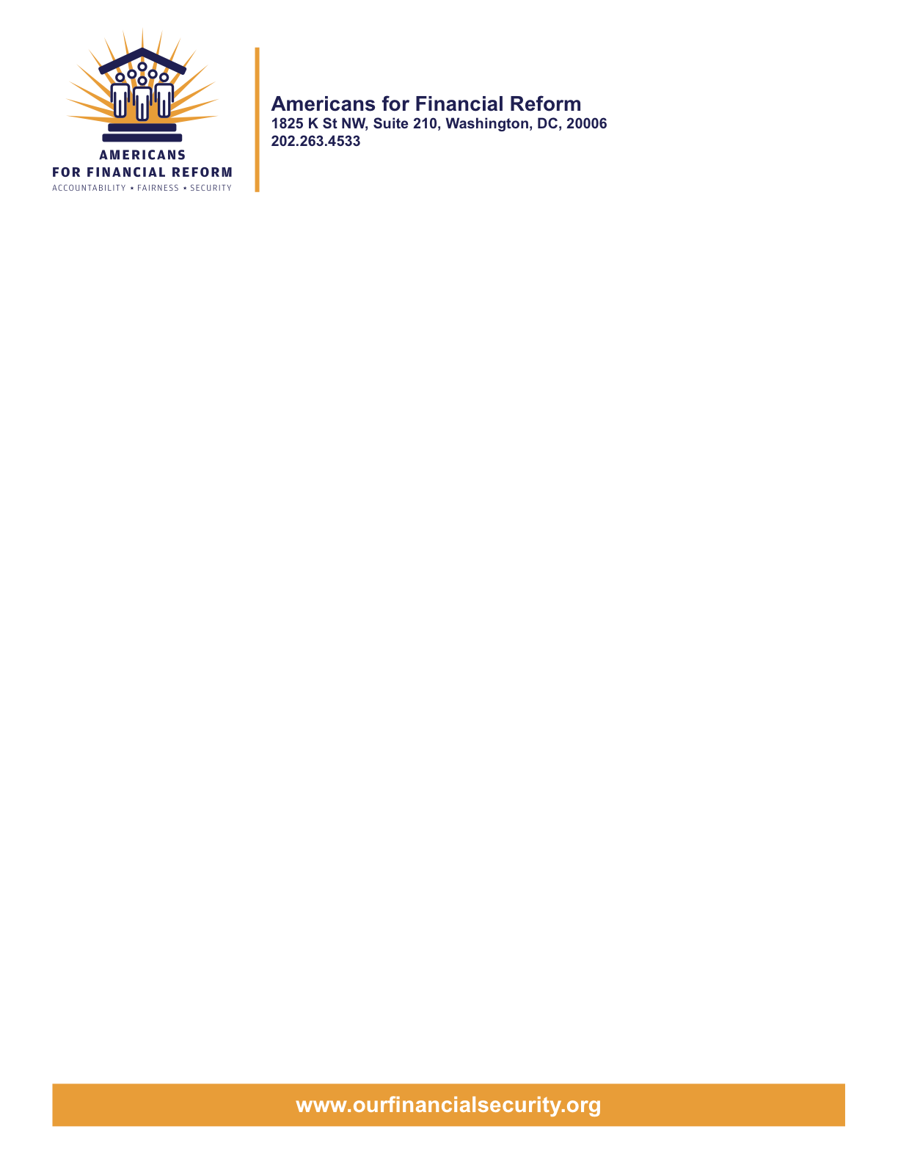

May 13, 2010

Senator
United States Senate
Washington, DC 20510

Regulatory Reform Should Include Strong Tools to Deter Bad Mortgage Lending:
Defeat Corker Amendments 3955
Dear Senator:

We write on behalf of Americans for Financial Reform to urge you to oppose the Corker-Gregg-Isakson (#3955) amendment to S. 3217, the Restoring American Financial Stability Act of 2010. As you know, AFR is an unprecedented coalition of more than 250 national, state and local groups who have come together to reform the financial industry. Members of our coalition include consumer, civil rights, investor, retiree, community, labor, religious and business groups as well as Nobel Prize-winning economists.

Don’t promote irresponsible loan packaging – keep credit risk retention requirement in the bill

The Corker-Gregg-Isakson (#3955) amendment would eliminate the risk retention provisions of S. 3217, Title VII, Subtitle D, (b) Credit Risk Retention, and replace them with nothing but a study. This Amendment would leave in place the misaligned incentives and bad business practices that led us into the mortgage crisis. The mortgage meltdown and resulting financial crisis were caused by lenders making bad loans and then selling them to Wall Street, where securitizers sold them to our pension funds, mutual funds, and other investors and thereby widely poisoned the global economy. The lenders and packagers had no “skin in the game” and not enough incentive to care if the loans were bad loans.

The provision in the bill is nuanced and well-crafted. It already permits the regulators to reduce the risk retention requirement when the underlying loans meet a standard for reduced credit risk and to permit an exception “as may be appropriate in the public interest and for the protection of investors.” Reject this amendment and put an end to “keep the fee, pass the risk.”

Don’t unnecessarily cut off families from home mortgage credit, especially minority and lower-income communities.

The amendment would make it harder for families to purchase a home even when responsible underwriting determines that the family can make the monthly payments. By adding a 5 percent down payment requirement, this amendment would significantly harm efforts to extend homeownership to low and moderate income households, communities of color, and first-time homebuyers. Many of these households can afford monthly mortgage payments, particularly if they get a fixed rate mortgage with current low interest rates and current house prices that in many markets are below historical trends. But these families may be unable to acquire the wealth needed to meet the down payment requirement proposed in this amendment. The National Association of Realtors’ 2009 Profile of Home Buyers and Sellers showed that 11 percent of all home purchasers surveyed made down payments of 5 percent or less. When considering only first-time homebuyers, the percentage making a down payment below 5 percent increases to 18 percent. Improving underwriting to ensure that the consumer has the ability to repay their obligation is in the best interest of everyone, but randomly selecting just one mortgage term and creating an onerous statutory requirement related to that term will have significant detrimental ramifications for American families, the housing sector and those businesses that support it.

Don’t leave oversight of mortgage underwriting with the failed regulatory system

Finally, we oppose restrictions on the authority of the Consumer Financial Protection Bureau to address underwriting in home mortgages. Banking regulators were largely asleep at the switch – or in some cases, actively assisting wrongdoers – while the mortgage crisis unfolded, which is one of the core reasons that the CFPB is needed. Senator Corker’s amendment would unacceptably gut the ability of the CFPB to help consumers with what is typically the largest financial transaction in which they will ever participate.

We appreciate the opportunity to share our views with you on these amendments. We urge your opposition to Corker Amendments 3955. For more information, please contact Julia Gordon at the Center for Responsible Lending at 202-349-1878 (julia.gordon@responsiblelending.org), or Gail Hillebrand at Consumers Union at 415 431 6747 (hillga@consumer.org).

Sincerely,

Americans for Financial Reform

Following are the partners of Americans for Financial Reform.

All the organizations support the overall principles of AFR and are working for an accountable, fair and secure financial system. Not all of these organizations work on all of the issues covered by the coalition or have signed on to every statement.

National Organizations
- A New Way Forward
- AARP
- Accountable America
- Adler and Colvin
- AFL-CIO
- AFSCME
- Alliance For Justice
- American Family Voices
- American Income Life Insurance
- Americans for Democratic Action, Inc.
- Americans for Fairness in Lending
- American Sustainable Business Council
- Americans United for Change
- Business for Shared Prosperity
- Calvert Asset Management Company, Inc.
- Campaign for America’s Future
- Campaign Money
- Center for Digital Democracy
- Center for Economic and Policy Research
- Center for Economic Progress
- Center for Responsible Lending
- Center for Justice and Democracy
- Center of Concern
- Change to Win
- Clean Yield Asset Management
- Coastal Enterprises Inc.
- Color of Change
- Common Cause
- Communications Workers of America
- Community Development Transportation Lending Services
- Community Law Center
- Consumer Action
- Consumer Association Council
- Consumers for Auto Safety and Reliability
- Consumer Federation of America
- Consumer Watchdog
- Consumers Union
- Corporation for Enterprise Development
- CREDO
- CTW Investment Group
- Demos
- Economic Policy Institute
- Essential Action
- Green America
- Greenlining Institute
- Good Business International
- Help Is On the Way, Inc
- HNMA Funding
- Home Actions
- Housing Counseling Services
- Information Press
- Institute for Global Communications
- Institute for Policy Studies: Global Economy Project
- International Brotherhood of Teamsters
- Institute of Women’s Policy Research
- Keystone Research Center
- Krull & Company
- Laborers’ International Union of North America
- Lake Research Partners
- Lawyers’ Committee for Civil Rights Under Law
- Leadership Conference on Civil Rights
- MoveOn.org Political Action
- NAACP
- NASCAT
- National Association of Consumer Advocates
- National Association of Investment Professionals
- National Association of Neighborhoods
- National Coalition for Asian Pacific American Community Development
- National Community Reinvestment Coalition
- National Consumer Law Center (on behalf of its low-income clients)
- National Consumers League
- National Council of La Raza
- National Fair Housing Alliance
- National Federation of Community Development Credit Unions
- National Housing Institute
- National Housing Trust
- National Housing Trust Community Development Fund
- National NeighborWorks Association
- National Peoples Action
- National Council of Womens Organizations
- National Worksright Institute
- Next Step
- OMB Watch
- Opportunity Finance Network
- Partners for the Common Good
- National People’s Action (NPA)
- PICO
- Progress Now Action
- Progressive States Network
- Poverty and Race Research Action Council
- Public Citizen
- Responsible Endowments Coalition
- Sargent Shriver Center on Poverty Law
- Scam Victims United
- SEIU
- Sojourners
- State Voices
- Taxpayer’s for Common Sense
- The Association for Housing and Neighborhood Development
- The Carrots and Sticks Project
- The Fuel Savers Club
- The Seminal
- UNET
- Union Plus
- United for a Fair Economy
- U.S. PIRG
- Unitarian Universalist for a Just Economic Community
- United Food and Commercial Workers
- United States Student Association
- USAction
- Veris Wealth Partners
- Veterans Chanmber of Commerce
- We The People Now
- Western States Center
- Woodstock Institute
- Working America
- World Business Academy
- World Privacy Forum

State Organizations
- 207 CCAG
- 9 to 5, the National Association of Working Women (CO)
- AARP Rhode Island
- Alaska PIRG
- Arizona PIRG
- Arizona Advocacy Network
- Arizonans for Responsible Lending
- Arkansas Community Organizations
- Arkansas Public Policy Panel
- Association for Neighborhood and Housing Development (NY)
- Audubon Partnership for Economic Development LDC (New York, NY)
- Aurora NAACP
- BAC Funding Consortium Inc. (Miami, FL)
- Beech Capital Venture Corporation (Philadelphia, PA)
- Bell Policy Center (CO)
- California PIRG
- California Reinvestment Coalition
- Center for Media and Democracy
- Center for NYC Neighborhoods
- Century Housing Corporation (Culver City, CA)
- Changer(NY)
- Chautauqua Home Rehabilitation and Improvement Corporation (NY)
- Chicago Community Loan Fund (Chicago, IL)
- Chicago Community Ventures (Chicago, IL)
- Chicago Consumer Coalition
- Citizen Potawatomi CDC (Shawnee, OK)
- Club Change of Martin County (Florida)
- Coalition on Homeless Housing in Ohio
- Coffee Party of Pensacola, Florida
- Coffee Party of Union Square, New York City
- Colorado AFL-CIO
- Colorado Center on Law and Policy
- Colorado Immigrants Rights Coalition
- Colorado PIRG
- Colorado Spring NAACP
- Community Action of Nebraska
- Community Capital Development
- Community Capital Fund (Bridgeport, CT)
- Community Capital of Maryland (Baltimore, MD)
- Community Development Financial Institution of the Tohono O’odham Nation (Sells, AZ)
- Community Redevelopment Loan and Investment Fund, (Atlanta, GA)
- Community Reinvestment Association of North Carolina
- Community Resource Group (Fayetteville, AR)
- Connecticut Association for Human Services
- Connecticut Citizen Action Group
- Connecticut PIRG
- Consumer Assistance Council
- Cooper Square Committee (New York, NY)
- Cooperative Fund of New England (Wilmington, NC)
- Corporacion de Desarrollo Economico de Ceiba (Ceiba, PR)
- CWA 7777 (CO)
- Delta Foundation, Inc. (Greenville, MS)
- Economic Opportunity Fund (EOF) (Philadelphia, PA)
- Empire Justice Center (NY)
- Enterprises, Inc., Berea KY
- Fair Housing Contact Service OH
- Federation of Appalachian Housing Enterprises, Inc. (Berea, KY)
- Fitness and Praise Youth Development, Inc. (Baton Rouge, LA)
- Florida Consumer Action Network
- Florida PIRG
- Forward Community Investments (Madison, WI)
- Funding Partners for Housing Solutions (Ft. Collins, CO)
- Georgia PIRG
- Grow Iowa Foundation (Greenfield, IA)
- Homewise, Inc. (Santa Fe, NM)
- Humanitas Community Development Corporation
- Idaho Chapter, National Association of Social Workers
- Idaho Community Action Network
- Idaho Nevada CDFI (Pocatello, ID)
- Illinois PIRG
- Impact Capital (Seattle, WA)
- Indiana PIRG
- Indiana University PIRG
- Information Press (CA)
- Iowa PIRG
- Iowa Citizens for Community Improvement
- JobStart Chautauqua, Inc. (Mayville, NY)
- Keystone Research Center
- La Casa Federal Credit Union (Newark, NJ)
- Low Income Investment Fund (San Francisco, CA)
- Long Island Housing Services NY
- MaineStream Finance (Bangor, ME)
- Maryland PIRG
- Massachusetts Consumers’ Coalition
- Massachusetts Fair Housing Center
- MASSPIRG
- Michigan PIRG
- Midland Community Development Corporation (Midland, TX)
- Midwest Minnesota Community Development Corporation (Detroit Lakes, MN)
- Mile High Community Loan Fund (Denver, CO)
- Missouri PIRG
- Montana Community Development Corporation (Missoula, MT)
- Montana PIRG
- Mortgage Recovery Service Center of L.A.
- Neighborhood Economic Development Advocacy Project
- New Hampshire PIRG
- New Jersey Community Capital (Trenton, NJ)
- New Jersey Citizen Action
- New Jersey PIRG
- New Mexico PIRG
- New York PIRG
- New York City AIDS Housing Network
- Next Step (MN)
- NOAH Community Development Fund, Inc. (Boston, MA)
- Nonprofit Finance Fund (New York, NY)
- Nonprofits Assistance Fund (Minneapolis, MN)
- North Carolina Association of Community Development Corporations
- North Carolina PIRG
- Northern Community Investment Corporation (St. Johnsbury, VT)
- Northside Community Development Fund (Pittsburgh, PA)
- Ohio Capital Corporation for Housing (Columbus, OH)
- Ohio PIRG
- Oregon State PIRG
- Our Oregon
- PennPIRG
- Piedmont Housing Alliance (Charlottesville, VA)
- Rhode Island PIRG
- Rights for All People
- The Rocky Mountain Peace and Justice Center
- Rural Community Assistance Corporation (West Sacramento, CA)
- Rural Organizing Project OR
- San Francisco Metropolitan Transportation Authority
- Seattle Economic Development Fund dba Community Capital Development
- SEIU Local 105 (Colorado)
- SEIU Rhode Island
- Siouxland Economic Development Corporation (Sioux City, IA)
- Southern Bancorp (Arkadelphia, AR)
- TexPIRG
- The Association for Housing and Neighborhood Development
- The Fair Housing Council of Central New York
- The Help Network
- The Loan Fund (Albuquerque, NM)
- Third Reconstruction Institute (NC)
- V-Family, Inc.
- Vermont PIRG
- Village Capital Corporation (Cleveland, OH)
- Virginia Citizens Consumer Council
- Virginia Poverty Law Center
- War on Poverty – Florida
- Washington Community Action Network
- WashPIRG
- Westchester Residential Oppurtunities Inc. NY
- Wigamig Owners Loan Fund, Inc. (Lac du Flambeau, WI)
- WISPIRG

Businesses

- Blu
- Bowden-Gill Environmental
- Community MedPAC
- Diversified Env. Planning
- Hayden & Craig, PLLC\
- The Holographic Repatterning Institute at Austin
- Mid City Animal Hospital (Phoenix, AZ)
- UNET

