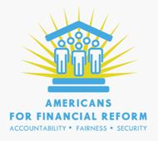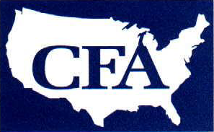

June 15, 2010

Chairman Christopher Dodd
United States Senate
Washington, DC 20510

Chairman Barney Frank
United States House of Representatives
Washington, DC 20510

Protect Investors from Accounting Fraud: Oppose Exemptions to Sarbanes-Oxley

Dear Conferee,

As the Conference Committee prepares to begin deliberations on the investor protection title of the financial regulatory reform bill, we write on behalf of Consumer Federation of America and Americans for Financial Reform to express our strong opposition to efforts to weaken protections against accounting fraud at small public companies.

Although the Senate bill is silent on the issue, the House bill included three separate provisions related to the Sarbanes-Oxley Act requirement that the financial statement audits of all public companies include an evaluation by the auditor of the company’s internal controls to prevent accounting fraud and promote accurate financial reporting. The most egregious of these would provide a permanent exemption from the requirement for companies with under $75 million in market capitalization. Despite extensive evidence that costs of compliance are both reasonable and dropping, some members of the conference committee have made it clear that they intend to try to insert this provision in the conference report.

If adopted, the exemption would not only leave investors with fewer defenses against fraud, it would raise the cost of capital for smaller companies by increasing the risk premium they must pay to investors wary of that fraud risk. That is because small companies have been shown to be more prone to both accounting fraud and to accounting errors. Where fraud does occur at these companies, it almost always involves top executives, making management’s assessment of fraud controls virtually meaningless without an independent auditor’s review. Absent that independent review, companies with strong and weak fraud controls alike would both be forced to pay a higher risk premium, since the markets would have no basis for distinguishing between them.

This is a misguided proposal based on the false notion that weakening our investor protections will improve our markets’ competitiveness. In reality, our markets depend on our higher standards of investor protection to attract capital. Moreover, this provision reflects precisely the sort of anti-regulatory thinking that landed us in the current financial crisis. It has no place in legislation designed to strengthen regulation and restore investor confidence in the integrity of the markets. We urge you to resist any efforts to include a permanent exemption from SOX 404(b) for small companies in the conference report.

Sincerely,

Heather Booth Barbara Roper
Executive Director Director of Investor Protection
Americans for Financial Reform Consumer Federation of America

AFR’s 250 member groups: http://ourfinancialsecurity.org/about/our-coalition/

