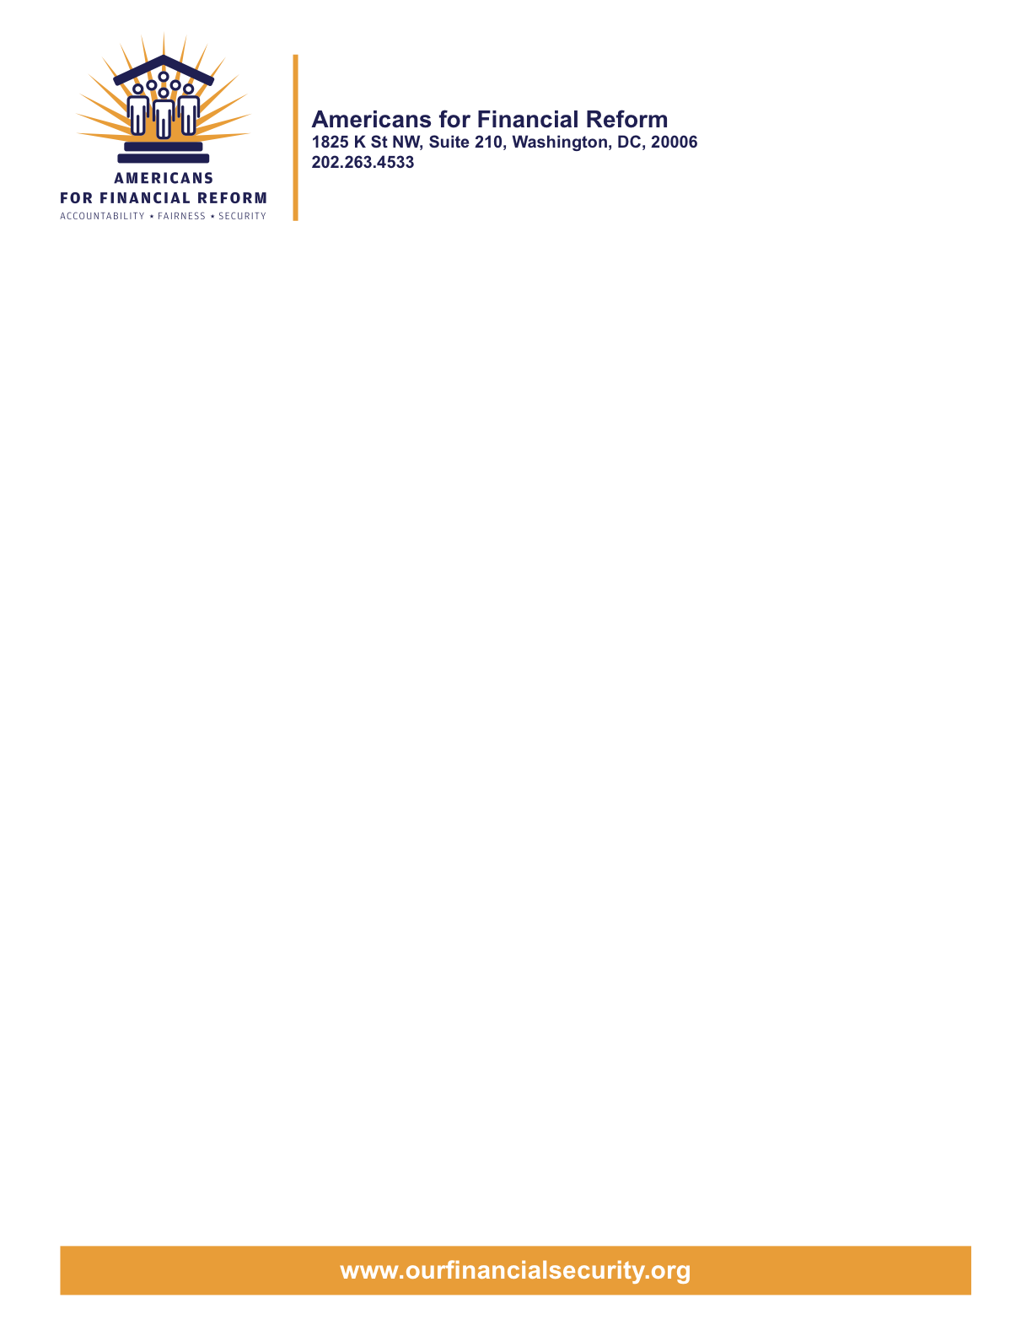

Oppose the House Offer on H.R. 4173 to Exempt Attorneys
Engaged in Unfair, Deceptive or Abusive Consumer Financial Practices

June 22, 2010
House-Senate Conferees, H.R. 4173
Washington, DC 20510

Dear Senator or Representative:
Americans for Financial Reform and the undersigned organizations – including several that have or serve attorneys – urge the House-Senate Wall Street Reform and Consumer Protection Act Conference to reject the House offer to create a broad exemption for attorneys from the rules addressing unfair, deceptive or abusive practices.
We support the ability of the Consumer Financial Protection Bureau, where appropriate, to develop carefully crafted exemptions for attorneys on a case-by-case basis from specific rules. The CFPB has that power in the base text. But we oppose any broad exemption from the CFPB’s jurisdiction for the “practice of law,” activities “incidental” to the practice of law, or work under an attorney’s “direction.” Attorneys and others under their cloak have used exemptions to shield many unfair activities from consumer protections. The House language would prevent the CFPB from addressing the following abuses:
- Loan modification scams. Foreclosure prevention and loan modification outfits that harm vulnerable consumers are rampant among attorneys. The House offer broadly exempts these services.
  - Any activities purporting to help avoid foreclosure or modify a loan can be described as “practice of law” or “legal services to a client,” even if the work performed is no different than the scam services provided by nonlawyers.
  - Exemptions from state laws have been exploited: "In my 21 years in attorney discipline, I have not seen a crisis of this magnitude," said Interim California Bar Chief Trial Counsel Russell Weiner. "The number of attorneys using their law licenses to essentially take money from unwary but trusting consumers is astounding." The crisis led California to eliminate the attorney exemption from its foreclosure consultant statute.
  - Under the exemption, nonlawyer loan modification firms could continue to recruit attorneys—as they do on Craigslist right now—and claim to be operating under their “direction” or providing “incidental” services.
- Debt settlement scams. Attorneys have engaged in the same shady practices as nonlawyers, collecting up-front fees with an illusive promise to renegotiate credit card and other debt.
  - An offer to renegotiate debt could be “practice of law” even if no different from nonlawyer services. Again, nonlawyers can recruit attorneys for cover.
  - The CFPB, which would take over debt settlement from the FTC, would not have the same power to address abuses. In March, the FTC obtained an order against an attorney involved in practices to obtain thousands of dollars from consumers based on false promises to solve credit and debt problems.
- Arbitration. The debt collection law firm Mann Bracken was an integral part of the unfair and deceptive arbitration practices uncovered by the Minnesota attorney general, who forced the National Arbitration Forum out of consumer arbitrations due to the conflicts of interest in the interwoven ownership of the “judge” (the NAF) and the collectors (a conglomerate that included Mann Bracken).
  - Mann Bracken was engaged in the “practice of law” in the debt collection actions and would be exempt under the House language.
Attorneys are not exempt from the FTC’s jurisdiction now when they engage in unfair or deceptive practices and there should not be a gaping hole in the CFPB’s jurisdiction. Like the FTC, the CFPB will have no interest in or power to regulate the general practice of law. The base text exempts attorneys unless they engage in consumer financial products or services, and the CFPB can write its rules to avoid unintended impacts on lawyers just as it can protect the legitimate practices of other industries. But broad exemptions for the practice of law have led to enormous problems in the past and will in the future if attorneys are broadly exempt from CFPB rules.
For more information, contact Lauren Saunders, National Consumer Law Center, (202) 452-6252 x 105, lsaunders@nclcdc.org.
Yours very truly,
Americans for Financial Reform
California Reinvestment Coalition
Center for Responsible Lending
Consumer Action
Consumer Federation of America
Consumer Watchdog
Consumers Union
Empire Justice Center
Lawyers’ Committee for Civil Rights Under Law
Leadership Conference on Civil Rights
National Association of Consumer Advocates
National Community Reinvestment Coalition
National Consumer Law Center (on behalf of its low income clients)
National Council of La Raza
National Fair Housing Alliance
Neighborhood Economic Development Advocacy Project
A New Way Forward
New York Public Interest Research Group
Sargent Shriver National Center on Poverty Law
U.S. PIRG
Western States Center

