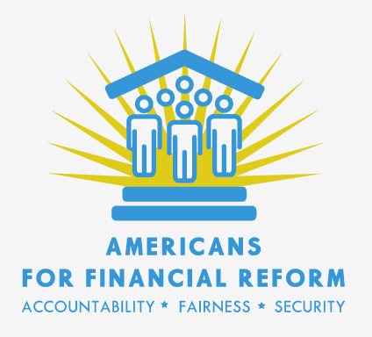

AFR Plain English Priorities

- Establishing a Consumer Financial Protection Bureau that is independent, has broad enforcement authority, and the necessary funding to protect consumers. There should be no carve-outs or exceptions for car dealers or other special interest groups.

- Ending the “Casino Economy” and shining a light on the shadowy derivatives market, by creating new rules for this $600 trillion market that would require that banks’ bets be backed by capital. Congress must also ensure that the new regulations not be undermined by exemptions or enforcement gaps.

- Holding Corporate Directors Accountable. Shareholders -the owners of public companies -- need better tools to hold corporate directors accountable so they will be motivated to challenge executives who pursue excessively risky strategies. Congress must ease the way for shareholders to nominate candidates for corporate boards and give shareholders an annual advisory vote on executive compensation.

- Ensuring comprehensive regulation of leveraged investment fund managers such as hedge funds, leveraged buyouts, and venture capital funds which now operate almost entirely without public oversight. Stronger House language is needed in conference to change this.

- Addressing Systemic Risk by closing the Senate bill’s gaps in authority to regulate shadow banks and tomorrow’s riskiest financial companies. We must also separate high-risk speculative activities from the basic commercial banking business of making loans to consumers and businesses, through a Volcker rule strengthened by the Merkley-Levin amendment and Section 716’s separation of derivatives dealing from banks. Congress must also ensure that banks and speculators – not taxpayers – pay the costs when financial institutions fail.

- Protecting investors by requiring all financial advisors to put their clients’ interest first. Without the changes in the House bill, brokers and insurance agents will be able to present themselves as advisors, but recommend products that they know are not in their customers’ best interests in order to turn a profit.
- Reforming Bad Mortgage Lending Practices by creating strong, enforceable standards for home lending to protect American families’ largest investments – their homes – and to prevent lending abuses. Congress must also include provisions to protect families from losing their homes to foreclosure.
- Taking on conflicts of interest and holding credit rating agencies accountable for stamping AAA seals of approval on the enormously risky products that brought down the economy. Congress should insulate the rating agencies from industry pressure to loosen standards by retaining the "Franken Amendment" to award rating assignments based on the agencies’ accuracy and value to investors. The strong House-passed liability language is also critical to giving investors the ability to hold credit rating agencies accountable.

- Reforming Federal Reserve governance and increasing transparency by barring member banks from voting for regional Fed directors, giving the President and the Senate the right to select the powerful New York Fed president, and mandating audits of the Fed.

