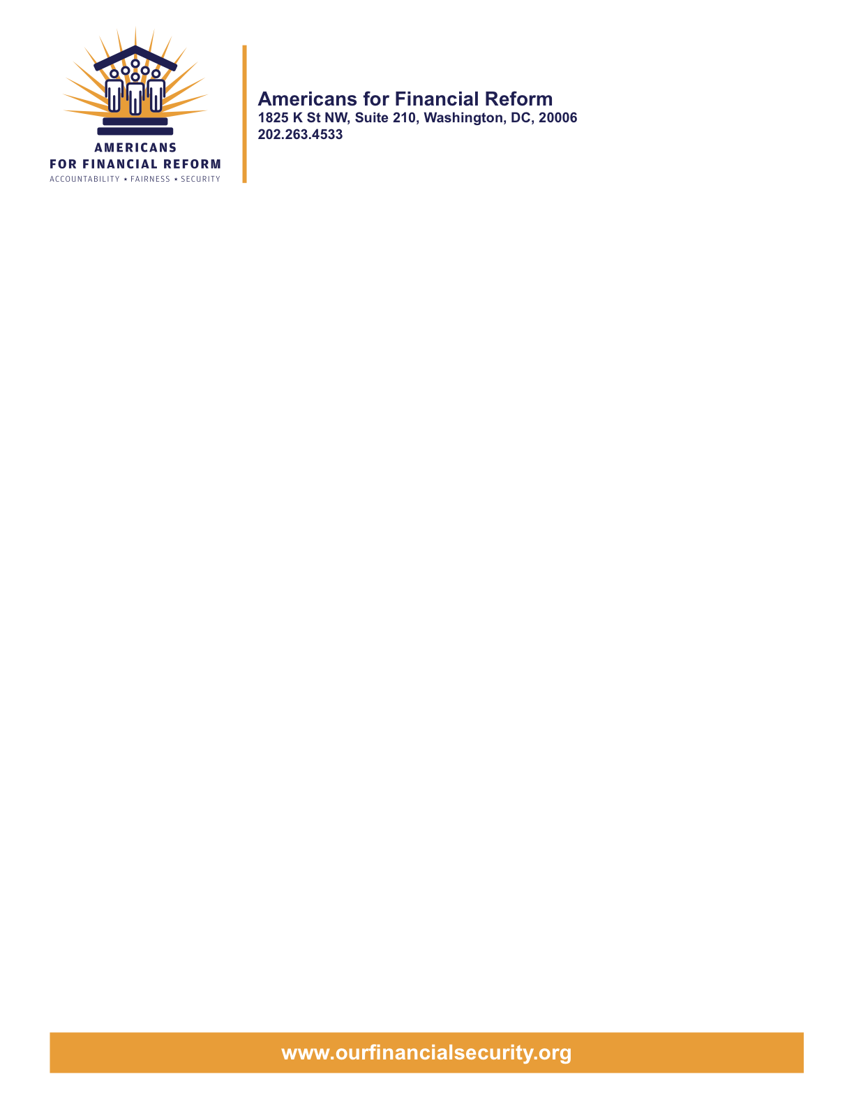

June 15, 2010

Chairman Christopher Dodd
United States Senate
Washington, DC 20510

Chairman Barney Frank
United States House of Representatives
Washington, DC 20510

Dear Conferee:

As you proceed with these final stages of writing the financial regulatory reform bill we ask you to work for and support a conference report which includes the strongest elements of the legislation developed in each chamber. Deregulation was a fundamental cause of the financial crisis that has cost more than 8 million jobs, along with trillions of dollars in lost wealth. The reckless and irresponsible behavior of the big Wall Street banks has done overwhelming harm, and we urge you to do everything possible to rewrite the rules so that Main Street’s interests come first.

In particular, we urge you to make sure that the legislation is strong in the following crucial ways.
- Protect Consumers. The new Consumer Financial Protection Bureau must have all the functional independence it needs, including a single director named by the President and approved by the Senate, and adequate protected funding. There should be no special carve outs from its authority for auto dealers or others, or limitation of enforcement to large entities. House provisions providing back up authority should be preserved, and Senate provisions that provide entities like payday lenders an unfair first look at regulations should be jettisoned. The final bill should also strengthen the Federal Trade Commission’s ability to protect the public as it retains authority in gaps not covered by the new bureau. Further, no preemption of state law should be allowed unless there is a substantive federal standard that would protect consumers.
- End the “Casino Economy.” The final bill must bring the derivatives market into the light of day and require the maximum possible portion of these trades to be cleared and exchange traded; it should preserve the Senate language, exempting legitimate commercial end users hedging commercial risk, and making it clear that financial firms cannot be exempted. CFTC Chairman Gary Gensler has estimated that the Senate bill would cover 90% of transactions, and the House bill would cover only 60%. The Senate bill also has vitally important provisions ending taxpayer subsidy of risky derivatives trades by requiring that they be separated from the business of commercial banking, and requiring swaps dealers to act in their customers’ interests when they market deals to cities, states, other public institutions and pension funds. These provisions should remain in the final bill. A technical change to make sure clearing and exchange trading requirements are fully enforceable is also crucial.

- Regulate managers of private equity funds. Comprehensive regulation of private investment funds, such as hedge funds and private equity, is essential to prevent the buildup of systemic risks and to protect investors. The final bill should include the stronger House language requiring managers of hedge funds and private equity funds to register with the SEC and giving the SEC authority to require hedge fund and private equity fund advisers to disclose information to investors and creditors.

- Reduce Systemic Risk by strengthening the ‘Volcker rule’ with the Merkley-Levin language, and avoid exceptions to the prohibition against banks investing in private equity and hedge funds. The final bill should retain the Speier Amendment leverage limit, and the Collins Amendment’s capital requirements for bank holding companies as well as banks, along with the important provisions in the Senate bill limiting interconnectedness. The stronger House language defining non-bank, systemically risky financial institutions is essential to closing the “shadow bank” loophole that led to hundreds of billions in bailouts. The legislation must also ensure that banks and speculators – not taxpayers – pay the costs when financial institutions fail.

- Protect investors by requiring all financial advisors to put their clients’ interest first and rejecting attempts to weaken accounting anti-fraud provisions. The House language establishing a fiduciary duty for broker dealers should be a part of the conference report. On the other hand, the House bill weakens existing protections against accounting fraud at roughly half of all public companies; the Senate bill does not include such a weakening provision and should prevail.

- Reform Bad Mortgage Lending Practices by creating strong, enforceable standards for home lending to protect American families’ largest investments – their homes – and to prevent lending abuses. The base text does a good job combining the best features of the House and Senate bills; The final bill should also include provisions that are only in the House bill to address the foreclosure crisis, including making TARP funds available to help unemployed homeowners stay in their homes.
- Reign in the credit rating agencies. The final bill must retain the Senate’s Franken amendment, the only provision in either bill that addresses the conflict of interest that led credit rating agencies to inflate the ratings of junk securities to win market share from the issuers who pick and pay them. The Franken amendment, passed by an overwhelming bipartisan vote in the Senate, would ensure that at least one of a security's credit ratings comes from a credit rating agency selected by an independent, investor-led board based on its record of accuracy and reliability. The stronger liability language in the House bill will also make the rating agencies more accountable to investors, and is consistent with the bill’s goal of reducing overreliance on ratings.

- Reform Federal Reserve governance and increase transparency. The final bill should include the Senate language that bars member banks from voting for regional Fed directors, and gives the President and the Senate the right to select the powerful New York Fed President. It should incorporate the House language that allows audits of the Fed on an ongoing basis, rather than only on a one-time basis.

- Retain Corporate Governance improvements. The final legislation should retain the important new tools for holding corporate directors accountable, including the stronger House language on executive compensation.

We appreciate the enormity of the task you face, and the tremendous work that members and staff have done in bringing the legislation this far. We look forward to working with you in these final weeks to pass legislation that holds Wall Street accountable, and helps put our economy back on a safer and fairer track.

Sincerely,

Americans for Financial Reform

CC: Members of the Financial Reform Conference Committee

Following are the partners of Americans for Financial Reform.

All the organizations support the overall principles of AFR and are working for an accountable, fair and secure financial system. Not all of these organizations work on all of the issues covered by the coalition or have signed on to every statement.

National Organizations
- A New Way Forward
- AARP
- Accountable America
- Adler and Colvin
- AFL-CIO
- AFSCME
- Alliance For Justice
- American Family Voices
- American Income Life Insurance
- Americans for Democratic Action, Inc.
- Americans for Fairness in Lending
- American Sustainable Business Council
- Americans United for Change
- Business for Shared Prosperity
- Calvert Asset Management Company, Inc.
- Campaign for America’s Future
- Campaign Money
- Center for Digital Democracy
- Center for Economic and Policy Research
- Center for Economic Progress
- Center for Responsible Lending
- Center for Justice and Democracy
- Center of Concern
- Change to Win
- Clean Yield Asset Management
- Coastal Enterprises Inc.
- Color of Change
- Common Cause
- Communications Workers of America
- Community Development Transportation Lending Services
- Community Law Center
- Consumer Action
- Consumer Association Council
- Consumers for Auto Safety and Reliability
- Consumer Federation of America
- Consumer Watchdog
- Consumers Union
- Corporation for Enterprise Development
- CREDO
- CTW Investment Group
- Demos
- Economic Policy Institute
- Essential Action
- Green America
- Greenlining Institute
- Good Business International
- Help Is On the Way, Inc
- HNMA Funding
- Home Actions
- Housing Counseling Services
- Information Press
- Institute for Global Communications
- Institute for Policy Studies: Global Economy Project
- International Brotherhood of Teamsters
- Institute of Women’s Policy Research
- Keystone Research Center
- Krull & Company
- Laborers’ International Union of North America
- Lake Research Partners
- Lawyers’ Committee for Civil Rights Under Law
- Leadership Conference on Civil Rights
- MoveOn.org Political Action
- NAACP
- NASCAT
- National Association of Consumer Advocates
- National Association of Investment Professionals
- National Association of Neighborhoods
- National Coalition for Asian Pacific American Community Development
- National Community Reinvestment Coalition
- National Consumer Law Center (on behalf of its low-income clients)
- National Consumers League
- National Council of La Raza
- National Fair Housing Alliance
- National Federation of Community Development Credit Unions
- National Housing Institute
- National Housing Trust
- National Housing Trust Community Development Fund
- National NeighborWorks Association
- National Peoples Action
- National Council of Womens Organizations
- National Worksright Institute
- Next Step
- OMB Watch
- Opportunity Finance Network
- Partners for the Common Good
- National People’s Action (NPA)
- PICO
- Progress Now Action
- Progressive States Network
- Poverty and Race Research Action Council
- Public Citizen
- Responsible Endowments Coalition
- Sargent Shriver Center on Poverty Law
- Scam Victims United
- SEIU
- Sojourners
- State Voices
- Taxpayer’s for Common Sense
- The Association for Housing and Neighborhood Development
- The Carrots and Sticks Project
- The Fuel Savers Club
- The Seminal
- UNET
- Union Plus
- United for a Fair Economy
- U.S. PIRG
- Unitarian Universalist for a Just Economic Community
- United Food and Commercial Workers
- United States Student Association
- USAction
- Veris Wealth Partners
- Veterans Chanmber of Commerce
- We The People Now
- Western States Center
- Woodstock Institute
- Working America
- World Business Academy
- World Privacy Forum

State Organizations
- 207 CCAG
- 9 to 5, the National Association of Working Women (CO)
- AARP Rhode Island
- Alaska PIRG
- Arizona PIRG
- Arizona Advocacy Network
- Arizonans for Responsible Lending
- Arkansas Community Organizations
- Arkansas Public Policy Panel
- Association for Neighborhood and Housing Development (NY)
- Audubon Partnership for Economic Development LDC (New York, NY)
- Aurora NAACP
- BAC Funding Consortium Inc. (Miami, FL)
- Beech Capital Venture Corporation (Philadelphia, PA)
- Bell Policy Center (CO)
- California PIRG
- California Reinvestment Coalition
- Center for Media and Democracy
- Center for NYC Neighborhoods
- Century Housing Corporation (Culver City, CA)
- Changer(NY)
- Chautauqua Home Rehabilitation and Improvement Corporation (NY)
- Chicago Community Loan Fund (Chicago, IL)
- Chicago Community Ventures (Chicago, IL)
- Chicago Consumer Coalition
- Citizen Potawatomi CDC (Shawnee, OK)
- Club Change of Martin County (Florida)
- Coalition on Homeless Housing in Ohio
- Coffee Party of Pensacola, Florida
- Coffee Party of Union Square, New York City
- Colorado AFL-CIO
- Colorado Center on Law and Policy
- Colorado Immigrants Rights Coalition
- Colorado PIRG
- Colorado Spring NAACP
- Community Action of Nebraska
- Community Capital Development
- Community Capital Fund (Bridgeport, CT)
- Community Capital of Maryland (Baltimore, MD)
- Community Development Financial Institution of the Tohono O’odham Nation (Sells, AZ)
- Community Redevelopment Loan and Investment Fund, (Atlanta, GA)
- Community Reinvestment Association of North Carolina
- Community Resource Group (Fayetteville, AR)
- Connecticut Association for Human Services
- Connecticut Citizen Action Group
- Connecticut PIRG
- Consumer Assistance Council
- Cooper Square Committee (New York, NY)
- Cooperative Fund of New England (Wilmington, NC)
- Corporacion de Desarrollo Economico de Ceiba (Ceiba, PR)
- CWA 7777 (CO)
- Delta Foundation, Inc. (Greenville, MS)
- Economic Opportunity Fund (EOF) (Philadelphia, PA)
- Empire Justice Center (NY)
- Enterprises, Inc., Berea KY
- Fair Housing Contact Service OH
- Federation of Appalachian Housing Enterprises, Inc. (Berea, KY)
- Fitness and Praise Youth Development, Inc. (Baton Rouge, LA)
- Florida Consumer Action Network
- Florida PIRG
- Forward Community Investments (Madison, WI)
- Funding Partners for Housing Solutions (Ft. Collins, CO)
- Georgia PIRG
- Grow Iowa Foundation (Greenfield, IA)
- Homewise, Inc. (Santa Fe, NM)
- Humanitas Community Development Corporation
- Idaho Chapter, National Association of Social Workers
- Idaho Community Action Network
- Idaho Nevada CDFI (Pocatello, ID)
- Illinois PIRG
- Impact Capital (Seattle, WA)
- Indiana PIRG
- Indiana University PIRG
- Information Press (CA)
- Iowa PIRG
- Iowa Citizens for Community Improvement
- JobStart Chautauqua, Inc. (Mayville, NY)
- Keystone Research Center
- La Casa Federal Credit Union (Newark, NJ)
- Low Income Investment Fund (San Francisco, CA)
- Long Island Housing Services NY
- MaineStream Finance (Bangor, ME)
- Maryland PIRG
- Massachusetts Consumers’ Coalition
- Massachusetts Fair Housing Center
- MASSPIRG
- Michigan PIRG
- Midland Community Development Corporation (Midland, TX)
- Midwest Minnesota Community Development Corporation (Detroit Lakes, MN)
- Mile High Community Loan Fund (Denver, CO)
- Missouri PIRG
- Montana Community Development Corporation (Missoula, MT)
- Montana PIRG
- Mortgage Recovery Service Center of L.A.
- Neighborhood Economic Development Advocacy Project
- New Hampshire PIRG
- New Jersey Community Capital (Trenton, NJ)
- New Jersey Citizen Action
- New Jersey PIRG
- New Mexico PIRG
- New York PIRG
- New York City AIDS Housing Network
- Next Step (MN)
- NOAH Community Development Fund, Inc. (Boston, MA)
- Nonprofit Finance Fund (New York, NY)
- Nonprofits Assistance Fund (Minneapolis, MN)
- North Carolina Association of Community Development Corporations
- North Carolina PIRG
- Northern Community Investment Corporation (St. Johnsbury, VT)
- Northside Community Development Fund (Pittsburgh, PA)
- Ohio Capital Corporation for Housing (Columbus, OH)
- Ohio PIRG
- Oregon State PIRG
- Our Oregon
- PennPIRG
- Piedmont Housing Alliance (Charlottesville, VA)
- Rhode Island PIRG
- Rights for All People
- The Rocky Mountain Peace and Justice Center
- Rural Community Assistance Corporation (West Sacramento, CA)
- Rural Organizing Project OR
- San Francisco Metropolitan Transportation Authority
- Seattle Economic Development Fund dba Community Capital Development
- SEIU Local 105 (Colorado)
- SEIU Rhode Island
- Siouxland Economic Development Corporation (Sioux City, IA)
- Southern Bancorp (Arkadelphia, AR)
- TexPIRG
- The Association for Housing and Neighborhood Development
- The Fair Housing Council of Central New York
- The Help Network
- The Loan Fund (Albuquerque, NM)
- Third Reconstruction Institute (NC)
- V-Family, Inc.
- Vermont PIRG
- Village Capital Corporation (Cleveland, OH)
- Virginia Citizens Consumer Council
- Virginia Poverty Law Center
- War on Poverty – Florida
- Washington Community Action Network
- WashPIRG
- Westchester Residential Oppurtunities Inc. NY
- Wigamig Owners Loan Fund, Inc. (Lac du Flambeau, WI)
- WISPIRG

Businesses

- Blu
- Bowden-Gill Environmental
- Community MedPAC
- Diversified Env. Planning
- Hayden & Craig, PLLC\
- The Holographic Repatterning Institute at Austin
- Mid City Animal Hospital (Phoenix, AZ)
- UNET

