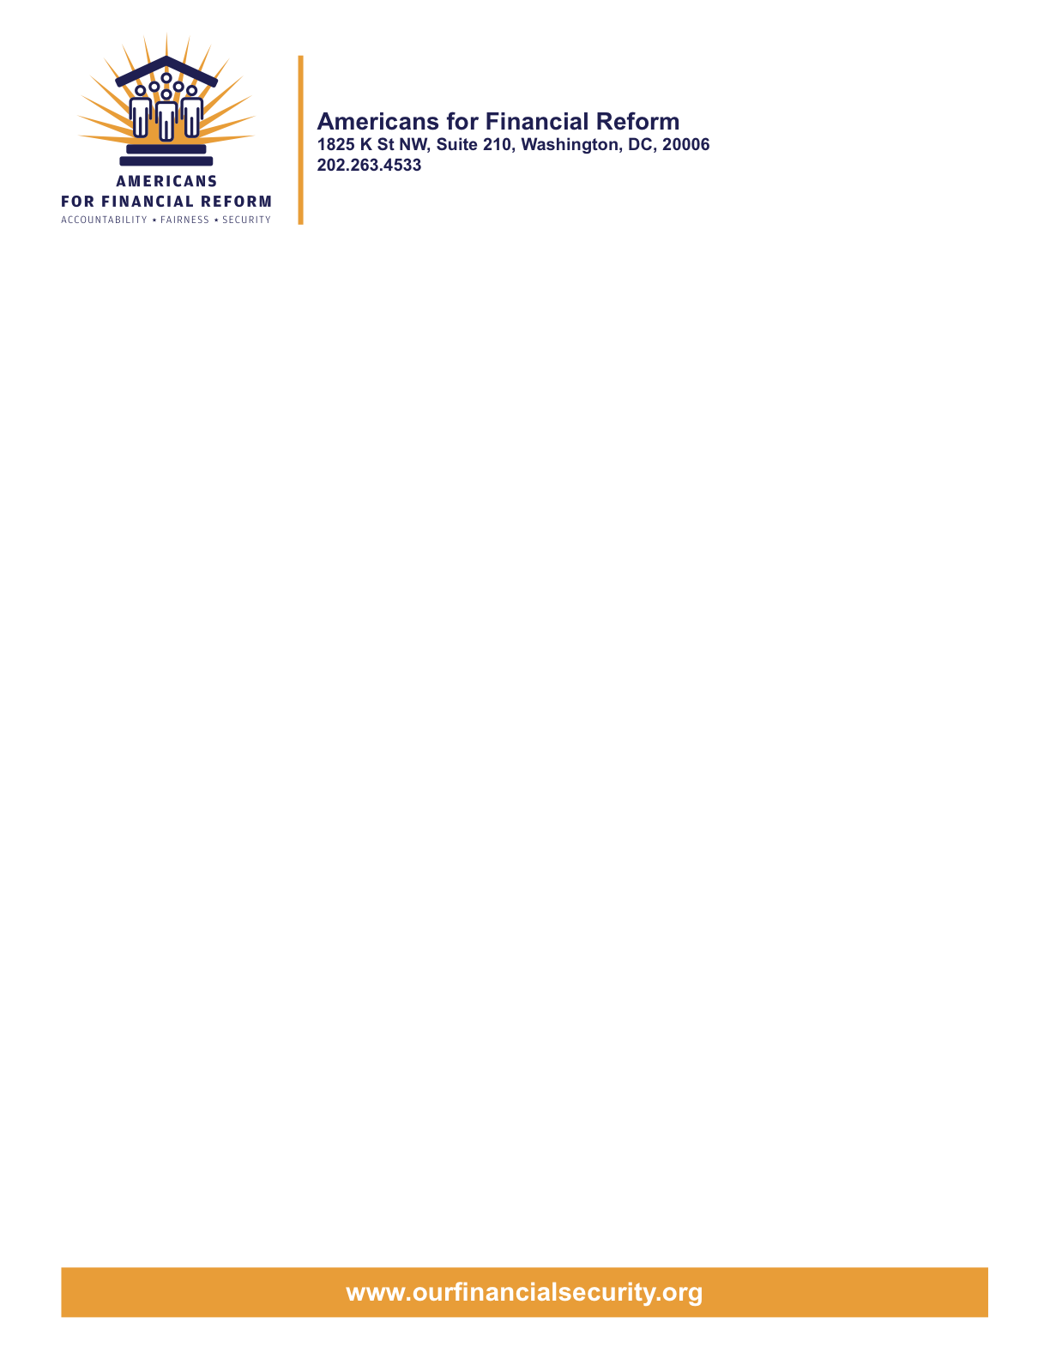

June 15, 2010

Chairman Christopher Dodd
United States Senate
Washington, DC 20510

Chairman Barney Frank
United States House of Representatives
Washington, DC 20510

Americans for Financial Reform supports strong investor protections
in the final conference report on H.R. 4173

Dear Conferee,

On behalf of Americans for Financial Reform (AFR), an unprecedented coalition of more than 250 national, state and local groups that have come together to reform the financial industry, I am writing to highlight our priorities with respect to investor protection and corporate governance reforms in the Wall Street reform bill. Members of our coalition include consumer, civil rights, investor, retiree, community, labor, religious and business groups as well as Nobel Prize-winning economists.

It is our understanding that the investor protection and corporate governance provisions may be considered by conferees as early as Wednesday of this week. Below are AFRs priorities for those issues where there are differences between the House and Senate bills on issues of importance to retail investors.

Impose a Fiduciary Duty on Brokers (retain House language, eliminate Senate provision)
Brokers are free to offer the same services as investment advisers without the same obligation to act in the best interests of their clients, leaving investors vulnerable to misleading and abusive practices. The House bill addresses this problem by requiring the Securities and Exchange Commission to (SEC) adopt rules holding brokers to a fiduciary duty when they give investment advice to retail investors. The Senate bill requires the SEC to restudy an issue it has already studied extensively and denies it the authority it would need to raise the standard for brokers, delaying indefinitely any solution to a known and pressing problem. AFR supports inclusion of the House language in the final bill.

Create an Office of Investor Advocate within the SEC (retain Senate language, eliminate House ombudsman provision)
The voices of investors can be all too easily drowned out by industry in debates over important policies that affect their interests. The Senate bill would create a powerful new Office of Investor Advocate within the SEC to ensure that investor interests are given due consideration in SEC policy debates. In addition, the office would help investors resolve problems that may arise in their dealings with the agency. A House ombudsman provision provides the office with less authority and, because it is not focused on helping investors, could be hijacked by industry interests, becoming another back-door way for industry to influence the agency.

Improve Investor Disclosures (Retain Senate language on pre-sale disclosure and financial literacy study)
Though both the House and Senate bills include provisions authorizing the SEC to adopt pre-sale disclosure rules, the Senate language is preferable. Particularly when combined with language in the Senate bill requiring a study of investor financial literacy and information needs, it provides the framework for significant improvements in investor disclosures. AFR also supports the House bill provision that authorizes the SEC to use monies in the Investor Protection Fund it maintains to fund investor education initiatives. The Senate bill does not contain a similar authorization.

Strengthen SEC Enforcement Tools (Retain House provisions on SEC authority, Senate language on self-funding)
The House bill includes a number of provisions missing from the Senate bill to enhance the SEC’s enforcement authority. These include provisions to provide the agency with clear authority to go after those who aid and abet violations, for example, and to prevent bad actors from evading regulators by operating outside U.S. borders. The Senate bill provides a self-funding mechanism to ensure that the agency has adequate resources. Together, these provisions would provide the agency with the authority and resources it needs to fulfill its investor protection mandate.

Maintain protections against accounting fraud (Retain Senate silence on Section 404(b) of the Sarbanes-Oxley Act, eliminate House language)
In a major set-back for investors, the House bill weakened existing protections against accounting fraud at roughly half of all public companies. Ignoring extensive evidence that the requirements are both affordable and effective, the House bill would permanently exempt companies with under $75 million in market capitalization from Section 404(b) of the Sarbanes-Oxley Act. It would be unfortunate if the investor protections adopted in the wake of the last major financial crisis were weakened in a bill that is designed to respond to the current financial crisis.

* * * *

By combining the best aspects of the House and Senate bills, Congress could strengthen investor protections and enhance the effectiveness of the Securities and Exchange Commission (SEC). We urge you to do so.

For more information, please contact Maureen Thompson at 703-276-3251 or mthompson@hastinggroup.com.

Sincerely,

Americans for Financial Reform

CC: Members of the Financial Reform Conference Committee

Following are the partners of Americans for Financial Reform.

All the organizations support the overall principles of AFR and are working for an accountable, fair and secure financial system. Not all of these organizations work on all of the issues covered by the coalition or have signed on to every statement.

National Organizations
- A New Way Forward
- AARP
- Accountable America
- Adler and Colvin
- AFL-CIO
- AFSCME
- Alliance For Justice
- American Family Voices
- American Income Life Insurance
- Americans for Democratic Action, Inc.
- Americans for Fairness in Lending
- American Sustainable Business Council
- Americans United for Change
- Business for Shared Prosperity
- Calvert Asset Management Company, Inc.
- Campaign for America’s Future
- Campaign Money
- Center for Digital Democracy
- Center for Economic and Policy Research
- Center for Economic Progress
- Center for Responsible Lending
- Center for Justice and Democracy
- Center of Concern
- Change to Win
- Clean Yield Asset Management
- Coastal Enterprises Inc.
- Color of Change
- Common Cause
- Communications Workers of America
- Community Development Transportation Lending Services
- Community Law Center
- Consumer Action
- Consumer Association Council
- Consumers for Auto Safety and Reliability
- Consumer Federation of America
- Consumer Watchdog
- Consumers Union
- Corporation for Enterprise Development
- CREDO
- CTW Investment Group
- Demos
- Economic Policy Institute
- Essential Action
- Green America
- Greenlining Institute
- Good Business International
- Help Is On the Way, Inc
- HNMA Funding
- Home Actions
- Housing Counseling Services
- Information Press
- Institute for Global Communications
- Institute for Policy Studies: Global Economy Project
- International Brotherhood of Teamsters
- Institute of Women’s Policy Research
- Keystone Research Center
- Krull & Company
- Laborers’ International Union of North America
- Lake Research Partners
- Lawyers’ Committee for Civil Rights Under Law
- Leadership Conference on Civil Rights
- MoveOn.org Political Action
- NAACP
- NASCAT
- National Association of Consumer Advocates
- National Association of Investment Professionals
- National Association of Neighborhoods
- National Coalition for Asian Pacific American Community Development
- National Community Reinvestment Coalition
- National Consumer Law Center (on behalf of its low-income clients)
- National Consumers League
- National Council of La Raza
- National Fair Housing Alliance
- National Federation of Community Development Credit Unions
- National Housing Institute
- National Housing Trust
- National Housing Trust Community Development Fund
- National NeighborWorks Association
- National Peoples Action
- National Council of Womens Organizations
- National Worksright Institute
- Next Step
- OMB Watch
- Opportunity Finance Network
- Partners for the Common Good
- National People’s Action (NPA)
- PICO
- Progress Now Action
- Progressive States Network
- Poverty and Race Research Action Council
- Public Citizen
- Responsible Endowments Coalition
- Sargent Shriver Center on Poverty Law
- Scam Victims United
- SEIU
- Sojourners
- State Voices
- Taxpayer’s for Common Sense
- The Association for Housing and Neighborhood Development
- The Carrots and Sticks Project
- The Fuel Savers Club
- The Seminal
- UNET
- Union Plus
- United for a Fair Economy
- U.S. PIRG
- Unitarian Universalist for a Just Economic Community
- United Food and Commercial Workers
- United States Student Association
- USAction
- Veris Wealth Partners
- Veterans Chanmber of Commerce
- We The People Now
- Western States Center
- Woodstock Institute
- Working America
- World Business Academy
- World Privacy Forum

State Organizations
- 207 CCAG
- 9 to 5, the National Association of Working Women (CO)
- AARP Rhode Island
- Alaska PIRG
- Arizona PIRG
- Arizona Advocacy Network
- Arizonans for Responsible Lending
- Arkansas Community Organizations
- Arkansas Public Policy Panel
- Association for Neighborhood and Housing Development (NY)
- Audubon Partnership for Economic Development LDC (New York, NY)
- Aurora NAACP
- BAC Funding Consortium Inc. (Miami, FL)
- Beech Capital Venture Corporation (Philadelphia, PA)
- Bell Policy Center (CO)
- California PIRG
- California Reinvestment Coalition
- Center for Media and Democracy
- Center for NYC Neighborhoods
- Century Housing Corporation (Culver City, CA)
- Changer(NY)
- Chautauqua Home Rehabilitation and Improvement Corporation (NY)
- Chicago Community Loan Fund (Chicago, IL)
- Chicago Community Ventures (Chicago, IL)
- Chicago Consumer Coalition
- Citizen Potawatomi CDC (Shawnee, OK)
- Club Change of Martin County (Florida)
- Coalition on Homeless Housing in Ohio
- Coffee Party of Pensacola, Florida
- Coffee Party of Union Square, New York City
- Colorado AFL-CIO
- Colorado Center on Law and Policy
- Colorado Immigrants Rights Coalition
- Colorado PIRG
- Colorado Spring NAACP
- Community Action of Nebraska
- Community Capital Development
- Community Capital Fund (Bridgeport, CT)
- Community Capital of Maryland (Baltimore, MD)
- Community Development Financial Institution of the Tohono O’odham Nation (Sells, AZ)
- Community Redevelopment Loan and Investment Fund, (Atlanta, GA)
- Community Reinvestment Association of North Carolina
- Community Resource Group (Fayetteville, AR)
- Connecticut Association for Human Services
- Connecticut Citizen Action Group
- Connecticut PIRG
- Consumer Assistance Council
- Cooper Square Committee (New York, NY)
- Cooperative Fund of New England (Wilmington, NC)
- Corporacion de Desarrollo Economico de Ceiba (Ceiba, PR)
- CWA 7777 (CO)
- Delta Foundation, Inc. (Greenville, MS)
- Economic Opportunity Fund (EOF) (Philadelphia, PA)
- Empire Justice Center (NY)
- Enterprises, Inc., Berea KY
- Fair Housing Contact Service OH
- Federation of Appalachian Housing Enterprises, Inc. (Berea, KY)
- Fitness and Praise Youth Development, Inc. (Baton Rouge, LA)
- Florida Consumer Action Network
- Florida PIRG
- Forward Community Investments (Madison, WI)
- Funding Partners for Housing Solutions (Ft. Collins, CO)
- Georgia PIRG
- Grow Iowa Foundation (Greenfield, IA)
- Homewise, Inc. (Santa Fe, NM)
- Humanitas Community Development Corporation
- Idaho Chapter, National Association of Social Workers
- Idaho Community Action Network
- Idaho Nevada CDFI (Pocatello, ID)
- Illinois PIRG
- Impact Capital (Seattle, WA)
- Indiana PIRG
- Indiana University PIRG
- Information Press (CA)
- Iowa PIRG
- Iowa Citizens for Community Improvement
- JobStart Chautauqua, Inc. (Mayville, NY)
- Keystone Research Center
- La Casa Federal Credit Union (Newark, NJ)
- Low Income Investment Fund (San Francisco, CA)
- Long Island Housing Services NY
- MaineStream Finance (Bangor, ME)
- Maryland PIRG
- Massachusetts Consumers’ Coalition
- Massachusetts Fair Housing Center
- MASSPIRG
- Michigan PIRG
- Midland Community Development Corporation (Midland, TX)
- Midwest Minnesota Community Development Corporation (Detroit Lakes, MN)
- Mile High Community Loan Fund (Denver, CO)
- Missouri PIRG
- Montana Community Development Corporation (Missoula, MT)
- Montana PIRG
- Mortgage Recovery Service Center of L.A.
- Neighborhood Economic Development Advocacy Project
- New Hampshire PIRG
- New Jersey Community Capital (Trenton, NJ)
- New Jersey Citizen Action
- New Jersey PIRG
- New Mexico PIRG
- New York PIRG
- New York City AIDS Housing Network
- Next Step (MN)
- NOAH Community Development Fund, Inc. (Boston, MA)
- Nonprofit Finance Fund (New York, NY)
- Nonprofits Assistance Fund (Minneapolis, MN)
- North Carolina Association of Community Development Corporations
- North Carolina PIRG
- Northern Community Investment Corporation (St. Johnsbury, VT)
- Northside Community Development Fund (Pittsburgh, PA)
- Ohio Capital Corporation for Housing (Columbus, OH)
- Ohio PIRG
- Oregon State PIRG
- Our Oregon
- PennPIRG
- Piedmont Housing Alliance (Charlottesville, VA)
- Rhode Island PIRG
- Rights for All People
- The Rocky Mountain Peace and Justice Center
- Rural Community Assistance Corporation (West Sacramento, CA)
- Rural Organizing Project OR
- San Francisco Metropolitan Transportation Authority
- Seattle Economic Development Fund dba Community Capital Development
- SEIU Local 105 (Colorado)
- SEIU Rhode Island
- Siouxland Economic Development Corporation (Sioux City, IA)
- Southern Bancorp (Arkadelphia, AR)
- TexPIRG
- The Association for Housing and Neighborhood Development
- The Fair Housing Council of Central New York
- The Help Network
- The Loan Fund (Albuquerque, NM)
- Third Reconstruction Institute (NC)
- V-Family, Inc.
- Vermont PIRG
- Village Capital Corporation (Cleveland, OH)
- Virginia Citizens Consumer Council
- Virginia Poverty Law Center
- War on Poverty – Florida
- Washington Community Action Network
- WashPIRG
- Westchester Residential Oppurtunities Inc. NY
- Wigamig Owners Loan Fund, Inc. (Lac du Flambeau, WI)
- WISPIRG

Businesses

- Blu
- Bowden-Gill Environmental
- Community MedPAC
- Diversified Env. Planning
- Hayden & Craig, PLLC\
- The Holographic Repatterning Institute at Austin
- Mid City Animal Hospital (Phoenix, AZ)
- UNET

