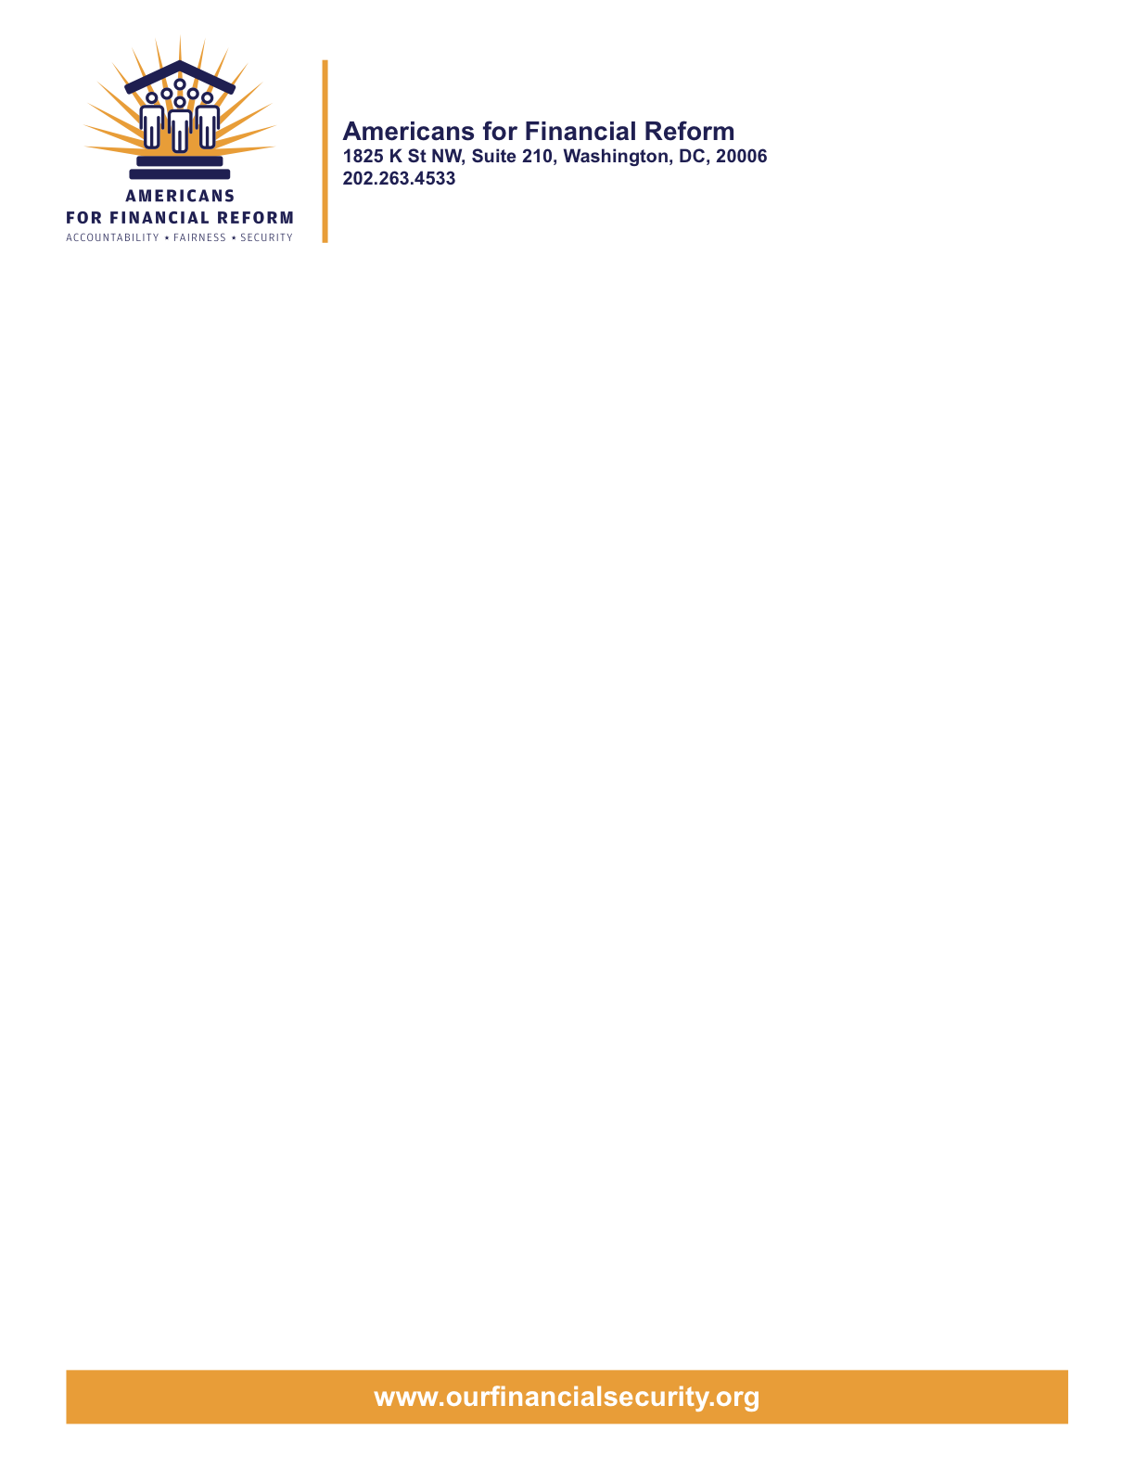

June 27, 2010

United States House of Representatives
Washington, DC 20515

Re: Support for Passage of the Dodd/Frank Reform Compromise
Dear Representatives:
Americans for Financial Reform applauds Congress, especially Chairman Dodd and Chairman Frank, for moving forward with such significant legislation reforming Wall Street and holding the big banks accountable.
This Dodd-Frank Act represents meaningful progress from the depths of our financial crisis. The forces of the big banks were all aligned against Americans yet Main Street was able to win important battles.
We see landmark legislation when it comes to consumer protection, offering all of us an independent watchdog on our side. For the first time the $600 trillion derivatives market will be transparent and have to maintain capital to back up its bets – a move that was once thought unachievable. The adoption of the Volcker Rule represents a major change of direction, stopping banks from using insured deposits to support speculative activity. There are big steps in the right direction when it comes to registration of hedge funds and private equity, as well as improved protections for investors.
Americans for Financial Reform call on Members of Congress to support this bill and move to final passage immediately. This is a big step forward, and a first step toward the full array of changes we need to make sure Wall Street serves Main Street and not vice versa.
Below are some of the bill’s provisions that will improve the financial system for all Americans.
Landmark consumer protection: Consumers will now have an independent advocate on their side to prevent tricks and traps related to mortgages, payday loans and checking accounts. Credit cards and mortgages will offer terms in language we can all understand. It will also offer help for those abused by predatory lenders and limit banks from charging businesses hefty fees for debit-card purchases.
Shining Light on Shadow Markets: The $600 trillion derivatives market will now operate in the open, so regulators can catch problems – like the credit default swaps that brought down the economy – before they happen. Most deals will have to be backed up by a separate clearinghouse and traded on public exchanges. The participants will have to actually prove they have the money to cover their bets. In addition, hedge funds and private equity funds will have to register with the SEC and have regulators watching over them.
Preventing taxpayer bailouts: The government will have the authority to step in and safely shut down any failing financial firm, not just banks, instead of propping them up with taxpayer money. One regulator will be in charge of watching for emerging threats to the whole financial system – and will have the tools and authority to ensure those threats are actually visible.
Reining in the Wall Street Casino: Banks will be barred from gambling for their own account with our money. Banks will have to separate some of their derivatives trading operations into affiliates.
Mortgage reforms: For the first time lenders are prohibited from making loans that borrowers cannot repay, and banned from receiving kickbacks for steering people into high rate loans when they qualify for lower rates. Consumers are protected from abusive loan fees and penalties for prepaying.
Strong investor protections: Shareholders will have new tools to hold corporate boards and management accountable, including a voice on executive compensation decisions and an enhanced ability to nominate and elect corporate directors. Brokers will have to act in the best interests of their customers.
Holding Credit Rating Agencies Accountable: Credit rating agencies will no longer have a vested financial interest in giving high ratings to risky investments. Better controls will hold rating agencies accountable for the reliability of their reporting. Investors will be able to sue credit rating agencies who slap a high rating on a risky investment.
Opening the Fed’s books: The Fed’s emergency lending programs from the financial crisis will be audited to see where the money went. The Fed will also have to disclose loans it makes to banks through its discount window.
Banks Pay Up. The largest financial firms have to pay $19 billion to ensure oversight to prevent another financial crisis.
Americans for Financial Reform urges Members of Congress to vote for final passage this week. Those who vote against this bill and prevent the American people from having our voice heard, are siding with Wall Street and their interests. Nearly two years have passed since financial crisis hit in September 2008; the Dodd-Frank Act’s landmark reforms need to be implemented immediately in order to protect Americans and create a more sustainable financial system.

For more information, please contact Lisa Donner, 202-263-4544 or lisa.donner@gmail.com

Sincerely,

Americans for Financial Reform

Following are the partners of Americans for Financial Reform.

All the organizations support the overall principles of AFR and are working for an accountable, fair and secure financial system. Not all of these organizations work on all of the issues covered by the coalition or have signed on to every statement.

National Organizations
- A New Way Forward
- AARP
- Accountable America
- Adler and Colvin
- AFL-CIO
- AFSCME
- Alliance For Justice
- American Family Voices
- American Income Life Insurance
- Americans for Democratic Action, Inc.
- Americans for Fairness in Lending
- American Sustainable Business Council
- Americans United for Change
- Business for Shared Prosperity
- Calvert Asset Management Company, Inc.
- Campaign for America’s Future
- Campaign Money
- Center for Digital Democracy
- Center for Economic and Policy Research
- Center for Economic Progress
- Center for Responsible Lending
- Center for Justice and Democracy
- Center of Concern
- Change to Win
- Clean Yield Asset Management
- Coastal Enterprises Inc.
- Color of Change
- Common Cause
- Communications Workers of America
- Community Development Transportation Lending Services
- Community Law Center
- Consumer Action
- Consumer Association Council
- Consumers for Auto Safety and Reliability
- Consumer Federation of America
- Consumer Watchdog
- Consumers Union
- Corporation for Enterprise Development
- CREDO
- CTW Investment Group
- Demos
- Economic Policy Institute
- Essential Action
- Green America
- Greenlining Institute
- Good Business International
- Help Is On the Way, Inc
- HNMA Funding
- Home Actions
- Housing Counseling Services
- Information Press
- Institute for Global Communications
- Institute for Policy Studies: Global Economy Project
- International Brotherhood of Teamsters
- Institute of Women’s Policy Research
- Keystone Research Center
- Krull & Company
- Laborers’ International Union of North America
- Lake Research Partners
- Lawyers’ Committee for Civil Rights Under Law
- Leadership Conference on Civil Rights
- MoveOn.org Political Action
- NAACP
- NASCAT
- National Association of Consumer Advocates
- National Association of Investment Professionals
- National Association of Neighborhoods
- National Coalition for Asian Pacific American Community Development
- National Community Reinvestment Coalition
- National Consumer Law Center (on behalf of its low-income clients)
- National Consumers League
- National Council of La Raza
- National Fair Housing Alliance
- National Federation of Community Development Credit Unions
- National Housing Institute
- National Housing Trust
- National Housing Trust Community Development Fund
- National NeighborWorks Association
- National Peoples Action
- National Council of Womens Organizations
- National Worksright Institute
- Next Step
- OMB Watch
- Opportunity Finance Network
- Partners for the Common Good
- National People’s Action (NPA)
- PICO
- Progress Now Action
- Progressive States Network
- Poverty and Race Research Action Council
- Public Citizen
- Responsible Endowments Coalition
- Sargent Shriver Center on Poverty Law
- Scam Victims United
- SEIU
- Sojourners
- State Voices
- Taxpayer’s for Common Sense
- The Association for Housing and Neighborhood Development
- The Carrots and Sticks Project
- The Fuel Savers Club
- The Seminal
- UNET
- Union Plus
- United for a Fair Economy
- U.S. PIRG
- Unitarian Universalist for a Just Economic Community
- United Food and Commercial Workers
- United States Student Association
- USAction
- Veris Wealth Partners
- Veterans Chanmber of Commerce
- We The People Now
- Western States Center
- Woodstock Institute
- Working America
- World Business Academy
- World Privacy Forum

State Organizations
- 207 CCAG
- 9 to 5, the National Association of Working Women (CO)
- AARP Rhode Island
- Alaska PIRG
- Arizona PIRG
- Arizona Advocacy Network
- Arizonans for Responsible Lending
- Arkansas Community Organizations
- Arkansas Public Policy Panel
- Association for Neighborhood and Housing Development (NY)
- Audubon Partnership for Economic Development LDC (New York, NY)
- Aurora NAACP
- BAC Funding Consortium Inc. (Miami, FL)
- Beech Capital Venture Corporation (Philadelphia, PA)
- Bell Policy Center (CO)
- California PIRG
- California Reinvestment Coalition
- Center for Media and Democracy
- Center for NYC Neighborhoods
- Century Housing Corporation (Culver City, CA)
- Changer(NY)
- Chautauqua Home Rehabilitation and Improvement Corporation (NY)
- Chicago Community Loan Fund (Chicago, IL)
- Chicago Community Ventures (Chicago, IL)
- Chicago Consumer Coalition
- Citizen Potawatomi CDC (Shawnee, OK)
- Club Change of Martin County (Florida)
- Coalition on Homeless Housing in Ohio
- Coffee Party of Pensacola, Florida
- Coffee Party of Union Square, New York City
- Colorado AFL-CIO
- Colorado Center on Law and Policy
- Colorado Immigrants Rights Coalition
- Colorado PIRG
- Colorado Spring NAACP
- Community Action of Nebraska
- Community Capital Development
- Community Capital Fund (Bridgeport, CT)
- Community Capital of Maryland (Baltimore, MD)
- Community Development Financial Institution of the Tohono O’odham Nation (Sells, AZ)
- Community Redevelopment Loan and Investment Fund, (Atlanta, GA)
- Community Reinvestment Association of North Carolina
- Community Resource Group (Fayetteville, AR)
- Connecticut Association for Human Services
- Connecticut Citizen Action Group
- Connecticut PIRG
- Consumer Assistance Council
- Cooper Square Committee (New York, NY)
- Cooperative Fund of New England (Wilmington, NC)
- Corporacion de Desarrollo Economico de Ceiba (Ceiba, PR)
- CWA 7777 (CO)
- Delta Foundation, Inc. (Greenville, MS)
- Economic Opportunity Fund (EOF) (Philadelphia, PA)
- Empire Justice Center (NY)
- Enterprises, Inc., Berea KY
- Fair Housing Contact Service OH
- Federation of Appalachian Housing Enterprises, Inc. (Berea, KY)
- Fitness and Praise Youth Development, Inc. (Baton Rouge, LA)
- Florida Consumer Action Network
- Florida PIRG
- Forward Community Investments (Madison, WI)
- Funding Partners for Housing Solutions (Ft. Collins, CO)
- Georgia PIRG
- Grow Iowa Foundation (Greenfield, IA)
- Homewise, Inc. (Santa Fe, NM)
- Humanitas Community Development Corporation
- Idaho Chapter, National Association of Social Workers
- Idaho Community Action Network
- Idaho Nevada CDFI (Pocatello, ID)
- Illinois PIRG
- Impact Capital (Seattle, WA)
- Indiana PIRG
- Indiana University PIRG
- Information Press (CA)
- Iowa PIRG
- Iowa Citizens for Community Improvement
- JobStart Chautauqua, Inc. (Mayville, NY)
- Keystone Research Center
- La Casa Federal Credit Union (Newark, NJ)
- Low Income Investment Fund (San Francisco, CA)
- Long Island Housing Services NY
- MaineStream Finance (Bangor, ME)
- Maryland PIRG
- Massachusetts Consumers’ Coalition
- Massachusetts Fair Housing Center
- MASSPIRG
- Michigan PIRG
- Midland Community Development Corporation (Midland, TX)
- Midwest Minnesota Community Development Corporation (Detroit Lakes, MN)
- Mile High Community Loan Fund (Denver, CO)
- Missouri PIRG
- Montana Community Development Corporation (Missoula, MT)
- Montana PIRG
- Mortgage Recovery Service Center of L.A.
- Neighborhood Economic Development Advocacy Project
- New Hampshire PIRG
- New Jersey Community Capital (Trenton, NJ)
- New Jersey Citizen Action
- New Jersey PIRG
- New Mexico PIRG
- New York PIRG
- New York City AIDS Housing Network
- Next Step (MN)
- NOAH Community Development Fund, Inc. (Boston, MA)
- Nonprofit Finance Fund (New York, NY)
- Nonprofits Assistance Fund (Minneapolis, MN)
- North Carolina Association of Community Development Corporations
- North Carolina PIRG
- Northern Community Investment Corporation (St. Johnsbury, VT)
- Northside Community Development Fund (Pittsburgh, PA)
- Ohio Capital Corporation for Housing (Columbus, OH)
- Ohio PIRG
- Oregon State PIRG
- Our Oregon
- PennPIRG
- Piedmont Housing Alliance (Charlottesville, VA)
- Rhode Island PIRG
- Rights for All People
- The Rocky Mountain Peace and Justice Center
- Rural Community Assistance Corporation (West Sacramento, CA)
- Rural Organizing Project OR
- San Francisco Metropolitan Transportation Authority
- Seattle Economic Development Fund dba Community Capital Development
- SEIU Local 105 (Colorado)
- SEIU Rhode Island
- Siouxland Economic Development Corporation (Sioux City, IA)
- Southern Bancorp (Arkadelphia, AR)
- TexPIRG
- The Association for Housing and Neighborhood Development
- The Fair Housing Council of Central New York
- The Help Network
- The Loan Fund (Albuquerque, NM)
- Third Reconstruction Institute (NC)
- V-Family, Inc.
- Vermont PIRG
- Village Capital Corporation (Cleveland, OH)
- Virginia Citizens Consumer Council
- Virginia Poverty Law Center
- War on Poverty – Florida
- Washington Community Action Network
- WashPIRG
- Westchester Residential Oppurtunities Inc. NY
- Wigamig Owners Loan Fund, Inc. (Lac du Flambeau, WI)
- WISPIRG

Businesses

- Blu
- Bowden-Gill Environmental
- Community MedPAC
- Diversified Env. Planning
- Hayden & Craig, PLLC\
- The Holographic Repatterning Institute at Austin
- Mid City Animal Hospital (Phoenix, AZ)
- UNET

