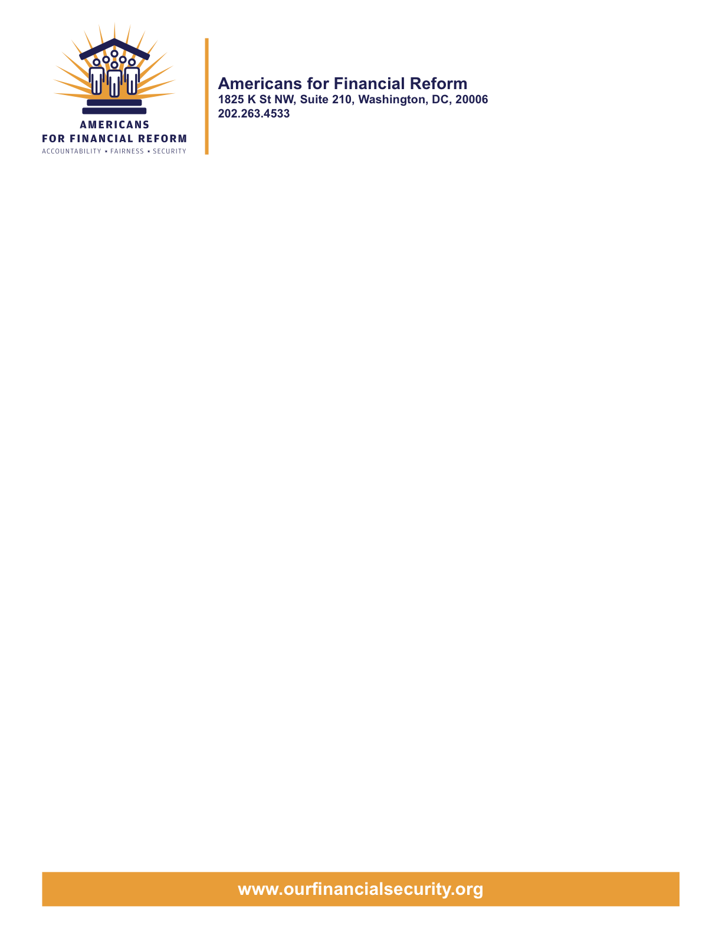

June 22, 2010
The Honorable Christopher Dodd
United States Senate
Washington, DC 20510

The Honorable Barney Frank
United States House of Representatives
Washington, DC 20510
Re: AFR positions on proposed House offer on Title XIV
We write on behalf of Americans for Financial Reform regarding the proposed House Conference offer on Title XIV of the financial reform bill, relating to the Mortgage Reform and Anti-Predatory Lending Act. We support House offer #1, #2, and #3 to Title XIV, including the $3 billion fund to assist homeowners facing foreclosure due to unemployment or medical debt; the authorization of funding for nonprofit lawyers assisting homeowners facing foreclosure; and additional funding for the Neighborhood Stabilization Program to support state and local efforts to purchase and redevelop foreclosed and abandoned homes.
1) Assistance for Unemployed Homeowners: This provision could help many hundreds of thousands of homeowners prevent needless foreclosures due to temporary unemployment and fill a major gap in current foreclosure prevention efforts.
Unemployment is now the leading cause for delinquency for families facing foreclosure. A recent study by NeighborWorks looking at reasons that people are falling behind on their mortgages found that 58% of delinquent homeowners were behind due to job loss. This has had a particular impact on minority communities who face high rates of joblessness.
The Obama Administration’s foreclosure prevention program, Making Home Affordable, was designed to assist homeowners in costly subprime loans. It has had mixed success dealing with that population. However, the only provision focused on the unemployed guarantees a mere three month’s forbearance to those without jobs. This is totally inadequate and offers homeowners little more than is already the practice in the private market.
Long term unemployment is at historic highs in the nation with the average worker out of work for eight months and with 6.7 million or 45% of the jobless classified as long term unemployed. Prime foreclosure rates have risen steadily as a result. Thus, we currently have a foreclosure prevention program which effectively leaves 58% of threatened homeowners (the unemployed) with no useful assistance.
The House bill includes a provision in Title VIII that creates a program to assist unemployed homeowners facing foreclosure. It is funded by $3 billion in TARP funds already allocated for foreclosure prevention activities. These funds would enable HUD to provide short term bridge loans of up to 24 months to laid off homeowners to give them time to become reemployed.
2) Legal Aid Foreclosure Prevention: It is well known that homeowners who have legal representation have a much better chance of successfully navigating the HAMP foreclosure prevention program, which is the main government foreclosure-prevention effort. Yet funding for non-profit legal aid attorneys is becoming increasingly scarce even as the demand continues to escalate. An authorization of $35 million – while admittedly a very small sum compared to the HAMP program funding or other economic recovery efforts – can be leveraged significantly by the legal aid community to make a real difference for homeowners.

3) Neighborhood Stabilization Program: Although we wish it had been otherwise, foreclosures have already devastated many neighborhoods, and significant investment is now required to bring back affordable housing and healthy neighborhoods.

We appreciate your interest in our views. Thank you again for your commitment to crafting strong and effective foreclosure prevention measures within the new legislation.

For more information, please contact John Dodds 215-557-0822 ext. 102 orjdoddspup@aol.com, Lew Finfer, lewfinfer@gmail.com, (617) 822-1499 and Graciela Aponte gaponte@nclr.com (202) 776-1578.

Sincerely,

Americans for Financial Reform

American Federation of Labor-Congress of Industrial
Organizations, AFL-CIO
Americans for Financial Reform
Campaign for Community Change
Center for Responsible Lending
Consumer Action
Consumer Federation of America
International Union, United Automobile, Aerospace & Agricultural Implement Workers of America, UAW
National Association of Consumer Advocates
National Association of Consumer Bankruptcy Attorneys
National Community Reinvestment Coalition
National Consumer Law Center (on behalf of its low-income clients)
National Council of La Raza
National Employment Law Project
National People’s Action
PICO National Network
Service Employees International Union
United Food and Commercial Workers

Brockton Interfaith Community, MA
Brooklyn Congregations United
Catholic Social Services, Philadelphia
Center for New York City Neighborhoods
Church of the Advocate, Philadelphia
Citizens Action of Wisconsin
Community Legal Services of Philadelphia
Connecticut Fair Housing Center
Consumer Credit Counseling Service of Delaware Valley
Georgia Citizens Coalition on Hunger
Housing Alliance of Pennsylvania
Illinois People’s Action
Jewish Labor Committee of Philadelphia
Massachusetts Communities Action Network
Maine People’s Alliance
Maine People’s Resource Center
Main Street Alliance
Montgomery County Community Action Development Commission, PA
Neighborhood Economic Development Advocacy Project, New York, NY
New Kensington CDC, Philadelphia
Northwest Federation of Community Organizations
Oakland Community Organization, CA
Office of Consumer Affairs, City of Philadelphia
Pennsylvania Council of Churches
PA Federation Brotherhood of Maintenance of the
Way Employees Division, IBT
Philadelphia Council for Community Advancement
Philadelphia Unemployment Project
Philadelphia VIP
Progressive Leadership Alliance of Nevada
SE PA Area Labor Federation, AFL-CIO
United Food and Commercial Workers Local 1776
Washington Community Outreach Foundation, PA
WIN Action Organizing Project, Cincinnati Ohio

Following are the partners of Americans for Financial Reform.

All the organizations support the overall principles of AFR and are working for an accountable, fair and secure financial system. Not all of these organizations work on all of the issues covered by the coalition or have signed on to every statement.

National Organizations
- A New Way Forward
- AARP
- Accountable America
- Adler and Colvin
- AFL-CIO
- AFSCME
- Alliance For Justice
- American Family Voices
- American Income Life Insurance
- Americans for Democratic Action, Inc.
- Americans for Fairness in Lending
- American Sustainable Business Council
- Americans United for Change
- Business for Shared Prosperity
- Calvert Asset Management Company, Inc.
- Campaign for America’s Future
- Campaign Money
- Center for Digital Democracy
- Center for Economic and Policy Research
- Center for Economic Progress
- Center for Responsible Lending
- Center for Justice and Democracy
- Center of Concern
- Change to Win
- Clean Yield Asset Management
- Coastal Enterprises Inc.
- Color of Change
- Common Cause
- Communications Workers of America
- Community Development Transportation Lending Services
- Community Law Center
- Consumer Action
- Consumer Association Council
- Consumers for Auto Safety and Reliability
- Consumer Federation of America
- Consumer Watchdog
- Consumers Union
- Corporation for Enterprise Development
- CREDO
- CTW Investment Group
- Demos
- Economic Policy Institute
- Essential Action
- Green America
- Greenlining Institute
- Good Business International
- Help Is On the Way, Inc
- HNMA Funding
- Home Actions
- Housing Counseling Services
- Information Press
- Institute for Global Communications
- Institute for Policy Studies: Global Economy Project
- International Brotherhood of Teamsters
- Institute of Women’s Policy Research
- Keystone Research Center
- Krull & Company
- Laborers’ International Union of North America
- Lake Research Partners
- Lawyers’ Committee for Civil Rights Under Law
- Leadership Conference on Civil Rights
- MoveOn.org Political Action
- NAACP
- NASCAT
- National Association of Consumer Advocates
- National Association of Investment Professionals
- National Association of Neighborhoods
- National Coalition for Asian Pacific American Community Development
- National Community Reinvestment Coalition
- National Consumer Law Center (on behalf of its low-income clients)
- National Consumers League
- National Council of La Raza
- National Fair Housing Alliance
- National Federation of Community Development Credit Unions
- National Housing Institute
- National Housing Trust
- National Housing Trust Community Development Fund
- National NeighborWorks Association
- National Peoples Action
- National Council of Womens Organizations
- National Worksright Institute
- Next Step
- OMB Watch
- Opportunity Finance Network
- Partners for the Common Good
- National People’s Action (NPA)
- PICO
- Progress Now Action
- Progressive States Network
- Poverty and Race Research Action Council
- Public Citizen
- Responsible Endowments Coalition
- Sargent Shriver Center on Poverty Law
- Scam Victims United
- SEIU
- Sojourners
- State Voices
- Taxpayer’s for Common Sense
- The Association for Housing and Neighborhood Development
- The Carrots and Sticks Project
- The Fuel Savers Club
- The Seminal
- UNET
- Union Plus
- United for a Fair Economy
- U.S. PIRG
- Unitarian Universalist for a Just Economic Community
- United Food and Commercial Workers
- United States Student Association
- USAction
- Veris Wealth Partners
- Veterans Chanmber of Commerce
- We The People Now
- Western States Center
- Woodstock Institute
- Working America
- World Business Academy
- World Privacy Forum

State Organizations
- 207 CCAG
- 9 to 5, the National Association of Working Women (CO)
- AARP Rhode Island
- Alaska PIRG
- Arizona PIRG
- Arizona Advocacy Network
- Arizonans for Responsible Lending
- Arkansas Community Organizations
- Arkansas Public Policy Panel
- Association for Neighborhood and Housing Development (NY)
- Audubon Partnership for Economic Development LDC (New York, NY)
- Aurora NAACP
- BAC Funding Consortium Inc. (Miami, FL)
- Beech Capital Venture Corporation (Philadelphia, PA)
- Bell Policy Center (CO)
- California PIRG
- California Reinvestment Coalition
- Center for Media and Democracy
- Center for NYC Neighborhoods
- Century Housing Corporation (Culver City, CA)
- Changer(NY)
- Chautauqua Home Rehabilitation and Improvement Corporation (NY)
- Chicago Community Loan Fund (Chicago, IL)
- Chicago Community Ventures (Chicago, IL)
- Chicago Consumer Coalition
- Citizen Potawatomi CDC (Shawnee, OK)
- Club Change of Martin County (Florida)
- Coalition on Homeless Housing in Ohio
- Coffee Party of Pensacola, Florida
- Coffee Party of Union Square, New York City
- Colorado AFL-CIO
- Colorado Center on Law and Policy
- Colorado Immigrants Rights Coalition
- Colorado PIRG
- Colorado Spring NAACP
- Community Action of Nebraska
- Community Capital Development
- Community Capital Fund (Bridgeport, CT)
- Community Capital of Maryland (Baltimore, MD)
- Community Development Financial Institution of the Tohono O’odham Nation (Sells, AZ)
- Community Redevelopment Loan and Investment Fund, (Atlanta, GA)
- Community Reinvestment Association of North Carolina
- Community Resource Group (Fayetteville, AR)
- Connecticut Association for Human Services
- Connecticut Citizen Action Group
- Connecticut PIRG
- Consumer Assistance Council
- Cooper Square Committee (New York, NY)
- Cooperative Fund of New England (Wilmington, NC)
- Corporacion de Desarrollo Economico de Ceiba (Ceiba, PR)
- CWA 7777 (CO)
- Delta Foundation, Inc. (Greenville, MS)
- Economic Opportunity Fund (EOF) (Philadelphia, PA)
- Empire Justice Center (NY)
- Enterprises, Inc., Berea KY
- Fair Housing Contact Service OH
- Federation of Appalachian Housing Enterprises, Inc. (Berea, KY)
- Fitness and Praise Youth Development, Inc. (Baton Rouge, LA)
- Florida Consumer Action Network
- Florida PIRG
- Forward Community Investments (Madison, WI)
- Funding Partners for Housing Solutions (Ft. Collins, CO)
- Georgia PIRG
- Grow Iowa Foundation (Greenfield, IA)
- Homewise, Inc. (Santa Fe, NM)
- Humanitas Community Development Corporation
- Idaho Chapter, National Association of Social Workers
- Idaho Community Action Network
- Idaho Nevada CDFI (Pocatello, ID)
- Illinois PIRG
- Impact Capital (Seattle, WA)
- Indiana PIRG
- Indiana University PIRG
- Information Press (CA)
- Iowa PIRG
- Iowa Citizens for Community Improvement
- JobStart Chautauqua, Inc. (Mayville, NY)
- Keystone Research Center
- La Casa Federal Credit Union (Newark, NJ)
- Low Income Investment Fund (San Francisco, CA)
- Long Island Housing Services NY
- MaineStream Finance (Bangor, ME)
- Maryland PIRG
- Massachusetts Consumers’ Coalition
- Massachusetts Fair Housing Center
- MASSPIRG
- Michigan PIRG
- Midland Community Development Corporation (Midland, TX)
- Midwest Minnesota Community Development Corporation (Detroit Lakes, MN)
- Mile High Community Loan Fund (Denver, CO)
- Missouri PIRG
- Montana Community Development Corporation (Missoula, MT)
- Montana PIRG
- Mortgage Recovery Service Center of L.A.
- Neighborhood Economic Development Advocacy Project
- New Hampshire PIRG
- New Jersey Community Capital (Trenton, NJ)
- New Jersey Citizen Action
- New Jersey PIRG
- New Mexico PIRG
- New York PIRG
- New York City AIDS Housing Network
- Next Step (MN)
- NOAH Community Development Fund, Inc. (Boston, MA)
- Nonprofit Finance Fund (New York, NY)
- Nonprofits Assistance Fund (Minneapolis, MN)
- North Carolina Association of Community Development Corporations
- North Carolina PIRG
- Northern Community Investment Corporation (St. Johnsbury, VT)
- Northside Community Development Fund (Pittsburgh, PA)
- Ohio Capital Corporation for Housing (Columbus, OH)
- Ohio PIRG
- Oregon State PIRG
- Our Oregon
- PennPIRG
- Piedmont Housing Alliance (Charlottesville, VA)
- Rhode Island PIRG
- Rights for All People
- The Rocky Mountain Peace and Justice Center
- Rural Community Assistance Corporation (West Sacramento, CA)
- Rural Organizing Project OR
- San Francisco Metropolitan Transportation Authority
- Seattle Economic Development Fund dba Community Capital Development
- SEIU Local 105 (Colorado)
- SEIU Rhode Island
- Siouxland Economic Development Corporation (Sioux City, IA)
- Southern Bancorp (Arkadelphia, AR)
- TexPIRG
- The Association for Housing and Neighborhood Development
- The Fair Housing Council of Central New York
- The Help Network
- The Loan Fund (Albuquerque, NM)
- Third Reconstruction Institute (NC)
- V-Family, Inc.
- Vermont PIRG
- Village Capital Corporation (Cleveland, OH)
- Virginia Citizens Consumer Council
- Virginia Poverty Law Center
- War on Poverty – Florida
- Washington Community Action Network
- WashPIRG
- Westchester Residential Oppurtunities Inc. NY
- Wigamig Owners Loan Fund, Inc. (Lac du Flambeau, WI)
- WISPIRG

Businesses

- Blu
- Bowden-Gill Environmental
- Community MedPAC
- Diversified Env. Planning
- Hayden & Craig, PLLC\
- The Holographic Repatterning Institute at Austin
- Mid City Animal Hospital (Phoenix, AZ)
- UNET

