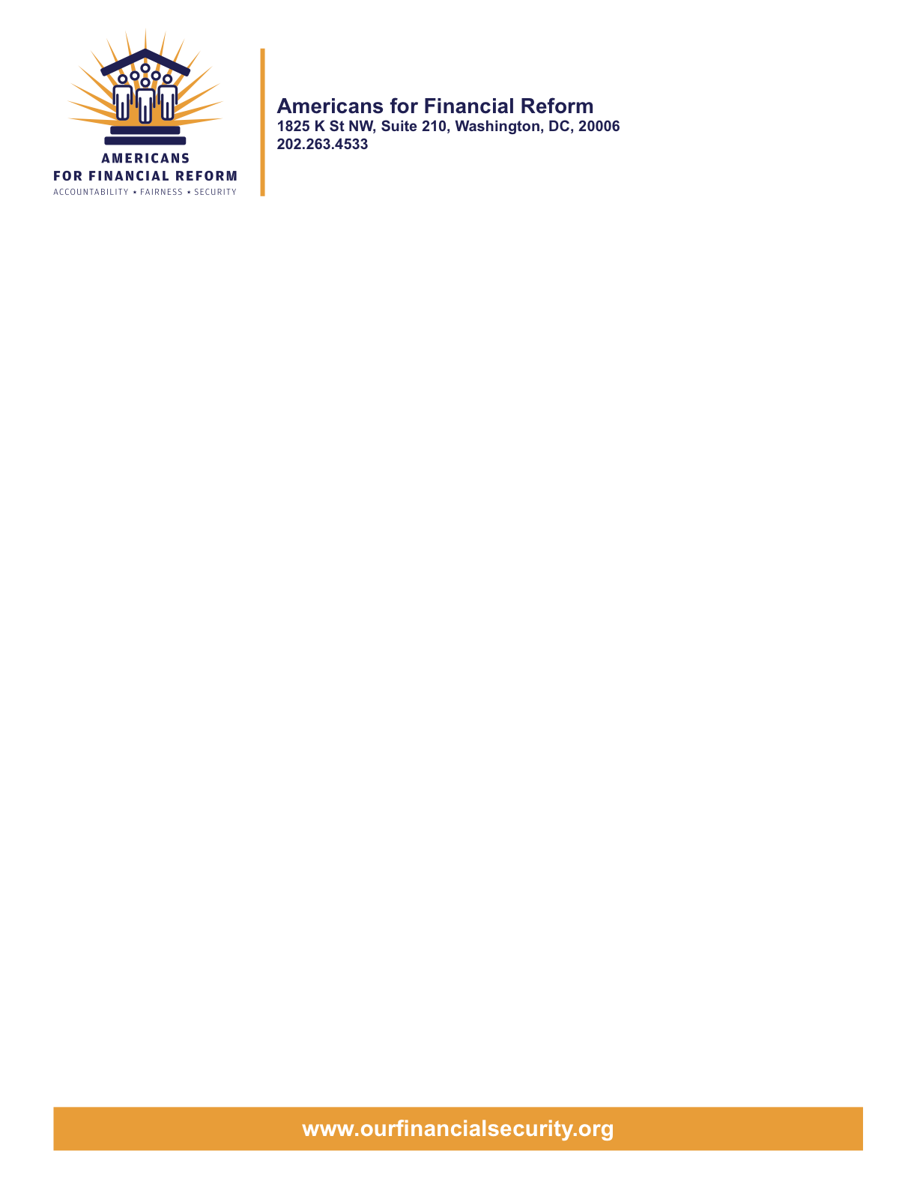

June 18, 2010

To Members of the H.R. 4173 Restoring American Financial Stability Act of 2010 Conference Committee
Washington, DC 20510

Re: Opposition of the Fed to regulate
Securities, Futures and Derivatives Clearinghouses

Dear Conferee:

The over 250 consumer, employee, investor, community, small business and civil rights groups who are members of Americans for Financial Reform (AFR) write to express our opposition to language that would authorize the Fed to effectively regulate securities, futures and derivatives clearinghouses.

"The central tenet of the new Congressional framework for bringing the $600 trillion risky derivatives market into a framework of capital adequacy and transparency is the requirement that standardized derivatives be cleared and exchange traded.

Currently, clearing organizations for futures and securities are overseen by the
market regulators: the CFTC and the SEC.

Within the House and Senate bills before the Conference Committee are critically important improvements to the CFTC’s regulation of clearing organizations for futures and standardized derivatives.

The financial reform bills fill a gap in regulation of payment systems by providing missing clear cut authority to the Federal Reserve to oversee inter-bank payment systems. The Senate bill, however, goes further by authorizing the Fed to effectively regulate securities, futures and derivatives clearinghouses.

This Fed provision was dropped from the House bill when the CFTC and SEC testified that, at best, this would create confusion over which agency is the appropriate derivatives clearing house regulator; at worst, the Senate bill would remove this clearing house oversight authority from the CFTC and SEC where it has long been placed.

The historical expertise of the SEC and CFTC in overseeing securities and derivatives clearing houses must not be displaced. Both of those agencies have repeatedly assured Congress that they would vigorously oversee the clearing houses in question and they have expressed a commitment that they will also ensure that the maximum number of standardized derivatives will be cleared and exchange traded. The Fed has not made a similar commitment to such vigorous regulation.

Indeed, the Fed appears to be sympathetic to Wall Street's desire to have the maximum number of standardized derivatives be free of clearing and exchange trading.

We strongly endorse the approach of the House bill to this issue -- that is, assuring that the SEC and CFTC retain their historic and exclusive oversight of these clearing facilities."

Thank you for considering the Americans for Financial Reform position on these important issues. For more information on derivatives reform, please contact Heather Slavkin, AFL-CIO, at 202-637-5318 or hslavkin@aflcio.org.

Sincerely,

Americans for Financial Reform

Following are the partners of Americans for Financial Reform.

All the organizations support the overall principles of AFR and are working for an accountable, fair and secure financial system. Not all of these organizations work on all of the issues covered by the coalition or have signed on to every statement.

National Organizations
- A New Way Forward
- AARP
- Accountable America
- Adler and Colvin
- AFL-CIO
- AFSCME
- Alliance For Justice
- American Family Voices
- American Income Life Insurance
- Americans for Democratic Action, Inc.
- Americans for Fairness in Lending
- American Sustainable Business Council
- Americans United for Change
- Business for Shared Prosperity
- Calvert Asset Management Company, Inc.
- Campaign for America’s Future
- Campaign Money
- Center for Digital Democracy
- Center for Economic and Policy Research
- Center for Economic Progress
- Center for Responsible Lending
- Center for Justice and Democracy
- Center of Concern
- Change to Win
- Clean Yield Asset Management
- Coastal Enterprises Inc.
- Color of Change
- Common Cause
- Communications Workers of America
- Community Development Transportation Lending Services
- Community Law Center
- Consumer Action
- Consumer Association Council
- Consumers for Auto Safety and Reliability
- Consumer Federation of America
- Consumer Watchdog
- Consumers Union
- Corporation for Enterprise Development
- CREDO
- CTW Investment Group
- Demos
- Economic Policy Institute
- Essential Action
- Green America
- Greenlining Institute
- Good Business International
- Help Is On the Way, Inc
- HNMA Funding
- Home Actions
- Housing Counseling Services
- Information Press
- Institute for Global Communications
- Institute for Policy Studies: Global Economy Project
- International Brotherhood of Teamsters
- Institute of Women’s Policy Research
- Keystone Research Center
- Krull & Company
- Laborers’ International Union of North America
- Lake Research Partners
- Lawyers’ Committee for Civil Rights Under Law
- Leadership Conference on Civil Rights
- MoveOn.org Political Action
- NAACP
- NASCAT
- National Association of Consumer Advocates
- National Association of Investment Professionals
- National Association of Neighborhoods
- National Coalition for Asian Pacific American Community Development
- National Community Reinvestment Coalition
- National Consumer Law Center (on behalf of its low-income clients)
- National Consumers League
- National Council of La Raza
- National Fair Housing Alliance
- National Federation of Community Development Credit Unions
- National Housing Institute
- National Housing Trust
- National Housing Trust Community Development Fund
- National NeighborWorks Association
- National Peoples Action
- National Council of Womens Organizations
- National Worksright Institute
- Next Step
- OMB Watch
- Opportunity Finance Network
- Partners for the Common Good
- National People’s Action (NPA)
- PICO
- Progress Now Action
- Progressive States Network
- Poverty and Race Research Action Council
- Public Citizen
- Responsible Endowments Coalition
- Sargent Shriver Center on Poverty Law
- Scam Victims United
- SEIU
- Sojourners
- State Voices
- Taxpayer’s for Common Sense
- The Association for Housing and Neighborhood Development
- The Carrots and Sticks Project
- The Fuel Savers Club
- The Seminal
- UNET
- Union Plus
- United for a Fair Economy
- U.S. PIRG
- Unitarian Universalist for a Just Economic Community
- United Food and Commercial Workers
- United States Student Association
- USAction
- Veris Wealth Partners
- Veterans Chanmber of Commerce
- We The People Now
- Western States Center
- Woodstock Institute
- Working America
- World Business Academy
- World Privacy Forum

State Organizations
- 207 CCAG
- 9 to 5, the National Association of Working Women (CO)
- AARP Rhode Island
- Alaska PIRG
- Arizona PIRG
- Arizona Advocacy Network
- Arizonans for Responsible Lending
- Arkansas Community Organizations
- Arkansas Public Policy Panel
- Association for Neighborhood and Housing Development (NY)
- Audubon Partnership for Economic Development LDC (New York, NY)
- Aurora NAACP
- BAC Funding Consortium Inc. (Miami, FL)
- Beech Capital Venture Corporation (Philadelphia, PA)
- Bell Policy Center (CO)
- California PIRG
- California Reinvestment Coalition
- Center for Media and Democracy
- Center for NYC Neighborhoods
- Century Housing Corporation (Culver City, CA)
- Changer(NY)
- Chautauqua Home Rehabilitation and Improvement Corporation (NY)
- Chicago Community Loan Fund (Chicago, IL)
- Chicago Community Ventures (Chicago, IL)
- Chicago Consumer Coalition
- Citizen Potawatomi CDC (Shawnee, OK)
- Club Change of Martin County (Florida)
- Coalition on Homeless Housing in Ohio
- Coffee Party of Pensacola, Florida
- Coffee Party of Union Square, New York City
- Colorado AFL-CIO
- Colorado Center on Law and Policy
- Colorado Immigrants Rights Coalition
- Colorado PIRG
- Colorado Spring NAACP
- Community Action of Nebraska
- Community Capital Development
- Community Capital Fund (Bridgeport, CT)
- Community Capital of Maryland (Baltimore, MD)
- Community Development Financial Institution of the Tohono O’odham Nation (Sells, AZ)
- Community Redevelopment Loan and Investment Fund, (Atlanta, GA)
- Community Reinvestment Association of North Carolina
- Community Resource Group (Fayetteville, AR)
- Connecticut Association for Human Services
- Connecticut Citizen Action Group
- Connecticut PIRG
- Consumer Assistance Council
- Cooper Square Committee (New York, NY)
- Cooperative Fund of New England (Wilmington, NC)
- Corporacion de Desarrollo Economico de Ceiba (Ceiba, PR)
- CWA 7777 (CO)
- Delta Foundation, Inc. (Greenville, MS)
- Economic Opportunity Fund (EOF) (Philadelphia, PA)
- Empire Justice Center (NY)
- Enterprises, Inc., Berea KY
- Fair Housing Contact Service OH
- Federation of Appalachian Housing Enterprises, Inc. (Berea, KY)
- Fitness and Praise Youth Development, Inc. (Baton Rouge, LA)
- Florida Consumer Action Network
- Florida PIRG
- Forward Community Investments (Madison, WI)
- Funding Partners for Housing Solutions (Ft. Collins, CO)
- Georgia PIRG
- Grow Iowa Foundation (Greenfield, IA)
- Homewise, Inc. (Santa Fe, NM)
- Humanitas Community Development Corporation
- Idaho Chapter, National Association of Social Workers
- Idaho Community Action Network
- Idaho Nevada CDFI (Pocatello, ID)
- Illinois PIRG
- Impact Capital (Seattle, WA)
- Indiana PIRG
- Indiana University PIRG
- Information Press (CA)
- Iowa PIRG
- Iowa Citizens for Community Improvement
- JobStart Chautauqua, Inc. (Mayville, NY)
- Keystone Research Center
- La Casa Federal Credit Union (Newark, NJ)
- Low Income Investment Fund (San Francisco, CA)
- Long Island Housing Services NY
- MaineStream Finance (Bangor, ME)
- Maryland PIRG
- Massachusetts Consumers’ Coalition
- Massachusetts Fair Housing Center
- MASSPIRG
- Michigan PIRG
- Midland Community Development Corporation (Midland, TX)
- Midwest Minnesota Community Development Corporation (Detroit Lakes, MN)
- Mile High Community Loan Fund (Denver, CO)
- Missouri PIRG
- Montana Community Development Corporation (Missoula, MT)
- Montana PIRG
- Mortgage Recovery Service Center of L.A.
- Neighborhood Economic Development Advocacy Project
- New Hampshire PIRG
- New Jersey Community Capital (Trenton, NJ)
- New Jersey Citizen Action
- New Jersey PIRG
- New Mexico PIRG
- New York PIRG
- New York City AIDS Housing Network
- Next Step (MN)
- NOAH Community Development Fund, Inc. (Boston, MA)
- Nonprofit Finance Fund (New York, NY)
- Nonprofits Assistance Fund (Minneapolis, MN)
- North Carolina Association of Community Development Corporations
- North Carolina PIRG
- Northern Community Investment Corporation (St. Johnsbury, VT)
- Northside Community Development Fund (Pittsburgh, PA)
- Ohio Capital Corporation for Housing (Columbus, OH)
- Ohio PIRG
- Oregon State PIRG
- Our Oregon
- PennPIRG
- Piedmont Housing Alliance (Charlottesville, VA)
- Rhode Island PIRG
- Rights for All People
- The Rocky Mountain Peace and Justice Center
- Rural Community Assistance Corporation (West Sacramento, CA)
- Rural Organizing Project OR
- San Francisco Metropolitan Transportation Authority
- Seattle Economic Development Fund dba Community Capital Development
- SEIU Local 105 (Colorado)
- SEIU Rhode Island
- Siouxland Economic Development Corporation (Sioux City, IA)
- Southern Bancorp (Arkadelphia, AR)
- TexPIRG
- The Association for Housing and Neighborhood Development
- The Fair Housing Council of Central New York
- The Help Network
- The Loan Fund (Albuquerque, NM)
- Third Reconstruction Institute (NC)
- V-Family, Inc.
- Vermont PIRG
- Village Capital Corporation (Cleveland, OH)
- Virginia Citizens Consumer Council
- Virginia Poverty Law Center
- War on Poverty – Florida
- Washington Community Action Network
- WashPIRG
- Westchester Residential Oppurtunities Inc. NY
- Wigamig Owners Loan Fund, Inc. (Lac du Flambeau, WI)
- WISPIRG

Businesses

- Blu
- Bowden-Gill Environmental
- Community MedPAC
- Diversified Env. Planning
- Hayden & Craig, PLLC\
- The Holographic Repatterning Institute at Austin
- Mid City Animal Hospital (Phoenix, AZ)
- UNET

