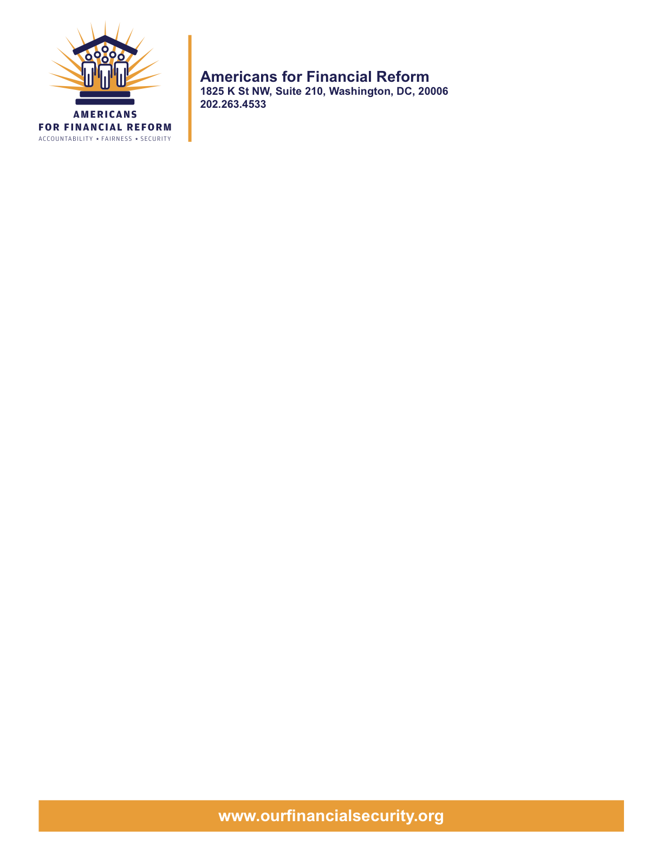

June 22, 2010

Chairman Christopher Dodd
United States Senate
Washington, DC 20510

Chairman Barney Frank
United States House of Representatives
Washington, DC 20510

Re: AFR positions on proposed House offer on Title X

Dear Senator/Representative:

We write on behalf of Americans for Financial Reform regarding the proposed House Conference offer on Title X of the financial reform bill, relating to the Consumer Financial Protection Bureau (CFPB). We strongly oppose exemptions for auto dealers and attorneys, have a concern about the funding proposal, and strongly support several other elements of the offer, especially the elimination of burdensome and one-sided rulemaking procedures, strengthening of the CFPB’s powers to police the entire market, and modernization of the FTC’s process and authority.

Provisions in the proposed House offer which AFR OPPOSES

We oppose proposed House offer #8, which exempts auto dealers from the new CFPB. The exemption is opposed not only by our coalition but also by banks, credit unions, and the military. Auto financial scams impede U.S. troop readiness, and they harm families inside and outside of the military. The Defense Department reports that 72 percent of surveyed military financial counselors across the country said they have counseled troops with these problems in the last six months. The provision in the House offer for consultation with the Office of Service Member Affairs does nothing to eliminate the problems posed by an exemption.

The auto dealer exemption in the proposed House offer is even broader than what the House passed last year, with the new language even exempting titled mobile homes sold by dealers, recreational boats, motorcycles, and motor homes. The exemption would create an uneven playing field, giving auto dealers who make or arrange loans an unfair competitive advantage over banks and credit unions. Moreover, the auto dealer exemption fails to protect communities of color and women who have been disproportionately steered into high interest loans. We ask you to reject the auto dealer exemption as a special interest carve out.

We oppose House offer #8, which broadly exempts from the CFPB activities by attorneys and activities under the direction of an attorney when those activities are part of or incidental to the practice of law. This proposed attorney exemption is both harmful and unnecessary. The base text already permits the CFPB to develop carefully crafted exemptions for attorneys on a case-by-case basis from specific rules. This much broader exemption for attorneys and those who work under their “direction” would be an open door for attorneys to use their law licenses to engage in practices that are otherwise illegal under CFPB rules.
A law license is not a guarantee against bad practices. In recent years, lawyers have been associated with loan modification scams, arbitration abuses, unfair debt collection practices, and debt settlement scams, and yet these activities could be construed as “practice of law”. States that have exempted attorneys have seen attorney abuses explode and the loophole be exploited. We ask you to reject the proposed House attorney exemption.
Provisions in the proposed House offer of CONCERN to AFR

We are concerned about House offer #2, which addresses appropriations’ funding for a portion of the CFPB’s budget. We prefer the Senate funding approach, which would fully fund the CFPB from funds provided by the Federal Reserve, because we are concerned that special interests would likely attempt to use the appropriations process to interfere with the independence of the agency.

Provisions in the proposed House offer which AFR SUPPORTS

We support proposed House offer #5 regarding examination and enforcement of financial institutions. This change contributes to a sensible, workable regulatory structure by permitting the CFPB to include an examiner at the time that the prudential regulator is conducting an examination of a depository institution of $10 billion or less in size. This provision also will help to ensure evenhanded enforcement of the laws with respect to all types of players, large and small, by providing for backstop enforcement authority if the prudential regulator fails to act after a formal referral from the CFPB.

We support proposed House offer #6 eliminating the burdensome, duplicative and one-sided consultation with industry before a rule can be proposed. This proposal will eliminate a process that would give predatory lenders the opportunity to influence CFPB rules before they are even proposed to the public and would delay rulemakings by several months.

We support proposed House offer #4 to give the CFPB supervisory authority over pay day lenders, money remitters, check cashers and private student loan providers. These lenders compete with other types of lenders who are subject to federal supervisory oversight. The practices of these types of lenders are among the most problematic for consumers, and the CFPB’s ability to protect the public would be less complete without this addition.

We support proposed House offer #7 to modernize the FTC’s regulatory process and enforcement powers. These basic provisions permit the FTC to use the Administrative Procedures Act process for public comment which is commonly used by many other federal agencies. The provisions will allow the FTC to pursue aiders and abetters, and to pursue civil penalties. These changes will enhance the FTC’s ability to stop conduct that hurts consumers and legitimate competitors.

We support proposed House offer #9, which restores the House requirement (also originally in the Senate bill) that preserves important state laws which address new abuses or gaps in federal law. Under the provision, the Office of Comptroller of the Currency may not preempt state law unless federal law provides a substantive standard regulating the activity. This change implements a simple idea – the OCC should not be able to knock out a state consumer protection statute when there is no federal standard to address the problem.

We support proposed House offer #15a on certification by the educational institution in connection with a private student loan. These provisions ensure that students have the opportunity to take out cheaper and safer federal loans before they take on more expensive and riskier private student loans.

We appreciate your interest in our views. As the Congress stands on the cusp of creating a structure for the future to address consumer protection issues in financial products and services, we ask you not to undermine the promise of that approach with broad exemptions for auto dealers or for lawyers.

Very truly yours,

Americans for Financial Reform

