

STATES MUST BE ALLOWED TO PROTECT THEIR RESIDENTS FROM HARMFUL FINANCIAL PRACTICES

May 5, 2010
Dear Senator:
As the Senate debates S. 3217, Restoring America’s Financial Stability Act, Consumers Union®, the nonprofit publisher of Consumer Reports®, urges you to oppose any amendments that would weaken states’ ability to protect their citizens from unsafe and predatory lending practices.
Please oppose amendments that would weaken the following provisions in the bill:
- Sections 1044-1046: State consumer protection legislation must apply equally to federally chartered banks and thrifts as it does to other types of financial services providers. S. 3127 contains modest steps towards this goal by reining in the OCC’s very broad approach to federal preemption of state law. We urge you not to weaken sections 1044-1046 of the bill.
- Sections 1042 and 1047: State Attorneys General must be able to engage in law enforcement of both state and federal consumer protections laws and rules. S. 3127 permits state Attorneys General to bring cases to protect their own state’s residents. We urge you not to weaken sections 1042 or 1047 of the bill.

We ask that you support:
- Amendment 3746 (Whitehouse) any banks that issue a loan to a consumer must abide any interest rate cap imposed by the State in which the consumer resides.
- Recent events have shown us that we need more cops on the beat to protect consumers from fraudulent and unsafe financial products and practices. State laws, and state enforcement of both state and federal laws, are an important part of policing the financial services marketplace. We respectfully urge you to support the role of the states in addressing consumer financial problems and in enforcing financial consumer protections laws.
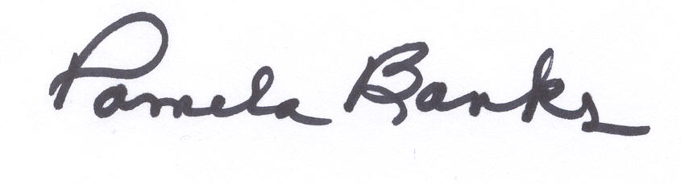
Thank you for your consideration of these important issues. We look forward to continuing to work with you as S. 3217 proceeds to final passage. If you have any questions, please contact Gail Hillebrand (415)431-6747 or Pamela Banks (202)462-6262.

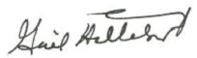
Sincerely,

Gail Hillebrand Pamela Banks
Financial Services Campaign Senior Policy Counsel
West Coast Office Washington Office
.

