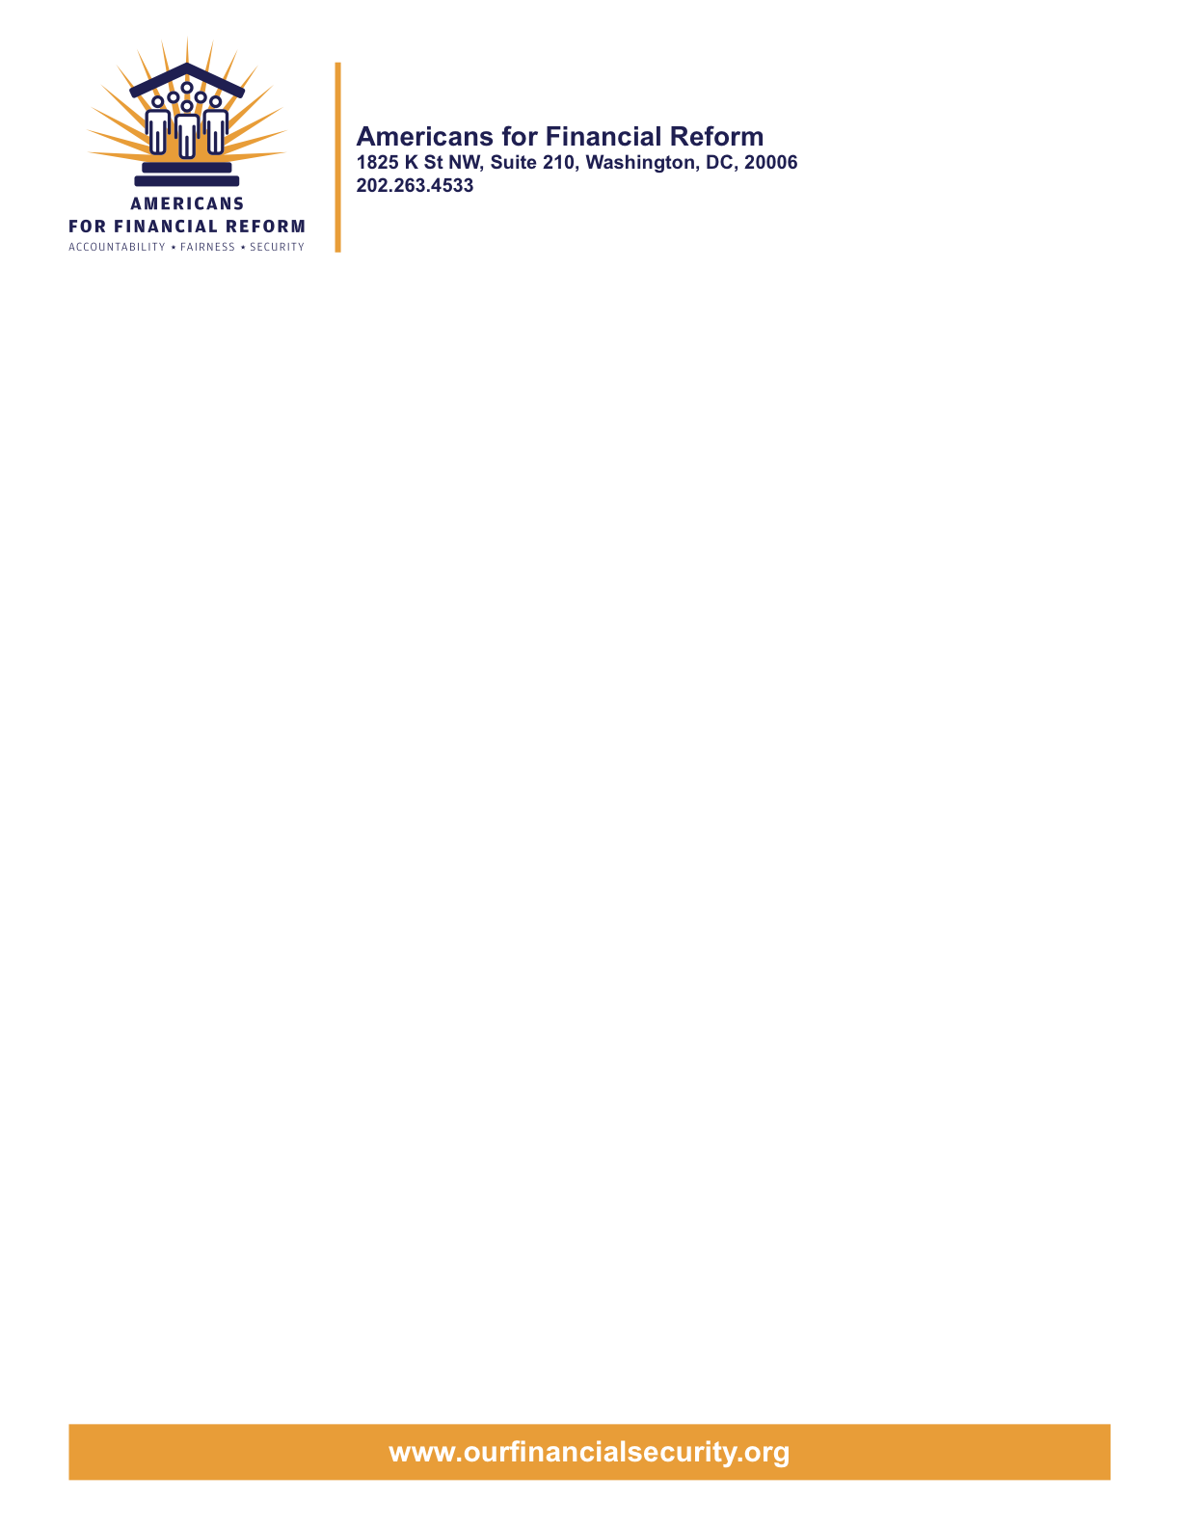

May 14, 2010

Senator
United States Senate
Washington, DC 20510

Re: End deceptive debt settlement practices identified by the GAO and tie debt settlement fees to results – Support Schumer-McCaskill amendment # 3960

Dear Senator:

Americans for Financial Reform supports the Schumer-McCaskill amendment #3960 to the Restoring American Financial Security bill, S 3217.

- This amendment is vital to protecting consumers from deceptive, abusive and financially injurious practices rampant in the debt settlement industry.

-This amendment will stop debt settlement companies from telling consumers to stop paying their debts, a current practice which harms both consumers and creditors.

-This amendment will end harmful practices in debt settlement identified by the GAO to Congress in April 2010.

Debt settlement has been a growing problem that cries out for a solution:

- The New York Times reports that consumers rarely benefit from debt settlement services. “More often, they say, a settlement company collects a large fee, often 15 percent of the total debt, and accomplishes little or nothing on the consumer’s behalf.” Debt Settlers Offer Promises But Little Help, New York Times, April 19, 2009, http://www.nytimes.com/2009/04/20/business/20settle.html?_r=1&emc=eta1.

- Debt settlement was identified in the March 2009 issue of Consumer Reports as one of five “financial traps.” Financial Traps are Flourishing, Tough Times Have Bred Five Costly Come Ons: High Fee Debt Settlement, Consumer Reports, March 2009, http://www.consumerreports.org/cro/magazine-archive/march-2009/money/scams/high-fee-debt-settlement/scams-high-fee-debt-settlement.htm.

- Smart Money reports that using these companies is “fraught with risk, not to mention outrageous fees.” Debt Settlement: A Costly Escape, August 6, 2007, http://articles.moneycentral.msn.com/SavingandDebt/ManageDebt/DebtSettlementACostlyEscape.aspx.

The Schumer-McCaskill debt settlement amendment will protect desperate consumers who are over-burdened with unsecured debt from deceptive practices and misconduct in the debt-settlement industry. The debt settlement industry purports to help consumers negotiate with creditors to pay off debts for less than the original balance due. Debt settlement providers typically instruct consumers to accumulate money in a special account. The idea is that the funds in the savings account will be used to make settlement offers to creditors, but first the debt settlement company deducts fees from those savings. The company gets and keeps the fees even if it never settles one penny of the consumer’s debt.

The debt settlement industry's practices often harm both consumers and creditors:

- Debt settlement providers often charge a percentage of the debt as their fee – even if they never settle one penny of the debt. The fees are deducted from the consumer’s savings regardless of whether any results are ultimately obtained. Taking the fees out early makes it harder for the consumer to save enough money to fund the proposed settlement offer, and it is just unfair to charge consumers something for nothing – paying a fee for no elimination of the debt. Amendment # 3960 requires that fees after the first $50 be computed based on the actual savings from real settlements that discharge the debt.

- The GAO determined that debt settlement providers often tell consumers to stop paying their creditors and put their money in the settlement fund instead. (GAO-10-593-T; April 2010) They don't tell consumers that this is likely to result in lawsuits by creditors, aggressive debt collection tactics and damage to the consumer's credit score. They also fail to tell consumers that any savings from the settlement may be taxed by the IRS as income. Amendment # 3960 would stop these practices.

- Debt settlement fees take money from consumers that could have been paid directly to creditors. Amendment # 3960 will make it harder for debt settlement companies to recruit consumers who can't afford debt settlement and who won't benefit from their inflated promises of relief. Under the amendment, those consumers won’t waste money paying high fees for little or no benefit—Instead that money will be available to pay creditors directly.

- Even the industry’s own statistics show that debt settlement does not regularly eliminate all of the debt for most consumers. An industry trade association survey shows most consumers do not eliminate all of their debt in debt settlement. Only 34.4% of consumers who started debt settlement three years earlier had either “substantially completed” their debt settlement plans or were still actively saving for settlements. Only 24.6% had eliminated at least 75% of their debt; while 9.8% were still trying to get rid of their debts through settlement three years after starting debt settlement. The fact that it is so rare for consumers to eliminate all or, even most, of their debt a big part of why it is so unfair to charge consumers a percentage of the debt. Amendment #3960 ends that percentage of debt fee approach.

- Debt settlement doesn’t deliver on its promises. The GAO found debt settlement companies' claims of success to be "suspiciously high" and "significantly higher than is suggested by evidence obtained by federal and state agencies."
Over the past five years, 21 states have brought 128 enforcement actions against 84 debt relief companies for unfair or deceptive trade practices. Most of these cases have been about debt settlement. States enforcement actions have alleged:
  - Unsubstantiated claims of consumer savings.
  - Deceptive representations about the length of time needed to complete a debt relief program.
  - Misleading or failing to adequately inform consumers about the risk of debt collection efforts, lawsuits and increased debt balances while enrolled in debt relief programs.
  - Deceptive disparagement of credit counseling and bankruptcy as alternatives for debtors.
  - Failure to conduct individualized financial analyses to determine whether the debt relief is suitable for the consumer.
  - Collection of substantial up-front fees even when the debt relief company fails to provide services to the consumer.
  - Basing savings claims and settlement fees on the debt including the amount by which the debt has grown during debt settlement, rather than on the original debt amount that the consumer had upon entering the program.

Amendment # 3960 addresses these practices.

The Schumer-McCaskill amendment will protect consumers and creditors by banning large upfront fees by debt settlement companies; banning unfair or deceptive acts or practices in the debt settlement industry; giving consumers a right to cancel debt settlement contracts; and requiring clear disclosure of the risks and costs of debt settlement.

This amendment would protect the millions of working families who are struggling with substantial personal debt, and would encourage those families to talk directly with their creditors rather than to cut off communications in the false hope that a debt settlement company will eliminate the debt.

Americans for Financial Reform supports Amendment # 3960. For more information, please contact Gail Hillebrand at Consumers Union, 415 431-6747, Susan Grant at the Consumer Federation of America, or Andrew Pizor at the National Consumer Law Center, 202-452-6252 x106.

This amendment is supported by, among others:

Consumers Union
Consumer Federation of America
National Consumer Law Center on behalf of its low income clients
National Foundation for Credit Counseling
Public Citizen
U.S. PIRG

Sincerely,

Americans for Financial Reform

Following are the partners of Americans for Financial Reform.

All the organizations support the overall principles of AFR and are working for an accountable, fair and secure financial system. Not all of these organizations work on all of the issues covered by the coalition or have signed on to every statement.

National Organizations
- A New Way Forward
- AARP
- Accountable America
- Adler and Colvin
- AFL-CIO
- AFSCME
- Alliance For Justice
- American Family Voices
- American Income Life Insurance
- Americans for Democratic Action, Inc.
- Americans for Fairness in Lending
- American Sustainable Business Council
- Americans United for Change
- Business for Shared Prosperity
- Calvert Asset Management Company, Inc.
- Campaign for America’s Future
- Campaign Money
- Center for Digital Democracy
- Center for Economic and Policy Research
- Center for Economic Progress
- Center for Responsible Lending
- Center for Justice and Democracy
- Center of Concern
- Change to Win
- Clean Yield Asset Management
- Coastal Enterprises Inc.
- Color of Change
- Common Cause
- Communications Workers of America
- Community Development Transportation Lending Services
- Community Law Center
- Consumer Action
- Consumer Association Council
- Consumers for Auto Safety and Reliability
- Consumer Federation of America
- Consumer Watchdog
- Consumers Union
- Corporation for Enterprise Development
- CREDO
- CTW Investment Group
- Demos
- Economic Policy Institute
- Essential Action
- Green America
- Greenlining Institute
- Good Business International
- Help Is On the Way, Inc
- HNMA Funding
- Home Actions
- Housing Counseling Services
- Information Press
- Institute for Global Communications
- Institute for Policy Studies: Global Economy Project
- International Brotherhood of Teamsters
- Institute of Women’s Policy Research
- Keystone Research Center
- Krull & Company
- Laborers’ International Union of North America
- Lake Research Partners
- Lawyers’ Committee for Civil Rights Under Law
- Leadership Conference on Civil Rights
- MoveOn.org Political Action
- NAACP
- NASCAT
- National Association of Consumer Advocates
- National Association of Investment Professionals
- National Association of Neighborhoods
- National Coalition for Asian Pacific American Community Development
- National Community Reinvestment Coalition
- National Consumer Law Center (on behalf of its low-income clients)
- National Consumers League
- National Council of La Raza
- National Fair Housing Alliance
- National Federation of Community Development Credit Unions
- National Housing Institute
- National Housing Trust
- National Housing Trust Community Development Fund
- National NeighborWorks Association
- National Peoples Action
- National Council of Womens Organizations
- National Worksright Institute
- Next Step
- OMB Watch
- Opportunity Finance Network
- Partners for the Common Good
- National People’s Action (NPA)
- PICO
- Progress Now Action
- Progressive States Network
- Poverty and Race Research Action Council
- Public Citizen
- Responsible Endowments Coalition
- Sargent Shriver Center on Poverty Law
- Scam Victims United
- SEIU
- Sojourners
- State Voices
- Taxpayer’s for Common Sense
- The Association for Housing and Neighborhood Development
- The Carrots and Sticks Project
- The Fuel Savers Club
- The Seminal
- UNET
- Union Plus
- United for a Fair Economy
- U.S. PIRG
- Unitarian Universalist for a Just Economic Community
- United Food and Commercial Workers
- United States Student Association
- USAction
- Veris Wealth Partners
- Veterans Chanmber of Commerce
- We The People Now
- Western States Center
- Woodstock Institute
- Working America
- World Business Academy
- World Privacy Forum

State Organizations
- 207 CCAG
- 9 to 5, the National Association of Working Women (CO)
- AARP Rhode Island
- Alaska PIRG
- Arizona PIRG
- Arizona Advocacy Network
- Arizonans for Responsible Lending
- Arkansas Community Organizations
- Arkansas Public Policy Panel
- Association for Neighborhood and Housing Development (NY)
- Audubon Partnership for Economic Development LDC (New York, NY)
- Aurora NAACP
- BAC Funding Consortium Inc. (Miami, FL)
- Beech Capital Venture Corporation (Philadelphia, PA)
- Bell Policy Center (CO)
- California PIRG
- California Reinvestment Coalition
- Center for Media and Democracy
- Center for NYC Neighborhoods
- Century Housing Corporation (Culver City, CA)
- Changer(NY)
- Chautauqua Home Rehabilitation and Improvement Corporation (NY)
- Chicago Community Loan Fund (Chicago, IL)
- Chicago Community Ventures (Chicago, IL)
- Chicago Consumer Coalition
- Citizen Potawatomi CDC (Shawnee, OK)
- Club Change of Martin County (Florida)
- Coalition on Homeless Housing in Ohio
- Coffee Party of Pensacola, Florida
- Coffee Party of Union Square, New York City
- Colorado AFL-CIO
- Colorado Center on Law and Policy
- Colorado Immigrants Rights Coalition
- Colorado PIRG
- Colorado Spring NAACP
- Community Action of Nebraska
- Community Capital Development
- Community Capital Fund (Bridgeport, CT)
- Community Capital of Maryland (Baltimore, MD)
- Community Development Financial Institution of the Tohono O’odham Nation (Sells, AZ)
- Community Redevelopment Loan and Investment Fund, (Atlanta, GA)
- Community Reinvestment Association of North Carolina
- Community Resource Group (Fayetteville, AR)
- Connecticut Association for Human Services
- Connecticut Citizen Action Group
- Connecticut PIRG
- Consumer Assistance Council
- Cooper Square Committee (New York, NY)
- Cooperative Fund of New England (Wilmington, NC)
- Corporacion de Desarrollo Economico de Ceiba (Ceiba, PR)
- CWA 7777 (CO)
- Delta Foundation, Inc. (Greenville, MS)
- Economic Opportunity Fund (EOF) (Philadelphia, PA)
- Empire Justice Center (NY)
- Enterprises, Inc., Berea KY
- Fair Housing Contact Service OH
- Federation of Appalachian Housing Enterprises, Inc. (Berea, KY)
- Fitness and Praise Youth Development, Inc. (Baton Rouge, LA)
- Florida Consumer Action Network
- Florida PIRG
- Forward Community Investments (Madison, WI)
- Funding Partners for Housing Solutions (Ft. Collins, CO)
- Georgia PIRG
- Grow Iowa Foundation (Greenfield, IA)
- Homewise, Inc. (Santa Fe, NM)
- Humanitas Community Development Corporation
- Idaho Chapter, National Association of Social Workers
- Idaho Community Action Network
- Idaho Nevada CDFI (Pocatello, ID)
- Illinois PIRG
- Impact Capital (Seattle, WA)
- Indiana PIRG
- Indiana University PIRG
- Information Press (CA)
- Iowa PIRG
- Iowa Citizens for Community Improvement
- JobStart Chautauqua, Inc. (Mayville, NY)
- Keystone Research Center
- La Casa Federal Credit Union (Newark, NJ)
- Low Income Investment Fund (San Francisco, CA)
- Long Island Housing Services NY
- MaineStream Finance (Bangor, ME)
- Maryland PIRG
- Massachusetts Consumers’ Coalition
- Massachusetts Fair Housing Center
- MASSPIRG
- Michigan PIRG
- Midland Community Development Corporation (Midland, TX)
- Midwest Minnesota Community Development Corporation (Detroit Lakes, MN)
- Mile High Community Loan Fund (Denver, CO)
- Missouri PIRG
- Montana Community Development Corporation (Missoula, MT)
- Montana PIRG
- Mortgage Recovery Service Center of L.A.
- Neighborhood Economic Development Advocacy Project
- New Hampshire PIRG
- New Jersey Community Capital (Trenton, NJ)
- New Jersey Citizen Action
- New Jersey PIRG
- New Mexico PIRG
- New York PIRG
- New York City AIDS Housing Network
- Next Step (MN)
- NOAH Community Development Fund, Inc. (Boston, MA)
- Nonprofit Finance Fund (New York, NY)
- Nonprofits Assistance Fund (Minneapolis, MN)
- North Carolina Association of Community Development Corporations
- North Carolina PIRG
- Northern Community Investment Corporation (St. Johnsbury, VT)
- Northside Community Development Fund (Pittsburgh, PA)
- Ohio Capital Corporation for Housing (Columbus, OH)
- Ohio PIRG
- Oregon State PIRG
- Our Oregon
- PennPIRG
- Piedmont Housing Alliance (Charlottesville, VA)
- Rhode Island PIRG
- Rights for All People
- The Rocky Mountain Peace and Justice Center
- Rural Community Assistance Corporation (West Sacramento, CA)
- Rural Organizing Project OR
- San Francisco Metropolitan Transportation Authority
- Seattle Economic Development Fund dba Community Capital Development
- SEIU Local 105 (Colorado)
- SEIU Rhode Island
- Siouxland Economic Development Corporation (Sioux City, IA)
- Southern Bancorp (Arkadelphia, AR)
- TexPIRG
- The Association for Housing and Neighborhood Development
- The Fair Housing Council of Central New York
- The Help Network
- The Loan Fund (Albuquerque, NM)
- Third Reconstruction Institute (NC)
- V-Family, Inc.
- Vermont PIRG
- Village Capital Corporation (Cleveland, OH)
- Virginia Citizens Consumer Council
- Virginia Poverty Law Center
- War on Poverty – Florida
- Washington Community Action Network
- WashPIRG
- Westchester Residential Oppurtunities Inc. NY
- Wigamig Owners Loan Fund, Inc. (Lac du Flambeau, WI)
- WISPIRG

Businesses

- Blu
- Bowden-Gill Environmental
- Community MedPAC
- Diversified Env. Planning
- Hayden & Craig, PLLC\
- The Holographic Repatterning Institute at Austin
- Mid City Animal Hospital (Phoenix, AZ)
- UNET

Source: The Association of Settlement Companies (TASC), October 26, 2009, comments to the FTC on the proposed amendments to the Telemarketing Sales Rule on the marketing of debt relief services, p. 9-11. http://www.ftc.gov/os/comments/tsrdebtrelief/543670-00202.pdf
Source: National Association of Attorneys General (NAAG) comments to the FTC on proposed amendments to the Telemarketing Sales Rule on the marketing of debt relief services, October 23, 2009, http://www.ftc.gov/os/comments/tsrdebtrelief/543670-00192.pdf

