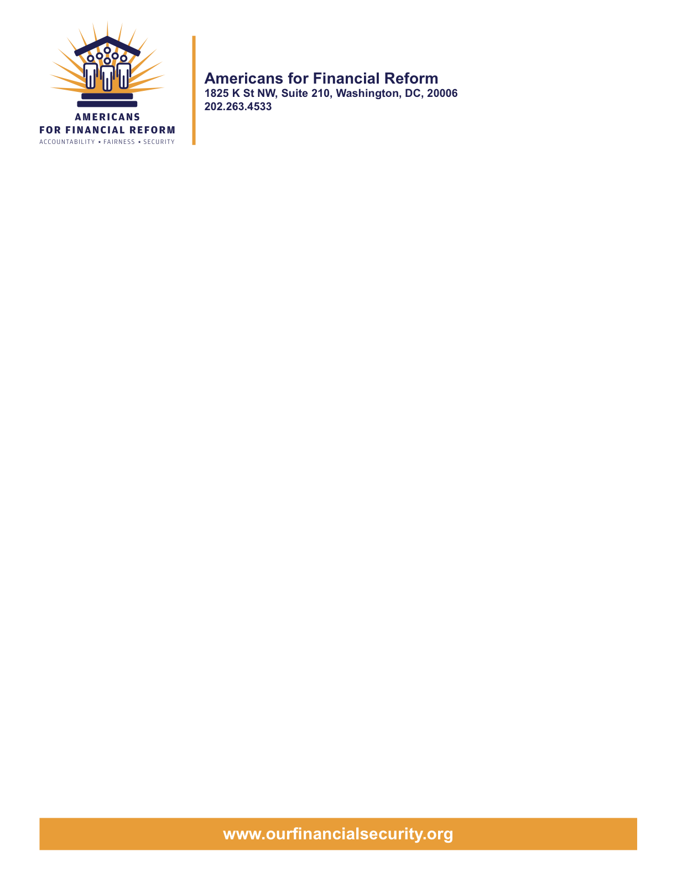

Bottom line:
The risky schemes of the big Wall Street banks caused the collapse of the economy and cost 7 million Americans their jobs. Now they’re at it again, gambling with our money and paying themselves massive bonuses. The Senate must pass real reform that holds the big Wall Street banks accountable. The more Congress delays and puts forth fake solutions bought-and-paid-for by the banks, the greater the risk of another collapse that will cost more jobs and end the economic recovery. We need to pass a strong, comprehensive bill through the Congress this year.

Derivatives

Bottom line: End the casino economy where Wall Street speculators make huge, risky and secret bets with our retirement accounts, pensions and college savings, and then sit back and wait to be bailed out, while we lose everything we have worked for all our lives.

What reformers want
- Everyone making the bets should be required to prove they have the money to cover them
- A stock-exchange style system that would make these now-secret trades transparent.
- No special rules for special interests

Why it matters
- In a casino, if you want to bet $100 worth of chips, you have to show you have $100. Not so in the derivatives market. Hence the bailouts. Because this multi-billion marketplace was secret, no one could put all the pieces together to head off the crash before it happened and we had to bail out Wall Street. Even if they could see the coming crisis, regulators wouldn’t have had the power to do anything about it.

Real world example: Taxpayers bailed out AIG because it couldn’t cover its bets.
What the banks and their pet senators say: We didn’t cause the crisis. The big banks and various gamblers and speculators are fixing this mess themselves and they promise to do better next time.
What reformers say to that: Yeah, because the banks are so trustworthy …..
State of play: Reform advocates believe the Senate Banking bill is good but needs to be better. The Senate Agriculture Committee is working on its version. It is likely to be much worse from the perspective of Americans for Financial Reform and more industry-friendly. Depending on what the ultimate language looks like, expect amendments to strengthen or work to block weakening amendments.

Too big to fail: Ending the Bailout era

The bottom line: Commercial banks – the kind that take deposits and make loans – should be taking care of your money, not gambling it on secret, risky deals that cost us trillions of dollars in savings and end up with our having to bail them out.

What reformers want:
- Reformers want to ban banks that are supposed to be taking care of your money from sinking it into risky schemes to pad their own bottom lines and leave you holding the bag.

Why it matters: The bailed-out banks grew “too big to fail” by trading with your money. You had to rescue them.

Real world example: The entire bailout.

What the big banks and their pet senators say: Limiting banks ability to speculate will hurt the economy.

What reformers say back: The only negative economic impact this will have is on the massive bonuses and salaries the bankers pay themselves. Financial data from the last decade – such as the gap between regular wage earners’ salaries and banker salaries – proves that the rest of us did not benefit from the growth of the financial sector.

State of play:
- Expect reform amendments to strengthen the separation language, known as the “Volcker Rule,” so there are no exceptions.
- Expect opposition/banker amendments to remove the existing language and ban altogether.

Too big to fail: Resolution authority

The bottom line: This creates a system to dismantle financial institutions and makes the banks and speculators pay the cost so taxpayers will never again have to bail out financial institutions that are deemed too big to fail.

What reformers want: An orderly system to dismantle financial institutions that protect working people and guards against another bailout.

Real world example: Had the government had the authority to wind down AIG and sell off its assets – like the FDIC can do for troubled banks – we would not have had to bail them out.

What the big Wall Street banks and their pet senators in Congress say: This bill creates a permanent bailout.

What reformers say: Exactly the opposite. This bill guarantees against another taxpayer-funded bailout – ever – by forcing the banks and financial institutions to pay into a “just in case fund” and creating a path to dismantle them.

State of play:
- Reformers will try to improve protections for workers should a company have to be dismantled.
- Reformers expect a fight to eliminate the responsibility of big banks and hedge funds and the like to pay into a pool that would cover the costs should an entity have to be resolved so that taxpayers would not have to pay for it.
- Reformers will fight against attempts to eliminate a provision that would change the process by which the Board of the New York Fed is chosen so that they are presidential appointees rather than people selected by the banks themselves to regulate themselves

Consumer Financial Protection

The bottom line: We need real protections for regular people from things like 29 percent interest rates hidden in credit card fine print; incomprehensible, trick mortgages peddled to people who qualified for regular mortgages; and car dealers who get kickbacks. Regulators whose main job is to make sure banks are profitable are clearly not the right people to look out for consumers or hold those same banks accountable. Even if we don’t borrow, we all suffer from lack of consumer protections – witness the subprime mortgage crisis, for example.

What reformers want:
- No lenders should be exempt from oversight by the Consumer Financial Protection Agency (CFPA). That includes payday lenders, mortgage companies large and small, car dealers and all other shady businesses that prey on people who can least afford to be scammed. Businesses need to be regulated based on what they do, not what they call themselves.
- The very agencies that blew it the last time around – ignoring what was going on at the mortgage companies, for example – should not have veto power, or any other power, over the CFPA.

Real world examples: Military leaders recently met with the White House to talk about how car dealers and other scam artists routinely prey on military personnel.

What the banks and their pet senators say: This creates a regulatory burden that is unnecessary because we already have entities in the government responsible for consumer financial protection.

What reformers say back: When the job was divided, because everyone was in charge, no one took responsibility. This is not creating a new bureaucracy, it is taking an existing bureaucracy and replacing it with a systematic, efficient mechanism for getting the job done.

State of play:
- Expect amendments from reformers to ensure that the CFPA is truly independent without meddling from failed regulators, has enforcement power and clearly covers all the necessary lenders. Similarly, expect amendments from the other side making the CFPA subject to the rule of other regulators.
- Expect a fight on likely Republican amendments to further remove power from states to enforce consumer protection t laws, acting as the first line of defense against scams.
- Expect Opposition amendments carving out exemptions for certain types of businesses, notably car dealers.

Private Equity and Hedge Funds

What reformers want: Currently, the Senate bill requires hedge fund managers in charge of more than $100 million to register with the Securities and Exchange Commission and to disclose information to regulators. Venture capital and private equity fund advisers should face similar requirements.

Why it matters:
- Private equity could be the next big bailout. Already, there are estimates of billions of defaults headed into the marketplace. But no one knows for sure because all these transactions are secret.
- Private investment firms currently employ 1 out of every 10 Americans in the firms they have purchased. If they saddle a company with too much debt, or strip it of its assets and flip it to another company, those people will lose their jobs – not something we can afford to have happen in this economy.

Real life examples:

- Hugo Boss: Ohio
The company: Hugo Boss is a German clothing company that manufacturers clothing in the U.S. and abroad
The buyout: Permira Advisors has controlled Hugo Boss since 2007.
The winners: In 2008, several Hugo Boss managers resigned after Permira’s insistence on taking a special dividend of 345 million euros out of the company to pay itself
The losers: Hugo Boss employs 300 people at its factory in the Cleveland suburb of Brooklyn. After unsuccessfully trying to get workers there to take a major pay cut, Hugo Boss announced plans to shut it down and move it overseas. They will not say whether or not it is profitable, only that they feel it is not “globally competitive.”

- Dollar General Stores: Tennessee, Virginia, Ohio, Oklahoma, nationwide
The company: This discount retailer sells food, cleaning supplies and household goods, mostly in rural towns.
The buyout: A group of investors led by Kohlberg Kravis Roberts & Co., bought Dollar General in 2007 and took it public in 2009.
The winners: IPO sponsors including Kohlberg took a $200 million dividend before the stock offering.
The losers: Since then, Dollar General has closed stores and cut jobs at distribution centers, laying off hundreds of workers in states including Virginia, Ohio, Missouri and Oklahoma.

What the big Wall Street firms and their pet senators say: Private equity doesn’t pose a systemic risk and so shouldn’t be regulated and treated as if it does.

What reformers say: One out of every 10 Americans works for a company owned by private equity. That strikes me as a systemic risk.

State of play: Reformers will offer amendments to restore requirements for private equity and venture capital.

Corporate Governance

Bottom line: We need to hold corporations and their CEOs accountable for risky decisions that fattened their paychecks but cost millions of Americans their jobs, retirement savings and financial security.

What reformers want:
- The Senate Banking bill makes it possible for shareholders to have a real say in who sits on the boards of directors of the companies they own.
- The bill also requires companies to hold nonbinding shareowner votes on executive pay.

Why it matters:
- CEO compensation packages for the big banks and Wall Street were designed to reward short-term, risky strategies that ultimately crashed the economy and cost Americans 7 million jobs.
- Similarly, boards of directors appointed by corporations themselves did nothing to check excessive risk-taking by management.

Real life example:
- Richard S. Fuld Jr. was the chairman and chief executive of Lehman Brothers when it collapsed in September 2008 and brought the world financial system to the brink of failure. For his performance Fuld collected more than $484 million in salary and bonuses from Lehman during his last five years at the helm thanks to his hand-picked board of directors.

What big corporations and their pet senators say: Corporate board failures didn’t cause the financial crisis. The proposal could result in boardroom havoc and cause investors harm.

What reformers say to that: Investors have already been harmed to the tune of billions of dollars. What the corporations are really afraid of having to answer to independent boards.

State of play: Reformers will fight amendments to strip these provisions.

Credit Rating Agencies

Bottom line: Credit-rating agencies enabled the financial crisis by stamping their AAA seal of approval on what were actually enormously risky products. They must be held accountable.

What reformers want:
- Investors should be able to sue credit-rating agencies – currently, they are virtually impossible to sue because they claim their grades are “opinions” subject to First Amendment protections.
- The SEC must have the authority it needs to hold credit rating agencies accountable

Why it matters: Credit Rating Agencies got paid to slap AAA ratings on packages of dangerous investments they did not even try to understand or evaluate. Their triple A ratings created huge markets for these investments, and spread them through every corner of the market. When the House of Cards built on their false promises collapsed, millions of Americans lost their savings.

Real world example: Ohio is suing Moody’s Investors Service, Standard & Poor’s and Fitch, claiming that they had cost state retirement and pension funds some $457 million by approving high-risk Wall Street securities that went bust in the financial collapse.

What the big banks and their pet senators say: Credit-rating agencies are protected by the First Amendment.

What reformers say back: The agencies put their own profit ahead of quality when they made their ratings. This is not protected speech. It is fraud.

State of play: Expect reformers to fight for more accountability for credit rating agencies, and to defend against amendments to grant them impunity.

Investor protections

What reformers want: The bill should include a strong package of investor protections, including a requirement that brokers and insurance agents act in the best interests of their customers when they recommend securities.

Why it matters: Brokers and insurance agents encourage their customers to rely on them as trusted advisers, but they don’t want to have to act like advisers. In other words, they don’t want to have to recommend the investments that are best for their customers instead of the ones that are most profitable for them. Hard-pressed, middle income investors can’t afford to squander their limited resources on high-cost, poorly performing investments just to help line the pockets of brokers and insurance agents.

Real world example: Brokers and insurance agents sell investors high-cost variable annuities loaded up with gimmicky riders, costing investors an estimated $25 billion a year in “spendable investment returns” that goes instead to line the pockets of the salespeople because those salespeople don’t have to recommend the product that is best for their customer.

What the brokers and their pet senators say: Forcing brokers to act in the best interests of their customers could have unintended consequences. We need another study of the issue.

What reformers say back:
The SEC has studied this issue to death, and the SEC Chairman has urged Congress to raise the standards for brokers. Investors need to know that the “financial advisers” they rely on for investment recommendations are putting their interests first.

State of play:
- The provision that would have required brokers to put their customers’ interests first was removed from the bill in Senate Banking Committee.
- An amendment is likely to be offered on the Senate floor to adopt the language that has already passed the House. It should be adopted and included in the final bill.

