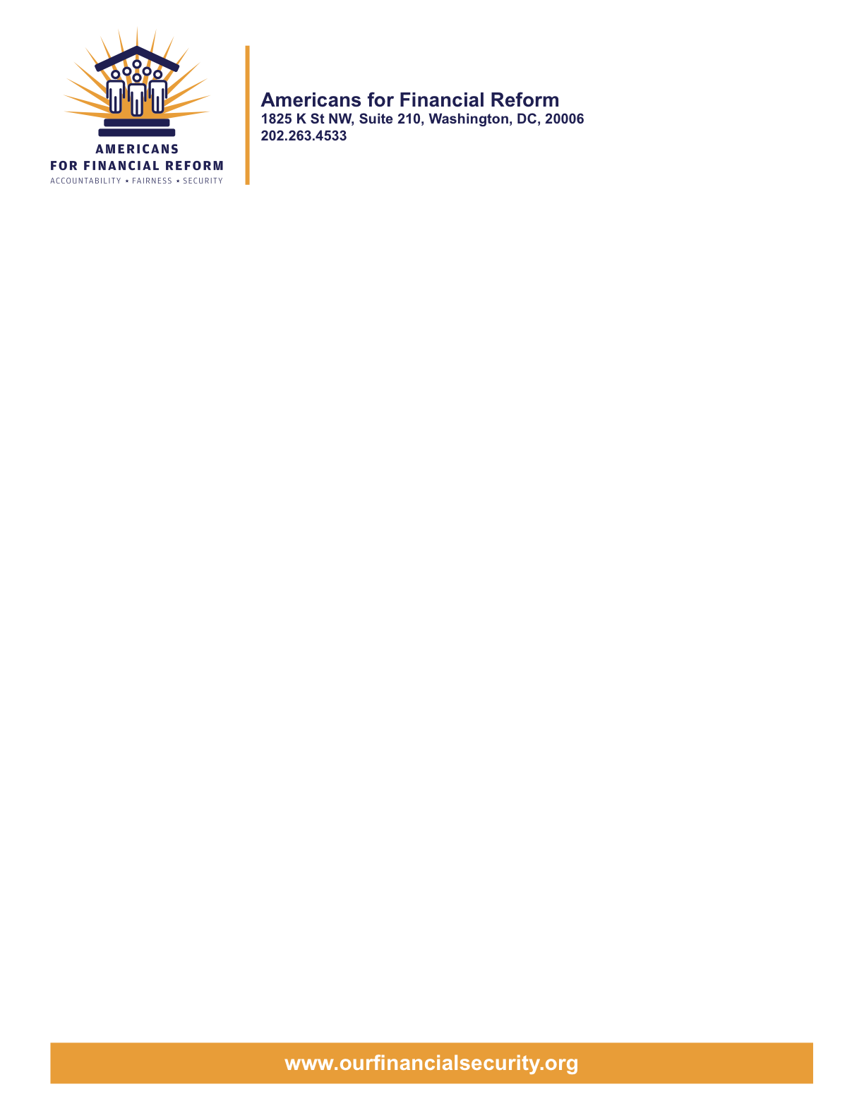

Credit Rating Agency Reform

Credit rating agencies were key enablers of the financial crisis. As quasi-official arbiters of credit risk, rating agencies got paid by the banks to slap triple-A ratings on packages of dangerous investments they did not even try to understand or evaluate. Their inflated ratings created huge markets for these toxic products, and spread them through every corner of the market. When the House of Cards built on their false promises collapsed, millions of Americans lost their savings.

The Dodd bill contains a strong package of reforms designed to hold the credit rating agencies accountable and to make our financial system less vulnerable to ratings failures. Industry opposition will be intense. These provisions must not be weakened:

- A new Office of Credit Ratings within the SEC with enhanced authority to oversee ratings agencies and levy fines or revoke or suspend a rating agency’s registration
- A case-by-case review of the reliance on credit ratings in federal regulation, to identify where alternative measures of creditworthiness are needed and to adopt appropriate alternatives wherever possible
- A universal rating scale for corporate bonds, municipal bonds, and structured finance products based on the likelihood of default
- A new standard of liability, enforceable through private action, for rating agencies who recklessly or knowingly fail to conduct an adequate investigation to support an accurate rating
- Enhanced corporate governance standards for ratings agencies, to ensure that they operate in the interest of users of ratings

A number of key areas still need to be improved. The following provisions would significantly strengthen the measure:

- An independent clearinghouse to randomly assign rating engagements and pay credit rating agencies, eliminating the fundamental conflict of interest in the issuer-pays business model
- SEC authority to require post-rating surveillance, to monitor and update ratings after they are issued, as included in the House bill
- SEC authority to oversee procedures and methodologies used by ratings agencies to ensure that they have appropriate procedures in place to produce reliable ratings
- Stronger “Section 11” liability language, as written in the House bill

