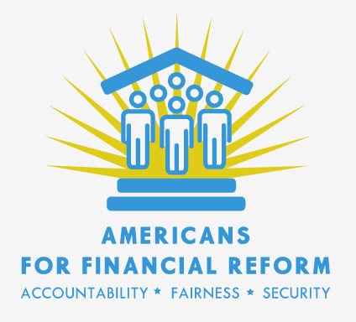

"They've [S&P's RMBS group] become so beholden to their top issuers [investment banks] for revenue they have all developed a kind of Stockholm syndrome which they mistakenly tag as Customer Value creation."
--Email from S&P employee, 8/08/2006, Subject: ''Roe: Loss severity vs gross/net proceeds"

From the FCIC hearing:

Eric Kolchinsky:

"It was very clear to me that my future at the company and my compensation would be based on the market share that we brought in." "Senior management would periodically distribute emails detailing their departments' market share. Even if the market share dropped by a few percentage points, managers would be expected to justify "missing" the deals which were not rated."

"The focus on market share inevitably led to an inability to say "no" to transactions. It was well understood that if one rating agency said no, then the banker could easily take their business to another. During my tenure at the head of US ABS CDOs, I was able to say no to just one particularly questionable deal. That did not stop the transaction - the banker enlisted another rating agency and received the two AAA ratings he was looking for."

Upshot: Moody's effectively "couldn't say no to a deal" - even to security issuers who had been caught lying about the contents of a deal. Lying was never reported to anyone. There was effectively no sanction for lying, according to Kolchinsky.

"What can be done to improve rating quality? One solution which has been proposed is to completely remove any references to ratings in regulations. While this proposal seems simple and just, it is also impractical. At this point in time there are no organizations ready to take the agencies' role in the capital markets. Furthermore, the perverse incentives described above will apply to any private organizations charged with the same task."

Gary Witt:

"They [bankers/securities packagers] always wanted higher ratings or bigger triple-A tranches and they would work hard to achieve that and could be very creative in the way they would explain things or the type of evidence they would use. They would just pull any lever, basically, that they could. Pressure might mean calling one of our superiors and describing some situation in terms that weren't really accurate to try and put me on the defensive. That was just a part of the job."

Question from Heather Murren to GW: How many times did people walk away bEcause you would say we will not give you the rating you want?
GQ: I'm sure there were many occasions over the year and a half.
HM: And typically those would go to another rating agency and they would get the rating they wanted?
GW: Often, yes.

GW in interview with commission was asked whether he had been pressured by bankers: “Oh God, are you kidding, all the time. I mean that's routine. They would threaten you all the time. “

Mark Froeba

"Under the guise of making Moody's more business-friendly, making it more responsive to clients - e.g., making sure that analysts would return telephone calls etc., - Moody's senior managers set in motion a radical change in Moody's analytical culture that not only changed the rating process but also profoundly affected Moody's ratings."

"When I joined Moody's in late 1997, an analyst's worst fear was that he would contribute to the assignment of a rating that was wrong, damage Moody's reputation for getting the answer right and lose his job as a result. "

"When I left Moody's, an analyst's worst fear was that he would do something that would allow him to be singled out for jeopardizing Moody's market share, for impairing Moody's revenue or for damaging Moody's relationships with its clients and lose his job as a result."

....

And here is Michael Lewis in Sunday's NY Times:

"The lone remaining risk to the status quo is the Franken amendment - introduced by Senator Al Franken of Minnesota - which would prevent us [bankers] from personally selecting the ratings agencies that offer opinions on our offerings. It creates a board inside the Securities and Exchange Commission to assign ratings agencies, thereby removing the direct incentive the raters have to please us. (Of course, it preserves their indirect incentive: that is, that we might one day offer them jobs.) The Franken amendment thus gums up what has been heretofore a very cleanly rigged system. In addition to encouraging public references to Stuart Smalley and Mr. Franken's other theatrical embarrassments, we should remind our friends on Capitol Hill and in the press that "the Franken amendment will give the federal government the same control over finance it has seized in health care."

....

Exhibits for hearing on "Wall Street and the Financial Crisis: The Role of Credit Rating Agencies," U.S. Senate Permanent Subcommittee on Investigations, Committee on Homeland Security and Governmental Affairs, April 23, 2010:

"Analysts and [Managing Directors] are continually 'pitched' by bankers, issuers, investors -all with reasonable arguments -- whose views can color credit judgment, sometimes improving it, other times degrading it (we "drink the kool-aid' ). Coupled with strong internal emphasis on market share & margin focus, this does constitute a 'risk' to ratings quality."
---Email from Moody's Chief Risk Officer to CEO Raymond McDaniel, 10/21/2007

"They've [S&P's RMBS group] become so beholden to their top issuers [investment banks] for revenue they have all developed a kind of Stockholm syndrome which they mistakenly tag as Customer Value creation."
--Email from S&P employee, 8/08/2006, Subject: ''Roe: Loss severity vs gross/net proceeds"

"And so what happened was, it was a slippery slope. As you see markets that are robust, an example would be what happened recently in commercial mortgages, or more importantly what happened with subordinated tranches in residential mortgages in '04 and '05 with respect to subordinated tranches is that our competition, Fitch and S&P went nuts. Everything was investment grade. It didn't really matter."
--Moody's CEO Raymond McDaniel at Moody's Town Hall Meeting, September 10, 2007

