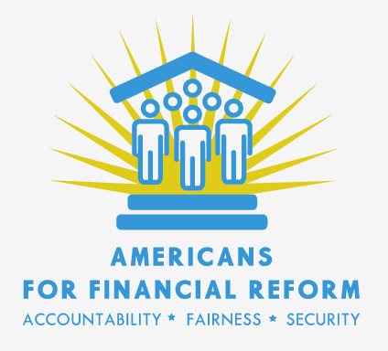
Conference Priorities (in alphabetical order)
May 27, 2010

Consumer Agency:
- Single presidentially appointed senate confirmed director (Senate)
- Guaranteed independent funding (Senate)
- Eliminate unnecessary delay and privileged access to regulatory process for payday lenders, debt collectors and other small credit providers. (Eliminate Senate Snowe amendment language, retain House silence)
- No special exemption for car dealers ( Eliminate House exemption, retain Senate silence)
- Enhance FTC authority (House)
- Ensure consistent enforcement of banking rules (CFPB backup enforcement for small banks, House)

Corporate Governance:
- Proxy Access Language (both Houses)
- Stronger executive compensation reform (House)

Credit Rating Agencies:
- Reduce credit rating agency conflict of interest (Franken amendment, Senate)
- Hold credit rating agencies accountable for fraudulent or reckless ratings. (Section 11 liability, House)
- Monitor the procedures and methodologies used to produce ratings (Adopt House language; Senate only covers adherence to procedures and methodologies)

Derivatives:
- Preserve the separation of swaps desks from commercial banking ( Senate section 716, House is silent)
- Preserve the fiduciary duty of swaps dealers to pension funds, municipalities and other clients ( Senate, House is silent)
- Capture the maximum number of derivatives trades under clearing and exchange trading requirements, and limit exemptions to true commercial end users hedging commercial risk (Senate end user language)
- Ensure transparency (Senate alternate trading facility language)
- Make the technical fix needed to make the clearing requirement work (Cantwell /Lincoln language)

Federal Reserve Reform:
- Fed Governance & Mission Reforms (Senate)
- Comprehensive Fed Audit—at minimum preserve language requiring GAO to make public all Section 13(3) recipients (House)

Hedge Funds and Private Equity:
- Record keeping, reporting, and examination requirements must apply to private equity and family offices as well as to hedge funds. (House)
- SEC authority to require hedge fund and private equity fund advisers to disclose information to investors and creditors (House)

Housing/Mortgage:
- Foreclosure prevention provisions from House bill Including unemployed homeowner mortgage assistance program (House )
- Best mortgage standards (Senate provisions on Yield Spread Premiums, prepayment penalties, ability to repay. Senate liability structure. House provisions on HOEPA, appraisal, servicer reforms, counseling)

Investor Protection:
- All investment advisors should have a fiduciary duty to their clients (Fiduciary duty. House)
- Preserve existing Sarbanes Oxley reporting requirements (Senate is silent. House rolls them back)

Resolution Authority:
- Fix the funding mechanism (House or alternative to guarantee industry payments and budget neutrality)
- Remove the judiciary panel (House)
- Secured Creditor Haircut (House)

Systemic Risk:
- Make sure systemically significant non-bank financial companies are subject to systemic regulation (Definition of financial company, House)
- Volcker Rule, strengthened per Merkley-Levin(Senate)
- Interconnectedness provisions (Senate Sec. 608, 610, 611)
- Statutory leverage limit (House)

